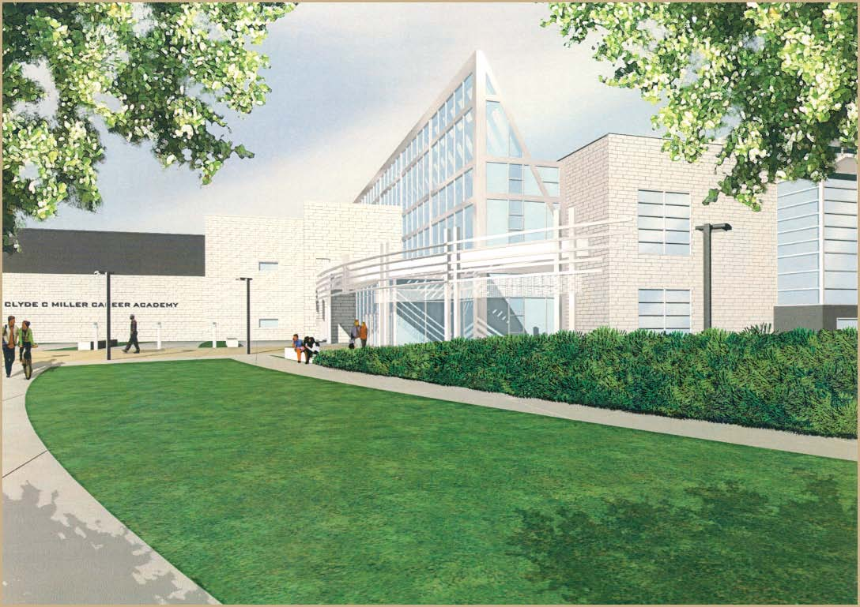

***2011-12 Application***

**“EVERY STUDENT CAREER AND COLLEGE READY” Developing potential… Smaller learning communities…**

**Creating learning opportunities that lead to college, technical school, apprenticeships and work…**

**Connecting school to careers…**

**Learning in a new state-of-the-art, highly technical building…**

***Molding the future…***

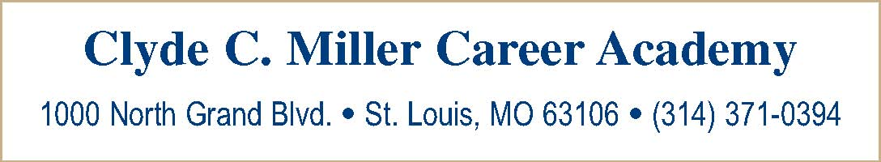

The Clyde C. Miller Career Academy has a commitment to provide the best academic, technical and college preparatory education to students. Clyde C. Miller will:

1. Teach 800 city students in grades 9-12;
2. Continue to expect students to have a high attendance and graduation rate;
3. Provide a four-year, full-day academic school with a career and technical education focus centered around 11 technical pathways;
4. Expect students to complete the school district’s rigorous graduation requirements;
5. Feature a 9th and 10th grade house of approximately 220 students;
6. Feature individualized pathway teams of 11th and 12th graders;
7. Operate on a block scheduling model;
8. Require students to complete real-world learning experiences in the form of shadowing, college visits and senior year internships;
9. Have a college articulation agreement for each of the 11 technical pathways;
10. Immerse students in a technical curriculum that is current with economic and workforce
11. trends that respond to the Regional Chamber and Growth Association (RCGA) and other
12. community needs.

Involve business, industry and college persons through advisory committees and student

1. experimental components.
2. Foster a positive, caring, culturally and racially sensitive learning environment.
3. Expose students to entrepreneurship and leadership curricula; and
4. Offer adult training in the evening.

* *Completed application to be received no later than February 3, 2006*
* Good attendance data
* A good discipline record
* Good academic achievement data
* A letter of recommendation from the principal.

All St. Louis City students are eligible to apply to Clyde C. Miller Career Academy. To complete the application process, we require the following information from your previous school:

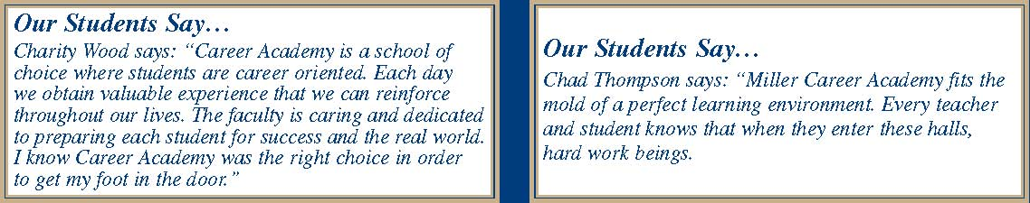

***TECHNICAL PATHWAY SPECIALITIES***

**(each pathway will have dual high school and college credit courses)**



Biotechnology is the science of using cells, their proteins and their DNA to produce useful products for the improvement of life. Biotechnology is used for such things as creating new agricultural products, finding solutions to medical problems and decreasing erosion and pollution. Students should have inquisitive minds, be interested in science, be persistent and want to find solutions to problems. Advanced biology, trigonometry, chemistry, genetic engineering, animal and plant technologies, ethics, and laboratory methods will be included. *Potential careers are phlebotomist, research technician, biomedical technician, geneticist and plant pathologist.*

Building Trades introduces students to the many facets of construction. Persons in this industry build and remodel houses and industrial buildings, build highways, streets and bridges and prepare tunnels. Building trades includes such areas as carpentry, floor laying, cabinetry, cement masonry, glazing, painting, tile setting, sheet metal working and operating engineers. Students should enjoy mathematics and science, be inquisitive and able to work with their hands, think logically and be creative. *Potential careers are carpenter, construction manager, cement mason, painter, sheet metal worker, operating engineer and floor layer.*

Business, Management and Administration allows students to explore the expanding scope of business services in areas such as organizational and time management, customer service and communications. Students are prepared for careers in planning, organizing, directing and evaluating business functions essential to effective business operations. Students should enjoy mathematics, English and foreign language, want to explore solutions to issues, enjoy working with people and be logical thinkers. Information systems, accounting, business technology, business dynamics and occupational ethics are included. *Potential careers are document editor, accountant, office manager, human resources administrator, entrepreneur, business analyst, billing supervisor and executive assistant.*

Computer Networking involves students in network analysis, planning and implementation, including design, installation, and management of network systems. Successful establishment and maintenance of information technology infrastructure is critical to the success of almost every organization today including medical facilities, offices and airports. Students should enjoy mathematics, science, English and electronics, specialize in problem solving, think logically and be drawn to taking things apart and putting them back together. A program, such as A+, will form the basis of the curriculum. *Potential careers are Internet work designer, systems operator, computer troubleshooter, certified network associate, network*

*engineer, data communications analyst and transport administrator.*

Culinary Arts offers exploration into the vast food preparation industry of restaurants, hotels, resorts and institutions. As the industry expands, students need to have expertise not only in cooking and baking, but also need exposure to leadership and management. Students should enjoy science and mathematics, relish working with their hands and possess good organizational and creative skills. Working in teams is as important as the ability to work independently. Baking and pastry, food and beverage management, equipment safety, menu planning and nutrition will be included. *Potential careers are executive chef, food and beverage manager, restaurant owner, catering manager, food preparation assistant and pastry chef.*



Database Management provides for the accuracy, security and accessibility of company data. Expertise in this area allows people to do work such as integrating multiple databases at a global investment company, enabling employees to share information between New York, Paris and Haifa. Students should be problem solvers, interested in science, mathematics, English and electronics, as well as be able to clearly communicate logically and in an organized fashion. Database design, database management and electronics will be included. *Potential careers are database administrator, help desk specialist, enterprise systems engineer, technical writer, application integrator, security analyst and PC systems coordinator.*

Electronics/Electricity explores the skills and knowledge of electrical systems and their application in design, construction and repair of industrial electrical wiring and circuitry. Students learn troubleshooting, test and measurement of equipment, printed circuit board repair and electronic theory of analog and digital systems. As the need for electronic technicians becomes more critical as systems become more sophisticated, it will be important for students to enjoy science, mathematics and English. They should want to explore the relationship between technology and science. *Potential careers are electrical contractor, electronics technician, electrical engineer and quality technician.*

Health Services allows students the chance to explore the Allied Health professions. Students in this program can develop entry level skills and competencies necessary to provide comfort, care and preventive maintenance in the treatment of persons who are ill, injured or disabled. In this helping profession, students need to have an interest in science, psychology and English, possess positive attitudes and critical thinking skills, be able to function independently and in a team and understand compassion, ethics and dependability. Rehabilitation, nursing, ethics and science are included. *Potential careers are certified nurse assistant, sports medicine technician and physical therapist.*

Hospitality Studies covers the vast industry of travel/tourism, lodging, recreation, amusement and attractions and food/beverage management. Students should enjoy English, mathematics, geography, psychology and social studies and learn a foreign language. They should be personable and flexible, enjoy travel and exploring diverse cultures and capable of handling multiple tasks at one time. Hotel operations, convention/meeting planning, reservation systems and transportation are included. *Potential careers are meeting planner, hotel front office manager, ticket agent, cruise director, sports marketer, room division manager, reservations manager and tour/ticket reservationist.*

Manufacturing explores the areas of hydraulics, pneumatics, computerized production control and robotics. Students will learn metallurgy, bench work, blueprint reading and the use of precision measuring tools through a national program, *Project Lead The Way*. Because students will produce a variety of products from concept to design to final production, it is important that they enjoy science, mathematics and engineering, that they be creative and capable of envisioning the “final product,” and that they be problem solvers, persistent and make good use of resources. *Potential careers are manufacturing lab assistant, quality control technician, computer technician, laser systems technician and quality engineer.*

Multimedia explores creating, designing and producing interactive media products and services, including development of digitally-generated media used in business, training, entertainment and marketing. Web page design and desktop publishing are also included. Creativity is important for students interested in this field as is a love of English, psychology, art and electronics. Graphic and web page design, animation, and layout theory are included*. Potential careers are graphic artist, web designer, 3D animator, game designer, videographer, virtual reality specialist and video engineer.*

**ST. LOUIS PUBLIC SCHOOLS Application for Enrollment Clyde C. Miller Career Academy 2006-2007 School Year 1000 North Grand Blvd. St. Louis, Missouri 63106**

***Applications must be mailed or hand delivered by***

**314/371-0394**

***Feebruary 3, 2006. Faxed applications will not be accepted.***

**I. Entrance Requirements** All St. Louis City students are eligible to apply to the Clyde C. Miller Career Academy. In order to obtain a clear picture of the applicant and his/her probability for success, we require the following:

* *Completed application* • *Copy of current semester report card \**
* *Discipline and behavior record* • *Evidence of good attendance at current school*
* *Individual Education Program record, if applicable* • *Entrance interview (see Part IV)*
* *Essay (see Part V)* • *Up-to-date immunization record*

**\*** *In order to achieve the competencies required by each technical pathway, a 2.5 minimum Grade Point Average is preferred.*

**II. About the Applicant**

**Student’s Name** _______________________________________________________ Date of Birth ________/__________/_______ Last First Middle Month Date Year Address ____________________________________________________________________________________________ ____________ Street City State Zip Code Gender: M F (Circle One) Expected Grade Level in September 2006: ________ Home Phone #: ____________________________ Social Security Number: __________-________-___________ Current School: ___________________________________________ Applicant’s race (select one): __ African-American __ White __ Hispanic __ Asian or Pacific Islander __ Native American __ Bi-racial Applicant’s Parent/Guardian: __________________________________________________ Work Phone #: __________________________ Relationship to Applicant: __________________________________________________ Alternate Phone #: _________________________

***List leadership and extra-curricular activities in which you have participated****:* _________________________________________________

**III. Application Permission** I give permission to my child’s current school to release all information needed to complete the application process. I understand providing false disciplinary information on this application is a Class B misdemeanor. I understand that the St. Louis Public School District is not responsible for errors made by me on this application (e.g., grade, birth date, incorrect school year).

Parent/Guardian Signature: _______________________________________ Student Signature: _________________________________________

**IV. “I AM EXCITED ABOUT CLYDE C. MILLER BECAUSE…”**

On the day of your interview, you will be asked to write a brief essay stating your reasons for wanting to attend the Clyde C. Miller Career Academy and which Career Pathway sparked your interest in applying to the Academy. You may also wish to incorporate your ideas for school leadership and community involvement in this essay. Your essay will be evaluated on content, originality, grammar and spelling.

**V. Student Information Form (Required for all new freshmen and all high school transfers.)**

*To be completed by the* ***Principal, Counselor or 8th Grade Team Leader*** *of the school the applicant now attends.*

Name of person completing Part VI: __________________________________________________ Title: _____________________________

**1. HOW LONG HAVE YOU KNOWN THIS STUDENT?**

**2. ACADEMIC ACHIEVEMENT:** Please attach a copy of the student’s last report card.

**3. ATTENDANCE DATA:**

A. Is the applicant currently enrolled at your school and in good standing? YES _______ NO ________

B. Number of days/hours absent for the current school year to date: ________

C. Please attach explanation of any extraordinary circumstances.

**4. PLEASE RATE THE APPLICANT IN THE FOLLOWING AREAS (5 POINTS IS THE HIGHEST):**

Leadership (school, community) 1 2 3 4 5 Relationship with Peers 1 2 3 4 5 Adheres to School Rules 1 2 3 4 5 Citizenship 1 2 3 4 5

**5. SAFE SCHOOLS**

Has the applicant been suspended or expelled from any school for a violation of school board policies relating to weapons, alcohol, drugs, or willful infliction of injury to another person? YES ________ Number of times _________ NO _________

***\*Please attach applicable discipline reports****.*

**6. WHAT QUALITIES WILL THIS STUDENT BRING TO OUR SCHOOL?**

**7. SPECIAL EDUCATION DATA (If applicable):**

Has the applicant been referred for special education evaluation or evaluated by the current or previous school district? YES _______ NO ________ Does this student receive special education services? YES _______ NO ________ If the student is receiving special education services, please complete the following:

A. Circle the one that best applies: Modified Regular Education Resource Self-Contained

B. If this student receives resource services, how many minutes per week? _____________ minutes

C. Circle programs that apply: Behavior Disorder Learning Disabled Speech/Language EMH Other (please specify) ________________________________________________________________________________

D. Does a current Individual Education Program exist for this student? YES ________ NO _________

Signature _______________________________________________ Date: _________________ Phone: ___________________

***Please submit all materials by Friday, February 3, 2006 to: Clyde C. Miller Career Academy Attn: Application Committee 1000 North Grand Blvd., St. Louis, Missouri 63106***

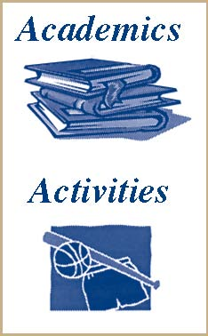

The academic program is rigorous and includes four years each of English, mathematics and science and three years of social studies. Students must earn 22 units to graduate. Most have more than that because of their technical specialty area. Additionally, our students must complete an internship in their senior year. College is emphasized through articulation agreements for many senior level courses within the students’ technical pathway or major.

We believe that well-rounded students lead to healthy, successful adults. Therefore, we offer a full complement of student activities, such as:

*National Honor Society*

*Full athletic program for young men and women Drama and debate*

*Yearbook and newspaper Vocational student organizations such as FBLA, HOSA, FCCLA and Skills USA/VICA FFA*



We are proud of our graduates. Because the Academy is an academic school with a technical focus, most of our graduates pursue some type of post-secondary training. They are seeking careers in a host of areas. Our

Many are employed at companies such as Bank of America, Bethesda, BJC, Classic Color, Euclid Chiropractic, Eureka Vet Clinical, Marriott Hotels, Show-Me-Online, St. Louis Post-Dispatch, St. Louis Zoo and Walgreen’s Pharmacy. Some of our students are in the military, as well.

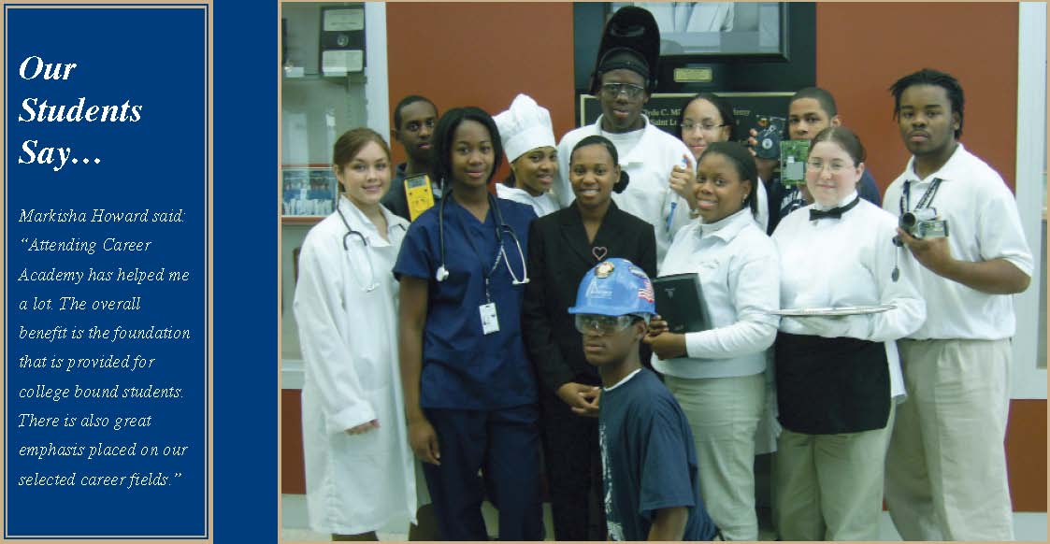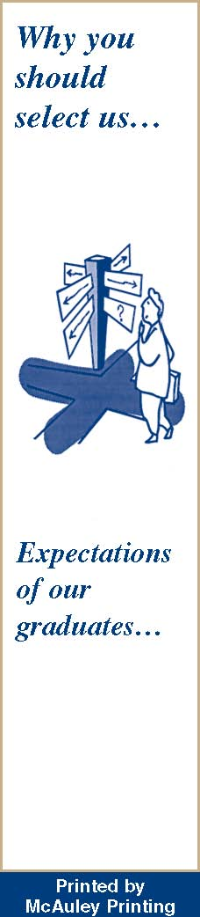

* New state-of-the-art 143,000 square foot facility
* A high student-to-computer ratio
* Leadership opportunities
* Excellent faculty trained in academic and technical areas
* Technical training to meet industry standards
* Safe, caring environment
* Collaborative relationships with business and industry
* Easily accessible
* Affiliation with AVID, College Summit, College Bound and others
* Surrounded by the Grand Center cultural neighborhood
* Strong college affiliations

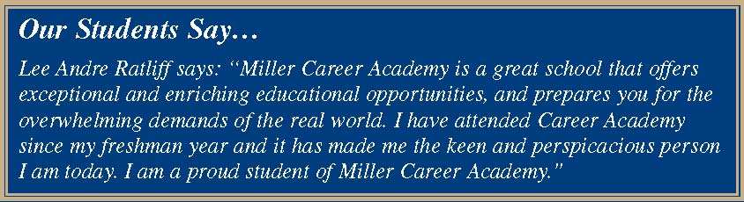

Our graduates will leave the Clyde C. Miller Career Academy equipped to:

* Enter college, technical school or work
* Perform academically
* Exhibit leadership
* Think independently
* Work effectively with others
* Work and understand a wide variety of technologies
* Think creatively and logically and make data-based decisions
* Demonstrate teamwork, confidence, initiative and problem solving
* Manage information
* Understand the role of entrepreneurs

St. Louis, MO ermit No. 268