U.S. History
Mr. Detjen
Murrin et al., Liberty, Equality, Power: A History of the American People 5/e (Thomson, 2008)

Ch. 18 “A Transformed Nation: The West and the New South, 1865-1900”

Chapter Outline. The following is a basic outline for the chapter, based on section headings in/of the chapter. Your task is to expand upon/amend/add to/enhance this basic foundation with details, examples and supporting evidence for each component of the outline. That is, flesh out the outline in a way that communicates your understanding of the substantive material in the chapter. In the class notes section of your notebook, write out your expanded outline at the beginning of each new respective unit or section so that it serves as the organizational concept map for subsequent class (lecture/discussion) notes on related material.

I. The Homestead Act
II. An Industrializing West
A. Railroads
B. Chinese laborers and Railroads
C. The Golden Spike
D. Railroads and Borderlands Communities
E. Mining
F. Ranching
G. Cattle Drives and the Open Range
H. The Industrialization of Ranching
I. Industrial Cowboys
J. Mexican American
K. Itinerant Laborers
L. Homesteading and Farming
M. The Experience of Homesteading
N. Gender and Western Settlement
III. Conquest and Resistance: American Indians in the Trans-Mississippi West
A. Conflict with the Sioux
B. Suppression of Other Plains Indians

C. The “Peace Policy”
D. The Dawes Severalty Act and Indian Boarding Schools
F. The Ghost Dance
F. Sitting Bull and Buffalo Bill: Popular Myths of the West
IV. Industrialization and the New South
A. Race and Industrialization
B. Southern Agriculture
C. Exodusters and Emigrationists
D. Race Relations in the New South
E. The Emergence of an African-American Middle Class
F. The Rise of Jim Crow
V. The Politics of Stalemate
A. Knife-Edge Electoral Balance
B. Civil Service Reform
C. The Tariff Issue
VI. Conclusion

IDs and Sigs. For the following key terms—people, events, concepts, places, titles—first, identify and place each in historical time and place and context by answering the “Who? What? When? Where?” questions, and second, analyze the “Why-is-this-important-and/or-significant?” question. Each component—identifying the term and analyzing its significance—is an essential aspect for understanding.

Jim Crow laws
New South
bonanza farms
range war
lint heads
crop lien system
longhorns
convict leasing system
“Peace Policy”
Turner thesis

FRQs/Short Essay/Review Questions. This final component of the study guide is designed to get you to think critically and collectively about the material in the chapter. You have outlined the chapter for use as an organizational map; you have identified and given the significance of some (very few) people and events of the period; now you will write a number of short (3-4 paragraph) essays that put the material together. For each of the following questions, rewrite (and underline) each question in the form of a thesis statement, and make sure that each paragraph itself begins with a topic sentence, contains appropriate supporting details and examples, and has an effective conclusion that brings everything together.

1. Compare and contrast the federal and state governments’ treatment of the Plains Indians and Mexican Americans in the 19th century.

2. Describe the sod-house frontier and the role of the farmer in settling the West.

3. Compare and contrast the lifestyles and treatment of the Eastern Woodland and Plains Indians.

4. Describe the U.S. government’s policies in dealing with the Plains Indians during the Civil War.

5. Describe the major political issues in presidential politics in the late 19th century.

U.S. History
Mr. Detjen
Source Analysis

“Young Factory Worker in the South”

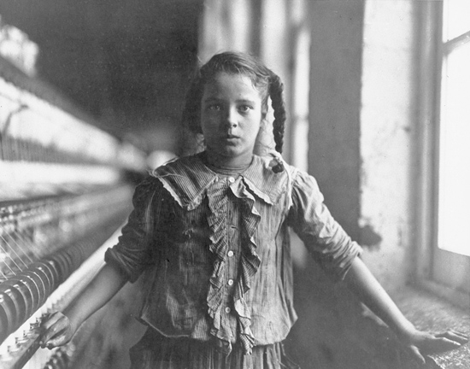

Questions to consider:

1. This picture shows a young white girl working in a factory setting. What groups of people were respectively associated with the various industries that proliferated in the New South?

2. What social and economic difficulties resulted from the proliferation of industries in the New South? How would the industrial experience of the girl in this photo have differed from that of her parents, if they worked alongside her?

Photo-Young textile/factory worker

1. This picture shows a young white girl working in a factory setting. What groups of people were respectively associated
with the various industries that proliferated in the New South?

Your answer should include the following:
• textiles: poor white southern families from rural backgrounds
• tobacco: Jewish immigrants
• tobacco: black southerners
• lumber: rootless single men

2. What social and economic difficulties resulted from the proliferation of industries in the New South? How would the industrial experience of the girl in this photo have differed from that of her parents, if they worked alongside her?

Your answer should include the following:
• Rural workers needed to accommodate to tedious rhythm and cramped spaces
• Corruption
• Exportation of raw materials instead of finished goods
• Environmental degradation
• Racial tensions when blacks supervised whites
• Fathers from rural backgrounds found adjustment most difficult

U.S. History
Mr. Detjen
Source Analysis

“Ethnic Diversity in the West”

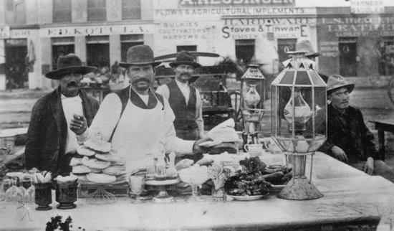

Questions to consider:

1. This picture shows that Latinos constituted a significant element of the western population. How did Hispanos respond to the rapidly increasing rate of white settlement in the West?
2. As this picture demonstrates, white and black were not the only races which were prominent in the West. Did the presence of a large and growing Hispanic population in Texas alongside whites and blacks complicate or solidify the prevailing southern racial system?

Photo-Ethnic Diversity in the West

1. This picture shows that Latinos constituted a significant element of the western population. How did Hispanos respond to the
rapidly increasing rate of white settlement in the West?

Your answer should include the following:
• Ricos aligned with whites
• Las Gorras Blancas and violent resistance
• legal struggles
• political involvement
• cultural retention in barrios

2. As this picture demonstrates, white and black were not the only races which were prominent in the West. Did the presence of a large and growing Hispanic population in Texas alongside whites and blacks complicate or solidify the prevailing southern racial system?
Your answer should include the following:
• economic dependence on Mexican laborers
• most Hispanics viewed by whites as inferiors
• some Hispanics penetrated into white society or fluctuated between castes
• lowly status of poor whites
• mutual interests of Hispanic and Anglo landowners
• mutual interests of wage workers of all races

U.S. History
Mr. Detjen
Source Analysis

“Buffalo Bill’s Wild West Show”

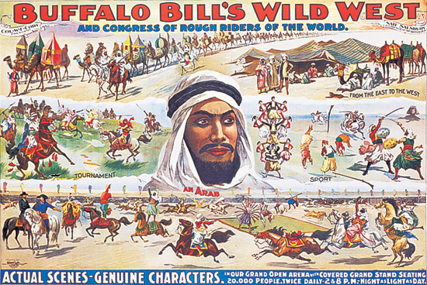

Questions to consider:

1. Examine the cast of Buffalo Bill Cody's Wild West Show. What sorts of people are represented? What role did Indians play in Cody's production? Were they partners in the production or objects of it? How accurate a depiction of Western life did Cody's show seem to offer?
2. Based on the advertisement for Buffalo Bill's Wild West Show, how did Cody "sell" the West to the outside world? What elements of the West did he exaggerate and which did he ignore? Why might eastern audiences have found Cody's product so enticing?

Poster-Buffalo Bill’s Wild West Show

1. Examine the cast of Buffalo Bill Cody's Wild West Show. What sorts of people are represented? What role did Indians play in Cody's production? Were they partners in the production or objects of it? How accurate a depiction of Western life did Cody's show seem to offer?
Your answer should include the following:
• Large numbers of Indians
• A few Anglo women; more Anglo men
• Indians largely undifferentiated
• Presents a West in which Indians remained a central fixture, and had not been pushed to marginal reservation lands
• Created an image of West as wild, tamed by whites' martial skills
• No apparent role for blacks, Hispanics

2. Based on the advertisement for Buffalo Bill's Wild West Show, how did Cody "sell" the West to the outside world? What elements of the West did he exaggerate and which did he ignore? Why might eastern audiences have found Cody's product so enticing?
Your answer should include the following:
• Mixed in exotics from various parts of the world
• Emphasis on martial competition
• Emphasis on riding (horses and camels)
• Limited presence of women, if any
• Little evidence of corporate interests, wage labor
• No evidence of settlements or farms
• West as a place of adventure and freedom

U.S. History
Mr. Detjen
Source Analysis

“‘Americanizing’ the Indian”
The federal government began a program to “Americanize” Indians in 1887, by force if necessary. Children were separated from parents and sent to boarding schools such as the one at the Carlisle Barracks in Pennsylvania. Its founder, Captain Richard Pratt, explains the rationale for the schools in the first document below. In the second document, Zitkla-Sa (later known as Gertrude Simmons Bonnin) describes the experience from an Indian point of view.
DOCUMENT 1
Advantages of “Americanizing” Indians
A great general has said that the only good Indian is a dead one, and that high sanction of his destruction has been an enormous factor in promoting Indian massacres. In a sense, I agree with the sentiment, but only in this: that all the Indian there is in the race should be dead. Kill the Indian in him, and save the man….
It is a sad day for the Indians when they fall under the assaults of our troops, as in the Piegan massacre, the massacre of Old Black Kettle and his Cheyennes at what is termed “the battle of the Washita,” and hundreds of other like places in the history of our dealings with them; but a far sadder day is it for them when they fall under the baneful influences of a treaty agreement with the United States whereby they are to receive large annuities, and to be protected on reservations, and held apart from all association with the best of our civilization. The destruction is not so speedy, but it is far more general….
The Indians under our care remained savage, because forced back upon themselves and away from association with English-speaking and civilized people, and because of our savage example and treatment of them….
We make our greatest mistake in feeding our civilization to the Indians instead of feeding the Indians to our civilization. America has different customs and civilizations from Germany. What would be the result of an attempt to plant American customs and civilization among the Germans in Germany, demanding that they shall become thoroughly American before we admit them to the country? Now, what we have all along attempted to do for and with the Indians is just exactly that, and nothing else. We invite the Germans to come into our country and communities, and share our customs, our civilization, to be of it; and the result is immediate success. Why not try it on the Indians? Why not invite them into experiences in our communities? Why always invite and compel them to remain a people unto themselves? …
The school at Carlisle is an attempt on the part of the government to do this. Carlisle has always planted treason to the tribe and loyalty to the nation at large. It has preached against colonizing Indians, and in favor of individualizing them. It has demanded for them the same multiplicity of chances which all others in the country enjoy. Carlisle fills young Indians with the spirit of loyalty to the stars and stripes, and then moves them out into our communities to show by their conduct and ability that the Indian is no different from the white or the colored, that he has the inalienable right to liberty and opportunity that the white and the negro have. Carlisle does not dictate to him what line of life he should fill, so it is an honest one. It says to him that, if he gets his living by the sweat of his brow, and demonstrates to the nation that he is a man, he does more good for his race than hundreds of his fellows who cling to their tribal communistic surroundings….
Source: Official Report of the Nineteenth Annual Conference of Charities and Correction (1892), pp. 46–59. Reprinted in Richard H. Pratt, “The Advantages of Mingling Indians with Whites,” Americanizing the American Indians: Writings by the “Friends of the Indian” 1880–1900 (Cambridge, Mass., 1973), pp. 260–271.

DOCUMENT 2
An Indian Girl's Experience
Late in the morning, my friend Judewin gave me a terrible warning…. She heard the paleface woman talk about cutting our long, heavy hair. Our mothers had taught us that only unskilled warriors who were captured had their hair shingled by the enemy. Among our people, short hair was worn by mourners, and shingled hair by cowards! We discussed our fate some moments, and when Judewin said, “We have to submit, because they are strong.” I rebelled.
“No, I will not submit! I will struggle first!” I answered….
I watched for my chance, and when no one noticed I disappeared, I crept up the stairs as quietly as I could in my squeaking shoes—my moccasins had been exchanged for shoes…. On my hands and knees I crawled under [a] bed, and cuddled myself in the dark corner….
What caused them to stoop and look under the bed I do not know. I remember being dragged out, though I resisted by kicking and scratching wildly. In spite of myself, I was carried downstairs and tied fast in a chair.
I cried aloud, shaking my head all the while until I felt the cold blades on the scissors, against my neck, and heard them gnaw off one of my thick braids. Then I lost my spirit. Since the day I was taken from my mother I had suffered extreme indignities. People had stared at me. I had been tossed about in the air like a wooden puppet. And now my long hair was shingled like a coward's! In my anguish I moaned for my mother, but no one came to comfort me. Not a soul reasoned quietly with me, as my own mother used to do; for now I was only one of many little animals driven by a herder.
Source: Zitkala-Sa (Gertrude Simmons Bonnin), “The School Days of an Indian Girl,” Atlantic Monthly, Vol. 89 (1900) January–March, pp. 45–47, 190, 192–194.

Questions to consider:

1. What cultural differences obstructed mutual understanding between whites and Indians? Were these differences insurmountable? Might the whites' goal of assimilation have been accomplished more quickly and peaceably if they had accepted the retention of some Indian customs?
2. Based on Zitkla-Sa's excerpt, was Pratt's advice to "kill the Indian, and save the man" any less violent than the earlier practice of killing "Indian" and "man" alike? How traumatic was the experience of losing one's native culture? Did the means by which whites stripped Indian children of their culture aggravate the emotional violence of the process?
3. What does Captain Richard Pratt mean by “kill the Indian … and save the man”?

4. How does he justify the Americanization program at Carlisle, and why might some whites at the time consider his reasoning to be “enlightened”?

5. What effect do efforts at Americanization, in particular hair-cutting, have on Zitkala-Sa?

6. In your view, who is more “civilized,” Pratt or Zitkala-Sa?

Primary Source-Americanizing the Indian

1. What cultural differences obstructed mutual understanding between whites and Indians? Were these differences insurmountable? Might the whites' goal of assimilation have been accomplished more quickly and peaceably if they had accepted the retention of some Indian customs?
Your answer should include the following:
• tribalism versus nationalism
• individualism versus communalism
• significance of seemingly superficial attributes such as clothing and hair
• centrality of family
• cultural chauvinism--insistence on assimilation

2. Based on Zitkla-Sa's excerpt, was Pratt's advice to "kill the Indian, and save the man" any less violent than the earlier practice of killing "Indian" and "man" alike? How traumatic was the experience of losing one's native culture? Did the means by which whites stripped Indian children of their culture aggravate the emotional violence of the process?
Your answer should include the following:
• reality of massacres
• trauma of cultural assimilaition
• loss of identity
• physical changes to Indian bodies accomplished through force (haircutting against Zitkla-Sa's will)
• disruption of Indian practices and communities
• rewards for successful assimilation--individual autonomy, property

U.S. History
Mr. Detjen
Source Analysis

Otto Becker, “Custer’s Last Fight” (1880)

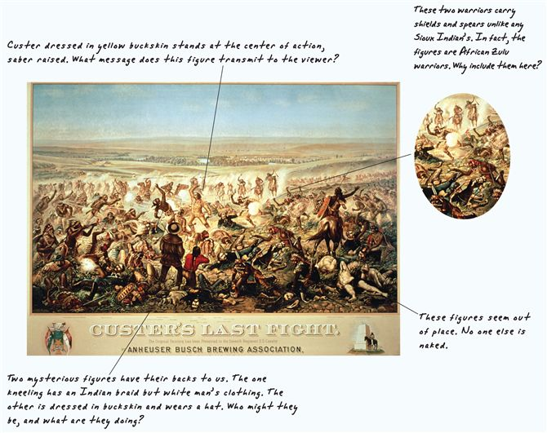

Question to consider:

1. Historian Frederick Jackson Turner in 1890 called the conquest of Indian peoples by whites the triumph of “civilization” over “savagery.” Does Becker's lithograph make that point graphically? Or the opposite?

U.S. History
Mr. Detjen
Source Analysis

“A Frontier Kitchen”

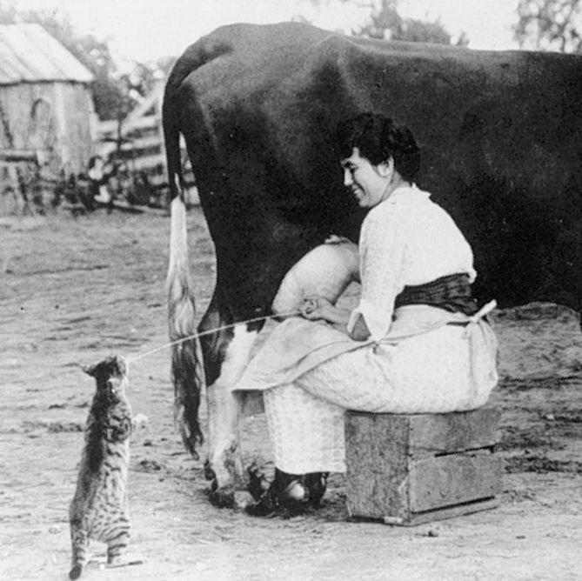

Out on the treeless plains the Indians had adjusted to scarcity of food, water, and other necessities by adopting a nomadic way of life. Their small kinship groups moved each season to wherever nature supplied the food they needed. Such mobility discouraged families from acquiring many possessions. Tools and housing had to be light and portable. Even tribes that raised crops on which to live often moved with the seasons.
Unlike the Indians, farmers, ranchers, and townspeople rooted themselves to a single place. What the surrounding countryside could not supply had to be brought from afar, generally at great effort and expense. For those on the isolated prairie, keeping food on the table was nearly impossible in some seasons. Something as simple as finding water suitable for drinking or cooking became a problem in the West, where the choice might be between “the strong alkaline water of the Rio Grande or the purchase of melted manufactured ice (shipped by rail) at its great cost.”
Gardening, generally a woman's responsibility, brought variety to the diet and color to the yard. The legume family of peas and beans, in particular, provided needed protein. Flowers were much prized but seldom survived the wind, heat, and droughts. To prepare for the lean winter months, women stocked their cellars and made wild fruits into leathery cakes eaten to ward off the scurvy that resulted from vitamin deficiency.
Until rail lines made the shipment of goods cheaper and until Sears, Roebuck “wishbooks” brought mail order to the frontier, a woman's kitchen was modest. One miner's wife in Montana during the 1870s considered her kitchen “well-furnished” with two kettles, a cast iron skillet, and a coffeepot. A kitchen cupboard might be little more than a box nailed to a log.
Without doctors, women learned how to take care of themselves. Whiskey and patent medicines were often more dangerous than the disease, but they were used to treat a range of ills from frostbite to snakebite and from sore throats to burns and rheumatism. Cobwebs could bandage small wounds; turpentine served as a disinfectant. Mosquitoes were repelled with a paste of vinegar and salt. Most parents thought the laxative castor oil could cure almost any childhood malady. Some women adapted remedies used on their farm animals. Sarah Olds, a Nevada homesteader whose family was plagued by fleas and lice, recalled that “we all took baths with plenty of sheep dip in the water…. I had no disinfectant … so I boiled all our clothing in sheep dip and kerosene.”
Gradually, as the market system penetrated the West, families had less need to improvise in matters of diet and medicine. Through catalogs they might order spices such as white pepper or poultry seasoning and appliances such as grinders for real coffee. If a local stagecoach passed by the house, a woman might send her eggs and butter to town to be exchanged for needed store-bought goods such as thread and needles.

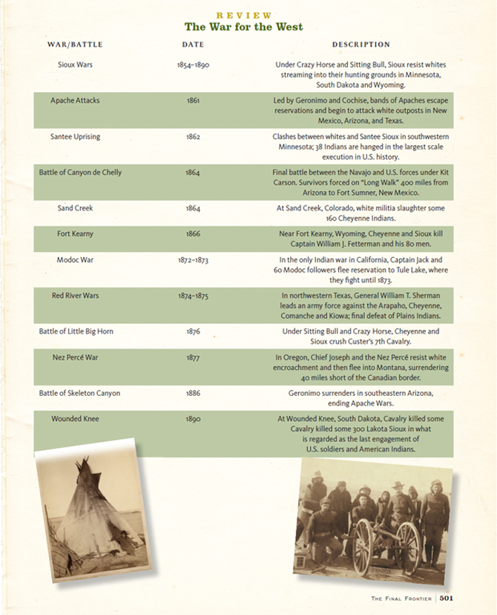

U.S. History
Mr. Detjen
Source Analysis

“The Cattle Kingdom, 1866-1887”

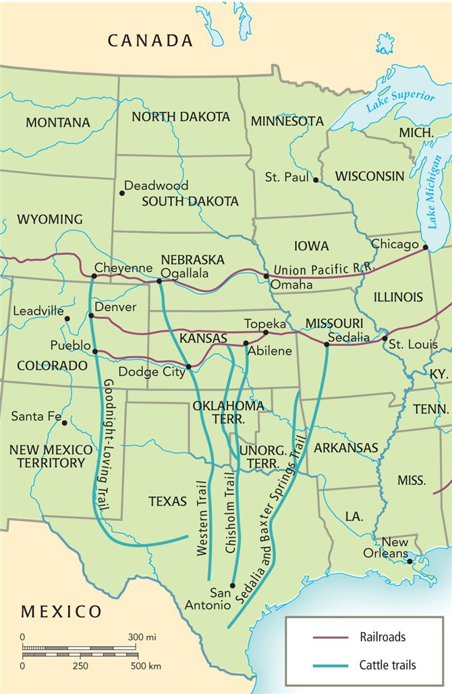

Questions to consider:

1. Why was Abilene initially such an important town for the early cattle drives?

2. Why was the long drive the most romanticized and mythologized aspect of life in the West?

Map Analysis-The Cattle Kingdom, 1866-1887

1. Why was Abilene initially such an important town for the early cattle drives?

Your answers will vary based on your analysis, but you should include: Abilene was the location of market facilities and the Kansas Pacific Railroad. That made Abilene the railhead of the cattle kingdom, and the Chisholm Trail saw more than 1.5 million head of cattle between 1867 and 1871.

2. Why was the long drive the most romanticized and mythologized aspect of life in the West?

Your answers will vary based on your analysis, but you should include: the sheer size of the undertaking, the massive numbers of cattle that made up the herds, as well as the cowboys themselves and the way they lived on the trail.

U.S. History
Mr. Detjen
Source Analysis

“The Wild West Show”

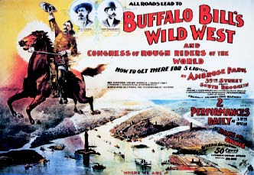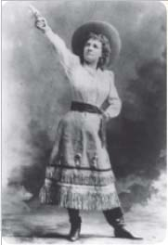

For many Americans, the “Old West” has always been a place of myth—a source of romantic and exciting stories. One reason the romantic depiction of the Old West persisted was the astonishing popularity of the “Wild West show” in the late nineteenth and early twentieth centuries. This colorful entertainment may have had little connection with the reality of western life, but it stamped on its audiences an image of the West as a place of adventure and romance that has lasted for generations. The Wild West show emerged out of a number of earlier entertainment traditions. The great showman P. T. Barnum had begun popularizing the “Wild West” as early as the 1840s when he staged a “Grand Buffalo Hunt” for spectators in New York, and such shows continued into the 1870s. At about the same time, western cowboys began staging versions of the modern rodeo when their cattle drives passed near substantial towns. But the first real Wild West show opened in Omaha, Nebraska, in 1883. Its organizer was William F. Cody, better known as “Buffalo Bill.”
Cody had ridden for the Pony Express, fought in the Civil War, and been a supplier of buffalo meat to workers on the transcontinental railroad (hence his celebrated nickname). But his real fame was a result of his work as a scout for the U.S. Cavalry during the Indian wars of the 1870s and as a guide for hunting parties of notable easterners.
Cody's Wild West shows included mock Indian attacks (by real Indians) on stagecoaches and wagon trains; portrayals of the Pony Express; and shooting, riding, and roping exhibitions. The grand finale—“A Grand Hunt on the Plains”—featured buffalo, elk, deer, mountain sheep, longhorn cattle, and wild horses. Cody's shows inspired dozens of imitators, and almost all of them used some version of his format. Always, at the center of every show—whether Cody's or one of his imitators—was the effort to evoke the mythic romance of the Old West.
Buffalo Bill was always the star performer in his own productions. But the show had other celebrities, too. A woman who used the stage name Annie Oakley became wildly popular for her shooting acts, during which she would throw into the air small cards with her picture on them, shoot a hole through their middle, and toss them into the audience as souvenirs.

Native Americans were important parts of the Wild West shows, and hundreds of them participated—showing off their martial skills and exotic costumes and customs. The great Sioux leader Sitting Bull toured with the show for four months in 1885, during which he discussed Indian affairs with President Cleveland, who was a member of one of Sitting Bull's audiences. The famous Chiricahua Apache warrior Geronimo, who had fought against the United States until 1886, spent a season touring with one of Buffalo Bill's competitors—having previously been paraded around the country as a prisoner by the U.S. Army.
An immediate success, Buffalo Bill's Wild West show traveled across the nation and throughout Europe. More than 41,000 people saw it on one day in Chicago in 1884. In 1886, it played for six months on Staten Island in New York, where General William T. Sherman, Mark Twain, P. T. Barnum, Thomas A. Edison, and the widow of General Custer all saw and praised it. Members of the royal family attended the show in England, and it drew large crowds as well in France, Germany, and Italy.
The Wild West shows died out not long after World War I, but many of their features survived in circuses and rodeos, and later in films, radio and television shows, and theme parks. Their popularity was evidence of the nostalgia with which late-nineteenth-century Americans looked at their own imagined past, and their eagerness to remember a “Wild West” that had never really been what they liked to believe. Buffalo Bill and his imitators confirmed the popular image of the West as a place of romance and glamour and helped keep that image alive for later generations.

Questions to consider:

1. How did the West portrayed in the Wild West shows contrast with the real West?

2. Why do you think Indians participated in the Wild West shows? How did their participation affect white audiences' perception of Native Americans?

3. Why has the romantic image of the Wild West remained so long-lived in American popular culture?

Poster and Secondary Analysis-The Wild West Show, Annie Oakley

1. How did the West portrayed in the Wild West shows contrast with the real West?

Your answers will vary based on your analysis, but you should include: These shows depicted an idealized, sanitized version of the reality of the West that omitted the harsh, brutal, and banal realities of life in the western regions in the interests of entertainment and spectacle.

2. Why do you think Indians participated in the Wild West shows? How did their participation affect white audiences' perception of Native Americans?

Your answers will vary based on your analysis, but you should include: Given the extremely limited options available for Native Americans in late-nineteenth-century America, participation in the shows offered employment, travel, and opportunities for individual fame and fortune.

3. Why has the romantic image of the Wild West remained so long-lived in American popular culture?

Your answers will vary based on your analysis, but you should include: The romantic image of the West as an exciting and entertaining place filled with exciting dangers serves as a foundation myth for modern American culture. This myth also represents the white American triumph over challenging natural and human adversaries.

U.S. History
Mr. Detjen
Source Analysis: Debating the Past

“The ‘Frontier’ and the West”

The American West, and the process by which people of European descent settled there, has been central both to the national imagination and to American historical scholarship.
Through most of the nineteenth century, the history of the West reflected the romantic and optimistic view of the region as a place of adventure and opportunity where brave and enterprising people endured great hardships to begin building a new civilization. The emergence of western history as an important field of scholarship can be traced to Frederick Jackson Turner's “The Significance of the Frontier in American History,” a paper he delivered at a meeting of the American Historical Association in 1893.
Turner stated his thesis simply. The settlement of the West by white people—“the existence of an area of free land, its continuous recession, and the advance of American settlement westward”—was the central story of American history. The process of westward expansion had transformed a desolate and savage land into a modern civilization. It had also continually renewed American ideas of democracy and individualism and had, therefore, shaped not just the West but the nation as a whole. The Turner thesis shaped the writing of American history for a generation, and it shaped the writing of western American history for even longer. In the first half of the twentieth century, virtually everyone who wrote about the West echoed at least part of Turner's argument. Ray Allen Billington's Westward Expansion (1949), a skillful revision of Turner's thesis, kept the idea of what Billington called the “westward course of empire” (the movement of Europeans into an unsettled land) at the center of scholarship. In The Great Plains (1931) and The Great Frontier (1952), Walter Prescott Webb similarly emphasized the bravery and ingenuity of white settlers in the Southwest.
Serious efforts to displace Turner's thesis as the explanation of western American history did not begin in earnest until after World War II. In Virgin Land (1950), Henry Nash Smith examined many of the same heroic images of the West that Turner and his disciples had presented, but he treated those images less as descriptions of reality than as myths. Earl Pomeroy challenged Turner's notion of the West as a place of individualism, innovation, and democratic renewal, claiming that “conservatism, inheritance, and continuity bulked at least as large.”
The western historians of the late 1970s launched an even more emphatic attack on the Turner thesis and the idea of the “frontier.” New western historians such as Richard White, Patricia Nelson Limerick, William Cronon, Donald Worster, Peggy Pascoe, and many others challenged the Turnerians on a number of points.
Turner saw the nineteenth-century West as “free land” awaiting the expansion of Anglo-American settlement and American democracy. Pioneers settled the region by conquering the “obstacles” that stood in the way of civilization. The new western historians rejected the concept of a “frontier” and emphasized, instead, the elaborate and highly developed civilizations that already existed in the region. White, English-speaking Americans, they argued, did not so much settle the West as conquer it, though their conquest was never complete. Anglo-Americans in the West continued to share the region not only with the Indians and Hispanics who preceded them there, but also with African Americans, Asians, Latino Americans, and others who flowed into the West at the same time they did.
The Turnerian West was a place of heroism, triumph, and, above all, progress, dominated by the feats of brave white men. The West the newer historians describe is a less triumphant (and less masculine) place in which bravery and success coexist with oppression, greed, and failure; in which decaying ghost towns, bleak Indian reservations, impoverished barrios, and ecologically devastated landscapes are as characteristic of western development as great ranches, rich farms, and prosperous cities; and in which women are as important as men in shaping the societies that emerged. This aspect of the “new western history” has attracted particular criticism from those attached to traditional accounts. The novelist Larry McMurtry, for example, has denounced the newer scholarship as “Failure Studies.” He has insisted that in rejecting the romantic image westerners had of themselves, the revisionists omit an important part of the western experience.
To Turner and his disciples, the nineteenth-century West was a place where rugged individualism flourished and replenished American democracy. The newer western scholars contend that western individualism is a self-serving myth. Western “pioneers,” they argue, were never self-sufficient but depended on government-subsidized railroads for access to markets, federal troops for protection from Indians, and (later) government-funded dams and canals for irrigating their fields and sustaining their towns.
While Turner defined the West as a process—a process of settlement that came to an end with the “closing of the frontier” in the late nineteenth century—more recent historians see the West as a region whose distinctive history did not end in 1890 but continues into our own time.

Questions to consider:

1. What are the main tenets of Turner’s frontier thesis?

2. How did the portrayal of the West by the new western historians of the 1970s differ from the West that Turner described?

3. Why did the new western historians challenge Turner's view, and why has their depiction of the West, in turn, provoked such controversy?

Debating the Past: The “Frontier” and the West

1. What are the main tenets of Turner’s frontier thesis?

Your answers will vary based on your analysis, but you should include:
• | The settling of the West by whites was the central story of American history.
• | This westward expansion had turned the savage West into a “civilized” land.
• | It had also renewed American ideals of democracy and individualism, which had profoundly influenced the nation as a whole.

2. How did the portrayal of the West by the new western historians of the 1970s differ from the West that Turner described?

Your answers will vary based on your analysis, but you should include:
• | Following on from earlier critics of Turner’s thesis (Smith, Pomeroy), the new western historians of the 1970s (White, Limerick, Cronon, Worster, Pascoe) aggressively challenged it.
• | These new western historians argued that rather than being a “frontier,” the West was a region that already contained many vibrant civilizations that were destroyed by the white advance.
• | They also argued that the West was never “won” or “conquered” but rather was transformed into a place of misery, devastation, and oppression.

3. Why did the new western historians challenge Turner's view, and why has their depiction of the West, in turn, provoked such controversy?
Your answers will vary based on your analysis, but you should include:
• | The new western historians argued that Turner’s thesis deliberately ignored the violent and depressing reality of white western expansion and also ignored the prominent roles played by women and other groups in the process.
• | This "de-masculinization" of the West has been assailed by many critics, who argue that the new western historians’ emphasis on the negative aspects of the process omit important aspects of the western experience.

