U.S. History
Mr. Detjen
Murrin et al., Liberty, Equality, Power: A History of the American People 5/e (Thomson, 2008)

Ch. 19 “The Emergence of Corporate America, 1865-1900”

Chapter Outline. The following is a basic outline for the chapter, based on section headings in/of the chapter. Your task is to expand upon/amend/add to/enhance this basic foundation with details, examples and supporting evidence for each component of the outline. That is, flesh out the outline in a way that communicates your understanding of the substantive material in the chapter. In the class notes section of your notebook, write out your expanded outline at the beginning of each new respective unit or section so that it serves as the organizational concept map for subsequent class (lecture/discussion) notes on related material.

I. An Expansive and Volatile Economy
A. Engines of Economic Growth
B. Technological Innovation and Celebrations of the Machine
C. Changes in Business Organization and Practice
D. Wealth and Society
E. Class Distinction and Cultural Hierarchy
II. Consolidation of Middle Class Culture
A. White Collar Workers
B. The Middle Class Home
C. Department Stores as Communities of Middle Class Taste
D. Domesticity versus Work
E. The Women’s Club Movement and Public Lives
F. The New Woman
G. Higher Education and Professional Organizations
H. Middle Class Cultural Institutions
I. Racial Hierarchy and the City: The 1893 Columbian Exposition
III. The City and Working Class Culture
A. Working Class Women and Men
B. Commercial Amusements
C. Popular Literature
IV. Emergence of a National Culture
A. Advertising
B. A Shared Visual Culture
C. Mail-Order Catalogues
V. Workers’ Resistance to the New Corporate Order
A. The Great Railroad Strike of 1877
B. The Knights of Labor
C. Haymarket
D. The Homestead Strike
E. The Depression of 1893-1897
F. The Pullman Strike
VI. Farmers’ Movements
A. Resistance to Railroads
B. Credit and Money
C. The Greenback and Silver Movements
D. Grangers and the Farmers’ Alliance
VII. The Rise and Fall of the People’s Party
A. The Silver Issue
B. The Election of 1896
VIII. Conclusion

IDs and Sigs. For the following key terms—people, events, concepts, places, titles—first, identify and place each in historical time and place and context by answering the “Who? What? When? Where?” questions, and second, analyze the “Why-is-this-important-and/or-significant?” question. Each component—identifying the term and analyzing its significance—is an essential aspect for understanding.

William Jennings Bryan Gilded Age
Populist Party
Eugene V. Debs
lockout
a sit-down
Pinkertons
trust
New Woman
Coxey’s Army
free silver movement
conspicuous consumption

FRQs/Short Essay/Review Questions. This final component of the study guide is designed to get you to think critically and collectively about the material in the chapter. You have outlined the chapter for use as an organizational map; you have identified and given the significance of some (very few) people and events of the period; now you will write a number of short (3-4 paragraph) essays that put the material together. For each of the following questions, rewrite (and underline) each question in the form of a thesis statement, and make sure that each paragraph itself begins with a topic sentence, contains appropriate supporting details and examples, and has an effective conclusion that brings everything together.

1. Examine the economic development of the United States during the Gilded Age. In what areas did the economy achieve its greatest growth?

2. Who were the critics of the American economic system during the Gilded Age? What were their criticisms” What did they propose?

3. Describe the role of the Populist Party in Gilded Age politics and evaluate its impact on American society.

4. Examine the role of the railroads in stimulating economic growth, arousing public hostility, and necessitating federal regulation of the industry.

5. Identify, define, describe, and evaluate the “robber barons.”

U.S. History
Mr. Detjen
Source Analysis

“Carnegie Steel Furnaces”

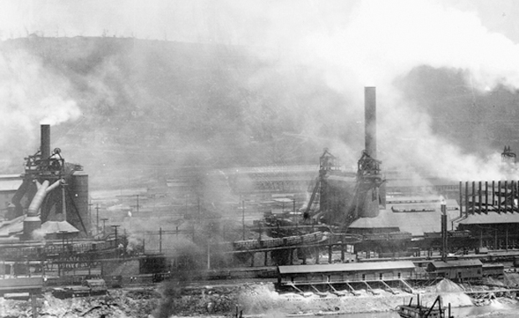

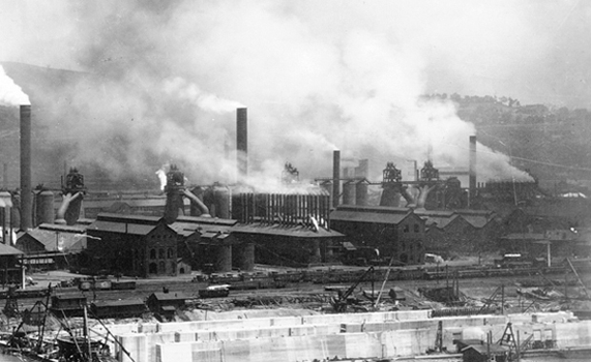

Questions to consider:
1. What does the size of Carnegie's steel furnaces at Braddock, Pennsylvania, suggest about the importance of steel to the industrial system and the need for new managerial techniques?
2. What do the railroad lines running beside the steel mills at Braddock, Pennsylvania, suggest about the connection between transportation and industrial development?
Photos-Carnegie Steel Furnaces

1. What does the size of Carnegie's steel furnaces at Braddock, Pennsylvania, suggest about the importance of steel to the industrial system and the need for new managerial techniques?
Your answer should include the following:
• too big to be overseen by one boss
• need for middle management
• cheap steel provided material for other industries
• size indicates large and steady demand for steel
• steel likely more cheaply produced in larger factories

2. What do the railroad lines running beside the steel mills at Braddock, Pennsylvania, suggest about the connection between transportation and industrial development?
Your answer should include the following:
• expansion of railroads created integrated national market
• railroads allowed for large-scale industries by transporting raw materials from various locations to a single spot
• steel served as the basis for railroad expansion
• goods produced by industrial factories too bulky to be transported overland except by railroads
• railroads encouraged industrial growth by allowing regular interactions among various nodes in the industrial network

U.S. History
Mr. Detjen
Source Analysis

“Sweatshop Boss and Seamstress”

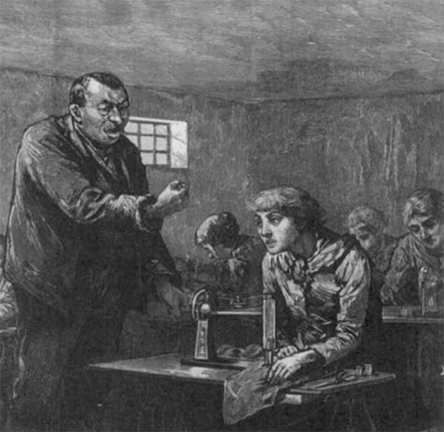

Questions to consider:

1. The picture shows a male boss yelling at one of several female workers. What opportunities could women find in the industrial workforce? Did they suffer greater exploitation than their male counterparts?
2. Based on the average female industrial worker, what could one assume about the woman at the front of this picture?

Image-Sweatshop Boss and Seamstress
1. The picture shows a male boss yelling at one of several female workers. What opportunities could women find in the industrial workforce? Did they suffer greater exploitation than their male counterparts?
Your answer should include the following:
• Only paid half the wages of men
• Worked in industries associated with housework
• Generally only worked until married
• Industrial work preferred to some types of domestic service
• New white-collar occupations
• Limited forays into professions
• Feminization of some professions

2. Based on the average female industrial worker, what could one assume about the woman at the front of this picture?

Your answer should include the following:
• Likely single
• Likely lived in a boardinghouse or with parents
• Likely provided money to her parents
• Likely in late teens to mid twenties
• Likely earned less than half of what a man did

U.S. History
Mr. Detjen
Source Analysis

Robert Koehler, “The Strike”

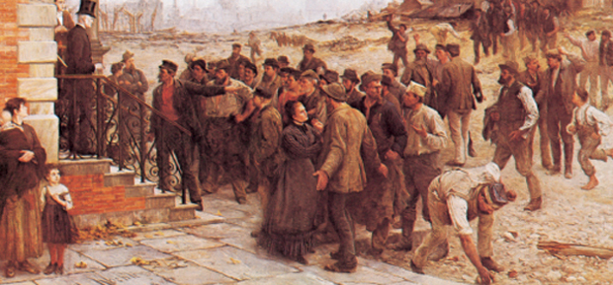

Questions to consider:

1. Analyze the faces of the men in the crowd in Robert Koehler's The Strike. What seems to be the dominant emotion? Does this painting suggest that workers feared management, respected it, or viewed it with contempt? Does the painting suggest sympathy for the workers or for the employer?

2. In the right foreground of Robert Koehler's The Strike, a worker bends over to pick up a stone, perhaps to throw it at representatives of management. Why did relations between workers and management turn violent so frequently in the late nineteenth century?

Painting-Robert Koehler, THE STRIKE

1. Analyze the faces of the men in the crowd in Robert Koehler's The Strike. What seems to be the dominant emotion? Does this painting suggest that workers feared management, respected it, or viewed it with contempt? Does the painting suggest sympathy for the workers or for the employer?

Your answer should include the following:
• angry stances of men closest to owner
• defiant attitude of speaker
• seeming bewilderment of others
• woman pleading with striker--suggest opposition to strike
• owner not portrayed as a villain

2. In the right foreground of Robert Koehler's The Strike, a worker bends over to pick up a stone, perhaps to throw it at representatives of management. Why did relations between workers and management turn violent so frequently in the late nineteenth century?

Your answer should include the following:
• uncertainty of employment
• low wages and high prices
• retaliation by management
• terrorism
• strikes
• government intervention

U.S. History
Mr. Detjen
Source Analysis

“Two Sides of Haymarket”

The Haymarket Square Affair on May 4, 1886, led to the arrest and conviction of eight people for the murder of police officer Mathias J. Degan. Degan died as a result of the explosion of a pipe bomb at a labor rally organized by anarchists in the Haymarket Square in Chicago. In the first document one of the convicted defendants—an anarchist named August Spies—explains how he became a radical and what he did at Haymarket. The second document is part of Judge Joseph E. Gary's address to the convicted men.

DOCUMENT 1
A Radical Explains His Beliefs
The factory: the ignominious regulations, the surveillance, the spy system, the servility and lack of manhood among the workers and the arrogant arbitrary behavior of the boss and mamelukes—all this made an impression upon me that I have never been able to divest myself of. At first I could not understand why the workers, among them many old men with bent backs, silently and without a sign of protest bore every insult the caprice of the foreman or boss would heap upon them. I was not then aware of the fact that the opportunity to work was a privilege, a favor, and that it was in the power of those who were in the possession of the factories and instruments of labor to deny or grant this privilege. I did not then understand how difficult it was to find a purchaser for one's labor, I did not know then that there were thousands and thousands of idle human bodies in the market, ready to hire out upon most any conditions, actually begging for employment. I became conscious of this, very soon, however, and I knew then why these people were so servile, whey [sic] suffered the humiliating dictates and capricious whims of their employers….
My connection with the meeting on the Haymarket on May 4th 86 did not go beyond that of an invited speaker. I had been invited to address the meeting in German, but no German speakers being present I spoke in English. The meeting had been called by the representatives of a number of Trades Union. Those present were workingmen of all beliefs and views; they were not Anarchists. Nor were the speeches anarchistic, they treated on the Eight Hour question. Anarchism was not even referred to by anyone…. But Anarchism was good enough to serve as a scapegoat for Bonfield. This fiend, in order to justify his murderous attack upon that meeting, said “They were Anarchists”.—“Anarchists! Oh, Horror!” The stupid mass imagined that “Anarchists” must be something very bad and they joined in the chorus with their enemies and fleecers: “Crucify, Crucify!”
Source: August Spies, Autobiography, 1886, pp. 18–20, 31–3, Chicago Historical Society, Haymarket Affair Digital Collection, www.chicagohistory.org/hadc/manuscripts/M06/M06.htm, accessed 6.24.09.

DOCUMENT 2
The Judge Speaks of Murder and Free Speech
… the law is common sense. It holds each man responsible for the natural and probable consequences of his own acts. It holds that whoever advises murder, is himself guilty of the murder that is committed in pursuance of his advice, and that if men band together for a forcible resistance to the execution of the law, and advise murder, as a means to make such resistance effectual, whether such advice is to one man to murder another, or to a numerous class to murder men of another class, all who are so banded together, are guilty of any murder that may be committed in pursuance of such advice.
The People of this country love their institutions, love their homes, love their property. They will never consent that by violence and murder, those institutions shall be broken down, their houses despoiled, and their property destroyed.
And the People are strong enough to protect and sustain their institutions, and to punish all offenders against their laws. And those who threaten danger to civil society, if the law is enforced, are leading to destruction whoever shall attempt to execute such threats.
The existing order of society can be changed only by the will of the majority.
Each man has a full right to entertain and advocate, by speech and print, such opinions as suit himself, and the great body of the People will usually care little what he says, but if he proposes murder as a means of enforcing his opinions, he puts his own life at stake. And no clamor about free speech, or evils to be cured, or wrongs to be redressed, will shield him from the consequences of his crime.
His liberty is not a license to destroy. The toleration that he enjoys, he must extend to others, and not arrogantly assume that the great majority are wrong, and may rightfully be coerced by terror, or removed by dynamite.
Source: Address by Judge Joseph E. Gary, 8 October 1886, Cook County (Ill.) Criminal Court, Chicago Historical Society, Haymarket Digital Collection, www.chicagohistory.org/hadc/manuscripts/m05/M05.htm, accessed 6.24.09.

Questions to consider:
1. Analyze the views of manhood expressed in the passages of Spies and Gary. Do the two speakers agree on the essential character of manhood? Do they agree on how the industrial system affects the manhood of workers? Based on the two men's conceptions of manhood, would it have been possible for them to reach an understanding about the problems of the industrial system and the best solutions for it?
2. Does Gary's speech indicate that the eight people convicted of the murder at Haymarket were guilty because of their actions or because of their ideology? Does that conviction support Gary's statement about citizens' "full right to entertain and advocate" unpopular views? Do Gary's accusations against the convicted men agree with the evidence set forth by Spies?
3. What about “the factory” so disturbed August Spies and led to his becoming a radical? On what grounds does Judge Gary explain the conviction and the sentence? How, if at all, does knowing that Illinois Governor John Peter Altgeld pardoned the three surviving defendants as innocent only a few years later change your view of these two documents?

Historiography-Two Sides of Haymarket

1. Analyze the views of manhood expressed in the passages of Spies and Gary. Do the two speakers agree on the essential character of manhood? Do they agree on how the industrial system affects the manhood of workers? Based on the two men's conceptions of manhood, would it have been possible for them to reach an understanding about the problems of the industrial system and the best solutions for it?
Your answer should include the following:
• Spies sees a lack of manhood
• Workers had to beg for jobs
• Employers kept workers under humiliating surveillance
• Employers treated workers disdainfully
• Gary sees men as responsible for their actions
• Men are imbued with certain rights
• Men may not impose their will on the majority

2. Does Gary's speech indicate that the eight people convicted of the murder at Haymarket were guilty because of their actions or because of their ideology? Does that conviction support Gary's statement about citizens' "full right to entertain and advocate" unpopular views? Do Gary's accusations against the convicted men agree with the evidence set forth by Spies?
Your answer should include the following:
• Gary assumes anarchists are violent
• Gary conflates anarchism and violent destruction
• Gary implies that citizens could be found guilty by association with terrorists
• Spies denies that anarchism was discussed at Haymarket
• Gary references no specific violent action committed by the convicts
• Gary only implies advocacy of violence

U.S. History
Mr. Detjen
Source Analysis

“The Rise of Information Systems”

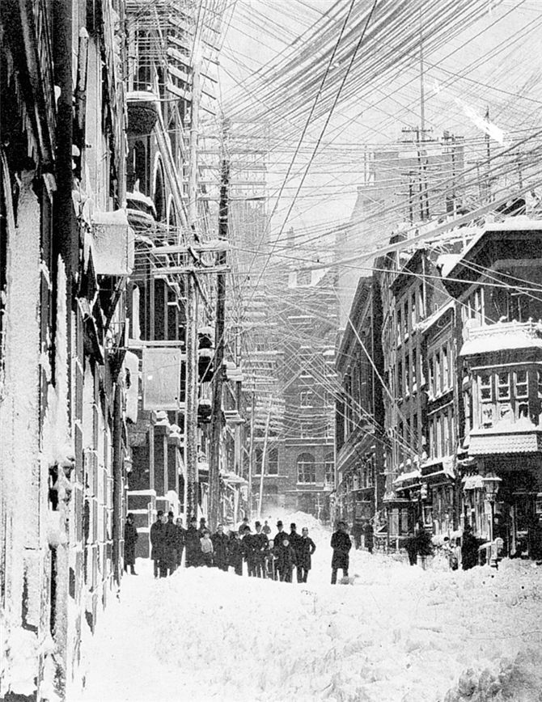
New York City, The Great Blizzard of 1888

In 1877, a year after its invention, advertisements were already touting Alexander Graham Bell's “speaking telegraph”: “Conversation can easily be carried on after slight practice and occasional repetition of a word or sentence…. [A]fter a few trials the ear becomes accustomed to the peculiar sound.”
It was not so for everyone. Some people reported terrifying “stage fright” that left them speechless. Others had no idea how to greet callers. Bell answered with a chipper “Ahoy!” Operators at the first public telephone exchange used the old-fashioned “What is wanted?” But it was Thomas Edison's melodious “Hello” (derived from “Halloo,” the traditional call to bring hounds to the chase) that won out by 1880.
At first Bell's electrical toys could be rented only in pairs by individuals who wanted to connect two places. In 1877 the advantages of such direct communication led to the first intercity hookup, between New York and Boston. Before the turn of the century the Bell-organized American Telephone and Telegraph Company had combined more than 100 local telephone companies to furnish business and government with long-distance service. When rates dropped after 1900 telephones found their way into ordinary American homes.
The telephone revolutionized communications, cutting time and obliterating distances. It also liberated social relations by freeing people from the nineteenth-century convention of addressing only those to whom they had been properly introduced. And it acted as a great social leveler. Almost overnight, telephone operators (called “hello girls”) began connecting people of different locales and classes who might never have spoken to each other at all, let alone as peers.
During the first half of the nineteenth century, information had traveled mostly through the mails. In 1844 Samuel F. B. Morse sent the first intercity message across electrical wires, thereby achieving instantaneous communication. But the telegraph had drawbacks. Instantaneous communication was hardly direct. Messages had to be taken to a telegraph office, where trained clerks could translate them into Morse code, an unwieldy system of dots and dashes. Only then could they be transmitted by electrical impulse. When they arrived at the receiving station, messages were recast into understandable language, then carried by hand to their precise destination.
The need for speed and efficiency in the office led to other breakthroughs. One device that increased business efficiency was the typewriter. C. Latham Sholes, a Milwaukee printer and editor, had been tinkering with an automatic numbering machine when a friend suggested he develop a mechanical letter-writing device. In 1868 he patented the “Type-Writer.” By the early twentieth century the typewriter had taken its modern shape—a keyboard with upper- and lowercase letters and a carriage that allowed typists to see the output.
In 1890 Alfred Dick invented the mimeograph to reproduce many copies of a single document cheaply, a communications boon not only to businesses but also to churches, reform organizations, and political groups.

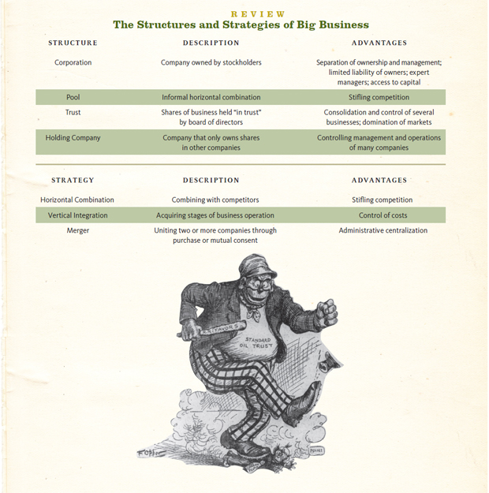

U.S. History
Mr. Detjen
Source Analysis

“Philanthropy: Andrew Carnegie and Warren Buffett”
the word philanthropy originally meant love of humanity or goodwill toward fellow humans but over time the term has come to mean large-scale giving by wealthy individuals. Steel magnate Andrew Carnegie accumulated a huge fortune in industry but devoted the last two decades of his life to philanthropy, establishing more than 2,500 libraries in the United States, endowing universities, and building Carnegie Hall in New York City and the Peace Palace in The Hague. In 1911, he established the Carnegie Corporation of New York “to promote the advancement and diffusion of knowledge and understanding.” Carnegie articulated his philosophy of the obligation of the wealthy to use their fortunes to improve the world in the essay “Wealth,” published in North American Review in 1889 and excerpted in the first source document below.
Investor and philanthropist Warren Buffett is the chairman and chief executive officer of Berkshire Hathaway, a conglomerate holding company whose assets include GEICO, The Pampered Chef, Fruit of the Loom, See's Candies, and Benjamin Moore & Co., among many others. Known as the “Sage of Omaha,” Buffett was born in Omaha, Nebraska, in 1930 and still resides in the house he bought there in 1957 for $31,500. He made his first stock purchase at age 11 when he bought shares of Cities Service Preferred. Today Buffett is one of the world's richest men, with an estimated net worth of $45 billion in 2010. In 2006, Buffett announced that he intended to give away most of his fortune during his lifetime, rather than having the funds distributed after his death. The majority of Buffett's wealth will go to the Bill and Melinda Gates Foundation, the charitable foundation established by his close friend, bridge partner, and fellow philanthropist Bill Gates.
Andrew Carnegie, Wealth 1889
This, then, is held to be the duty of the man of wealth: first, to set an example of modest, unostentatious living, shunning display or extravagance; to provide moderately for the legitimate wants of those dependent upon him; and after doing so to consider all surplus revenues which come to him simply as trust funds which he is called upon to administer, and strictly bound as a matter of duty to administer in the manner which, in his judgment, is best calculated to produce the most beneficial results for the community—the man of wealth thus becoming the mere agent and trustee for his poorer brethren, bringing to their service his superior wisdom, experience, and ability to administer, doing for them better than they would or could do for themselves….
In bestowing charity, the main consideration should be to help those who will help themselves; to provide part of the means by which those who desire to improve may do so; to give those who desire to rise the aids by which they may rise; to assist, but rarely or never to do all. Neither the individual nor the race is improved by almsgiving. Those worthy of assistance, except in rare cases, seldom require assistance. The really valuable men of the race never do, except in cases of accident or sudden change. Everyone has, of course, cases of individuals brought to his own knowledge where temporary assistance can do genuine good, and these he will not overlook. But the amount which can be wisely given by the individual for individuals is necessarily limited by his lack of knowledge of the circumstances connected with each. He is the only true reformer who is as careful and as anxious not to aid the unworthy as he is to aid the worthy, and, perhaps, even more so, for in almsgiving more injury is probably done by rewarding vice than by relieving virtue….
Thus is the problem of rich and poor to be solved. The laws of accumulation will be left free; the laws of distribution free. Individualism will continue, but the millionaire will be but a trustee for the poor; entrusted for a season with a great part of the increased wealth of the community, but administering it for the community far better than it could or would have done for itself. The best minds will thus have reached a stage in the development of the race in which it is clearly seen that there is no mode of disposing of surplus wealth creditable to thoughtful and earnest men into whose hands it flows save by using it year by year for the general good.
This day already dawns. But a little while, and although, without incurring the pity of their fellows, men may die sharers in great business enterprises from which their capital cannot be or has not been withdrawn, and is left chiefly at death for public uses, yet the man who dies leaving behind him millions of available wealth, which was his to administer during life, will pass away “unwept, unhonored, and unsung,” no matter to what uses he leaves the dross which he cannot take with him. Of such as these the public verdict will then be: “The man who dies thus rich dies disgraced.”
Such, in my opinion, is the true gospel concerning wealth, obedience to which is destined some day to solve the problem of the rich and the poor, and to bring “Peace on earth, among men goodwill.”
Source: North American Review (June 1889). Reprinted in The Annals of America, vol. 11, 1884–1894 (Chicago: Encyclopaedia Britannica, 1968), 222–226.

Warren Buffett, “My Philanthropic Pledge” (2010)

In 2006, I made a commitment to gradually give all of my Berkshire Hathaway stock to philanthropic foundations. I couldn't be happier with that decision.
Now, Bill and Melinda Gates and I are asking hundreds of rich Americans to pledge at least 50% of their wealth to charity. So I think it is fitting that I reiterate my intentions and explain the thinking that lies behind them.
First, my pledge: More than 99% of my wealth will go to philanthropy during my lifetime or at death. Measured by dollars, this commitment is large. In a comparative sense, though, many individuals give more to others every day.
Millions of people who regularly contribute to churches, schools, and other organizations thereby relinquish the use of funds that would otherwise benefit their own families. The dollars these people drop into a collection plate or give to United Way mean forgone movies, dinners out, or other personal pleasures. In contrast, my family and I will give up nothing we need or want by fulfilling this 99% pledge.
Moreover, this pledge does not leave me contributing the most precious asset, which is time. Many people, including—I'm proud to say—my three children, give extensively of their own time and talents to help others. Gifts of this kind often prove far more valuable than money. A struggling child, befriended and nurtured by a caring mentor, receives a gift whose value far exceeds what can be bestowed by a check. My sister, Doris, extends significant person-to-person help daily. I've done little of this.
What I can do, however, is to take a pile of Berkshire Hathaway stock certificates—“claim checks” that when converted to cash can command far-ranging resources—and commit them to benefit others who, through the luck of the draw, have received the short straws in life. To date about 20% of my shares have been distributed (including shares given me by my late wife, Susan Buffett). I will continue to annually distribute about 4% of the shares I retain. At the latest, the proceeds from all of my Berkshire shares will be expended for philanthropic purposes by 10 years after my estate is settled. Nothing will go to endowments; I want the money spent on current needs.
This pledge will leave my lifestyle untouched and that of my children as well. They have already received significant sums for their personal use and will receive more in the future. They live comfortable and productive lives. And I will continue to live in a manner that gives me everything I could possibly want in life.
Some material things make my life more enjoyable; many, however, would not. I like having an expensive private plane, but owning a half-dozen homes would be a burden. Too often, a vast collection of possessions ends up possessing its owner. The asset I most value, aside from health, is interesting, diverse, and long-standing friends.
My wealth has come from a combination of living in America, some lucky genes, and compound interest. Both my children and I won what I call the ovarian lottery. (For starters, the odds against my 1930 birth taking place in the U.S. were at least 30 to 1. My being male and white also removed huge obstacles that a majority of Americans then faced.)
My luck was accentuated by my living in a market system that sometimes produces distorted results, though overall it serves our country well. I've worked in an economy that rewards someone who saves the lives of others on a battlefield with a medal, rewards a great teacher with thank-you notes from parents, but rewards those who can detect the mispricing of securities with sums reaching into the billions. In short, fate's distribution of long straws is wildly capricious.
The reaction of my family and me to our extraordinary good fortune is not guilt, but rather gratitude. Were we to use more than 1% of my claim checks on ourselves, neither our happiness nor our well-being would be enhanced. In contrast, the remaining 99% can have a huge effect on the health and welfare of others. That reality sets an obvious course for me and my family: Keep all we can conceivably need and distribute the rest to society, for its needs. My pledge starts us down that course.
Warren Buffett (Reprinted by permission of Warren Buffett)

Questions to consider:

1. What does Carnegie say is the duty and responsibility of the wealthy?

2. What, according to Carnegie, is the responsibility of those who receive charity from the wealthy? How does Carnegie differentiate between almsgiving and philanthropy?

3. Does it appear that, according to his philanthropic pledge, Warren Buffett is a believer in Carnegie’s “gospel of wealth”?

4. What similarities are there between Buffett’s beliefs concerning wealth and personal fortune and Carnegie’s? Do you see any significant differences between the two men’s views on the responsibilities of the wealthy?

5. Do you think Carnegie would say that Warren Buffett, according to his philanthropic pledge, fulfills the “duty of the man of wealth”?

Then and Now: Philanthropy, Carnegie vs. Buffett

1. What does Carnegie say is the duty and responsibility of the wealthy?

Your answers will vary based on your analysis, but you should include:
• | Carnegie clearly stated that the wealthy should provide modestly for themselves and their dependents and, after doing so, should distribute funds in a way that the wealthy person determines will be most beneficial to the community.
• | The reason the wealthy should distribute funds in this manner is because the “poorer brethren” will benefit from the wealthy person’s “superior wisdom, experience, and ability to administer.”

2. What, according to Carnegie, is the responsibility of those who receive charity from the wealthy? How does Carnegie differentiate between almsgiving and philanthropy?

Your answers will vary based on your analysis, but you should include:
• | Carnegie was careful to point out that those who receive aid should be “worthy,” and the clear implication is that philanthropy should go to those who will strive to do what the wealthy person has done. They should work to improve, only relying on the wealthy for additional assistance, not for complete financing of a venture. Others’ wealth should not be the sole source of a person’s financing.
• | The difference between almsgiving and philanthropy is perhaps best summed up by Carnegie’s statement that “those worthy of assistance, except in rare cases, seldom require assistance.” Much of Carnegie’s discussion includes references to those who are “worthy” and those who are not, and the key, for him, is to recognize the difference.

3. Does it appear that, according to his philanthropic pledge, Warren Buffett is a believer in Carnegie’s “gospel of wealth”?

Your answers will vary based upon your interpretation of Buffet’s pledge, but should include:
• | More than once, Buffet has stated that by giving away 99 percent of his wealth, neither he nor his family will suffer for want of anything; that they will, in fact, continue to live very comfortable lives; and that more money would not enhance their happiness or well-being. These beliefs seem to echo Carnegie’s ideas.
• | Buffet also points out that his wealth will be distributed in his lifetime or within a very short period after his death for things that are needed now. Note that he specifies that he will not fund endowments, which are established to assist with needs in the future.
4. What similarities are there between Buffett’s beliefs concerning wealth and personal fortune and Carnegie’s? Do you see any significant differences between the two men’s views on the responsibilities of the wealthy?

Your answers will vary based on your analysis, but you should include:
• | It is notable that Buffet spends a significant portion of his pledge discussing the fact that in many ways his wealth has resulted from “luck.” He does not attribute all to luck, but it plays an important role, in his opinion.
• | Buffet does not really discuss who should benefit from his charity, other than that he has chosen to work with Bill and Melinda Gates. Unlike Carnegie, he does not go into great detail about the “worthiness” of those who receive charity. Instead, Buffett points out that it is not only the wealthy who give and also makes a point of the fact that time is often more valuable than money.

5. Do you think Carnegie would say that Warren Buffett, according to his philanthropic pledge, fulfills the “duty of the man of wealth”?

Your answers will vary based on your analysis, but you should include:
• | Carnegie would likely agree with much of Buffet’s pledge. They would likely agree on the need to give away what is not needed to make the wealthy person’s life comfortable. But Carnegie seems to focus much more on what qualifies a person as “worthy” to receive philanthropy. Buffet, on the other hand, spends more time discussing what role luck has played in his and his family’s current situation regarding their wealth, as well as the fact that philanthropy is not limited to monetary awards.
• | In many ways, the two men seem to reflect the times in which they live(d) (and the times in which they were born). The United States and the world are significantly different in 2010 than they were in 1889, which could explain some of the differences in the attitudes of Carnegie and Buffet.

U.S. History
Mr. Detjen
Source Analysis

“The Novels of Horatio Alger”

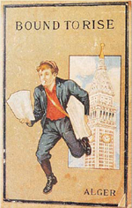

A young boy, perhaps an orphan, makes his perilous way through life on the rough streets of the city by selling newspapers or peddling matches. One day, his energy and determination catch the eye of a wealthy man, who gives him a chance to improve himself. Through honesty, charm, hard work, and aggressiveness, the boy rises in the world to become a successful man.

That, in a nutshell, is the story that Horatio Alger presented to his readers in novel after novel—more than 100 of them in all—for over forty years. During Alger's lifetime, Americans bought many million copies of his novels. After his death in 1899, his books (and others written in his name) continued to sell at an astonishing rate.
Alger was born in 1832 into a middle-class New England family, attended Harvard, and spent a short time as a Unitarian minister. He himself never experienced the hardships he later chronicled. In the mid-1850s, he turned to writing stories and books. His most famous novel, Ragged Dick, was published in 1868; but there were many others almost identical to it: Tom, the Bootblack; Sink or Swim; Jed, the Poorhouse Boy; Phil, the Fiddler; Andy Grant's Pluck. Most of his books were aimed at young people, and almost all of them were fables of a young man's rise “from rags to riches.” The purpose of his writing, he claimed, was twofold. He wanted to “exert a salutary influence upon the class of whom [I] was writing, by setting before them inspiring examples of what energy, ambition, and an honest purpose may achieve.” He also wanted to show his largely middle-class readers “the life and experiences of the friendless and vagrant children to be found in all our cities.”
Alger's intentions probably had little to do with the success of his books. Most Americans of the late nineteenth and early twentieth centuries were attracted to Alger because his stories helped reinforce one of the most cherished of their national myths: that with willpower and hard work, anyone could become a “self-made man.” That belief was all the more important in the late nineteenth century, when the rise of large-scale corporate industrialization was making it increasingly difficult for individuals to control their own fates.
Alger placed great emphasis on the moral qualities of his heroes; their success was a reward for their virtue. But many of his readers ignored the moral message and clung simply to the image of sudden and dramatic success. After the author's death, his publishers responded to that yearning by abridging many of Alger's works to eliminate the parts of his stories where the heroes do good deeds. Instead, they focused solely on the success of Alger's heroes in rising in the world.
Alger himself had very mixed feelings about the new industrial order he described. His books were meant to reveal not just the opportunities for advancement it sometimes created, but also its cruelty. To Alger, the modern age did not guarantee success through hard work alone; there had to be some providential assistance as well. That was one reason that in almost all his books, his heroes triumphed not just because of their own virtues or efforts, but because of some amazing stroke of luck as well. Over time, however, Alger's admirers came to ignore his own misgivings about industrialism and to portray his books purely as celebrations of (and justifications for) laissez-faire capitalism and the accumulation of wealth.
Today, though his books are largely forgotten, the name Horatio Alger lives on, representing the idea of individual advancement through (in a phrase Alger coined) “pluck and luck.” An example of the transformation of Alger into a symbol of individual achievement is the Horatio Alger Award, established in 1947 by the American Schools and Colleges Association to honor “living individuals who by their own efforts had pulled themselves up by their bootstraps in the American tradition.” Among its recipients have been Presidents Dwight D. Eisenhower and Ronald Reagan, evangelist Billy Graham, and U.S. Supreme Court Justice Clarence Thomas.

Questions to consider:

1. How do Alger's novels both defend industrial capitalism and criticize it?

2. According to the essay, Alger placed great emphasis on the moral qualities of his heroes, but his publishers later eliminated that aspect of the novels. Why?

3. Do Alger's themes—"rags to riches," success as a reward for virtue, "pluck and luck"—live on in contemporary popular culture? Can you cite some examples where you find these themes portrayed?

The Novels of Horatio Alger

1. How do Alger's novels both defend industrial capitalism and criticize it?

Your answers will depend upon your analysis, of course, but you could argue that Alger's novels both revealed the opportunities made available by the new industrial order, but also the misery and cruelty that accompanied these developments. As Alger's unabridged works acknowledged, the modern age did not guarantee success through hard work alone; often, good fortune was also necessary. These themes implicitly acted as a critique of the brutal realities of early industrial capitalism, where every single success was accompanied by dozens of failures.

2. According to the essay, Alger placed great emphasis on the moral qualities of his heroes, but his publishers later eliminated that aspect of the novels. Why?

Your answers will depend upon your analysis, of course, but you could argue that publishers - and readers - relished the stories of success for their own sake, and as secular interests - such as pursuit of fame and fortune - replaced religious and moral belief and devotion in modern America, Alger's stories were abridged to accommodate these new perspectives.

3. Do Alger's themes—"rags to riches," success as a reward for virtue, "pluck and luck"—live on in contemporary popular culture? Can you cite some examples where you find these themes portrayed?

Your answers will vary based on your analysis, of course, but you could perhaps argue that the emergence of recent television talent shows such as Fox's <i>American Idol</i> and NBC's <i>America's Got Talent</i>, as well as the internet's ability, through portals such as YouTube, to transform formerly anonymous individuals into famous—and successful—celebrities, is an example of the recurrence of many of Alger's themes.

U.S. History
Mr. Detjen
Source Analysis

“The Novels of Louisa May Alcott”

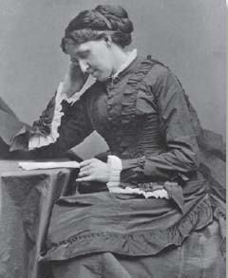

If Horatio Alger's rags-to-riches tales captured the aspirations of many men of the late nineteenth century, Louisa May Alcott's enormously popular novels helped give voice to the often unstated ambitions of many young women.

Alcott was born in 1832, the daughter of a prominent if generally impoverished reformer and educator, Bronson Alcott—a New England transcendentalist committed to abolishing slavery and advancing women's rights. Louisa May Alcott grew up wanting to write, one of the few serious vocations available to women. As a young adult, she wrote a series of popular adventure novels under the pen-name A. M. Barnard, populated by conventional male heroes. While serving as a nurse in the Civil War, she contracted typhoid and recovered, but developed mercury poisoning through her treatment and suffered from it until her death in 1888. After the war, she chose a different path—writing realistic fiction and basing it on the lives and experiences of women. The publication of Little Women (1868, 1869) established Alcott as a major literary figure and as an enduring, if sometimes puzzling, inspiration for girls and, indeed, women of all ages.
Little Women—and its successors Little Men (1871) and Jo's Boys (1886)—were in many ways wholly unlike the formulaic Horatio Alger stories, in which young men inevitably rose from humble circumstances to great success. And yet they both echoed and altered the message of those books. The fictional March family in the novels was in fact modeled on Alcott's own impoverished if intellectually lively childhood, and much of Little Women is a chronicle of poverty, suffering, and even death. But it is also the story of a young girl—Jo March, modeled to some degree on Alcott herself—who struggles to build a life for herself that is not defined by conventional women's roles and ambitions. Jo March, like Louisa May Alcott herself, becomes a writer. She spurns a conventional marriage (to her attractive and wealthy neighbor Laurie). Unlike Alcott, who never married, Jo does find a husband—an older man, a German professor who does not support Jo's literary ambitions.
Many readers have found this marriage troubling—and false to the message of the rest of the book. It seems to contradict Alcott's belief that women can have intellectual independence and achievement. But to Alcott, this unconventional marriage was a symbol of her own repudiation of an ordinary domestic life. “Girls write to ask who the little women marry, as if that was the only end and aim of a woman's life,” Alcott wrote a friend after the publication of the first volume of the novel. “I won't marry Jo to Laurie to please any one.” Jo's marriage to Professor Bhaer is in many ways a concession. “Jo should have remained a literary spinster [like Alcott herself],” she once wrote, “but so many enthusiastic ladies wrote to me clamorously demanding that she should marry Laurie, or somebody, that I didn't dare to refuse and out of perversity went and made a funny match for her.”
It is tempting to see Louisa May Alcott's life—as an independent woman, a writer, and an active suffragist—as a better model to her readers than the characters in her fiction. But it was through Little Women and her other novels that Alcott mostly affected her time; and whatever their limitations, they present a group of young women who do challenge, even if indirectly, the expectations of their era. Jo March is willful, rebellious, stubborn, ambitious, and often selfish, not the poised, romantic, submissive woman of most sentimental novels of her time. She hates housekeeping and drudgery. She yearns at times to be a boy. She resists society's expectations—through her literary aspirations, her sharp temper, and ultimately her unconventional marriage. Through those qualities, she captured the imaginations of late-nineteenth-century female readers and continues to capture the imaginations of readers today. Little Women has survived far longer than the Horatio Alger stories did precisely because it presents a story of growing up that, unlike Alger's, is not predictable but complicated, conflicted, and surprising.

Questions to consider:

1. Do the female characters of Alcott's novels reflect the actual status of women in the late nineteenth century?

2. In what ways are Alcott's novels similar to Alger's? How do they differ?

3. Little Women has continued to be popular as a novel, and it has been made several times into movies, and at least once into a Broadway musical. What accounts for its enduring popularity?

The Novels of Louisa May Alcott

1. Do the female characters of Alcott's novels reflect the actual status of women in the late nineteenth century?

Your answers will depend upon your analysis, of course, but you could reasonably argue that Alcott's female characters challenge the norms of the day. Some women, like Alcott herself, did so in real life, but most women did not. Perhaps it is most telling that Alcott "married" the character of Jo March because so many readers demanded it.

2. In what ways are Alcott's novels similar to Alger's? How do they differ?

Your answers will depend upon your analysis, of course, but you could argue that the first difference is in audience. Alger captured many men's aspirations to wealth, while Alcott's works gave voice to female ambitions. The works also differed in that Alger's were much more formulaic. They are similar, however, in that both gave voice to the era in very specific ways, whether formulaic or challenging to norms of the day.

3. Little Women has continued to be popular as a novel, and it has been made several times into movies, and at least once into a Broadway musical. What accounts for its enduring popularity?

Your answers will depend upon your analysis, of course, but you could argue that it is the unpredictability of the story that makes it so popular. It is not formulaic, like the Alger stories, and the story of each of the March girls takes interesting, and unpredictable, turns along the way. You could also argue that the book, though it may challenge the norms of the late-nineteenth-century American woman, it also captures the challenges women faced at the time in a way that continues to appeal to women today.

