Alphabet Adventures

A Journey Through the
Climatron
and
Shoenberg Temperate House

Missouri Botanical Gardens

March 14, 2013
The following information about the Climatron and Shoenberg Temperate House was found on the Missouri Botanical Garden website (www.missouribotanicalgarden.org).

The Climatron® is the first geodesic dome to be used as a conservatory, incorporating the principles of R. Buckminster Fuller, inventor of the geodesic system. It opened to the public on October 1, 1960. The design of the Climatron greenhouse was developed by St. Louis architects Murphy and Mackey, winning the 1961 Reynolds Award, an award for architectural excellence in a structure using aluminum. In 1976 it was named one of the 100 most significant architectural achievements in United States history. The term “Climatron” was coined to emphasize the climate-control technology of the greenhouse dome.
The Climatron has no interior support and no columns from floor to ceiling, allowing more light and space per square foot for plants than conventional designs. It rises 70 feet in the center, spans 175 feet in diameter at the base, has 1.3 million cubic feet, and encloses approximately 24,000 square feet (more than half an acre).
The interior of the Climatron is designed on a tropical rain forest theme, highlighting their diversity and ecology. Visitors enter and immediately experience the tropics: dense green foliage, a small native hut, sparkling waterfalls, rocky cliffs, a river aquarium with exotic fish, and a bridge from which the forest canopy and associated plants can be viewed.
More than 2,800 plants, including 1,400 different tropical species, grow inside the Climatron. They include banana, cacao, coffee, many wild-collected plants, orchids, and exotic, rare plants such as the double coconut, which produces the largest seed in the plant kingdom. The lush, green tropical rainforest environment is maintained by a computerized climate control system. Inside temperature ranges from 64°F (29° C) at night to a high of 85°F (18° C) during the day. The average humidity is 85 percent. Plants are watered with reverse osmosis purified, tempered water.
A ground-level entrance and energy-conserving automatic doors make the entire Climatron accessible to disabled visitors. The Shoenberg Temperate House hugs the north side of the building.


The Shoenberg Temperate House was dedicated in March 1990 after almost two years of construction. This building replaced the 1913 Mediterranean House on a site just north of the Climatron® geodesic dome conservatory. The new facility was given by the Trustees of the Shoenberg Foundation, Inc.
The Shoenberg Temperate House is glazed with the same low-emissivity, energy-efficient glass used in the Climatron, and its southward roof slope allows maximum penetration of solar rays. A computerized climate control system aims to maintain the Temperate House at temperatures between 40 and 90 degrees.
With 8,900 square feet of space, the Shoenberg Temperate House roughly doubles the exhibit capacity of its predecessor. It emphasizes displays of warm temperate-zone species requiring special protection from St. Louis winters. The largest portion of the house features species from five widely separated regions of the world known for their “Mediterranean” climate, chiefly characterized by warm, dry summers and cool, moist winters: coastal California, the central coast of Chile, the Mediterranean Sea basin, the Cape region of South Africa, and southern and southwestern Australia. Another portion of the Temperate House features plants found in the southeastern United States and the warm, temperate areas of Japan, China and Korea.
Plant collections are thematically displayed:
- A Moorish walled garden reflecting major elements in the history of formal design.
- Important economic plants, such as olives, figs, carob, grapes and cork oak.
- “Plants of the Bible” area.
- Wildflower, rock garden and vine species.
- Riparian plants, adapted to survive at the edge of watercourses such as rivers and streams.
- A large bog display of carnivorous plants from the southeastern U.S., including pitcher plants, flytraps, butterworts and sundews.
An additional element of interest is an antique portico overlooking the Moorish garden, once the facade of St. Leo’s School in St. Louis. This portico was the work of the sons of George I. Barnett, a local 19th century architect who designed several historical buildings on the Garden's grounds.
The Shoenberg Temperate House was designed by the Christner Partnership, Inc. of St. Louis. Interior displays were designed by Environmental Planning and Design of Pittsburgh, Penn.

On Thursday, March 14, 2013, the second grade classes at Mallinckrodt Academy enjoyed a field trip to the Missouri Botanical Garden. Despite promising forecasts of sunshine and temperatures in the low 60s, approximately 50 students and a handful of parents and teachers endured a chilly, windy, overcast visit complete with some unexpected (and most unwelcome) sleet. Despite such conditions, a good time was reportedly had by all. My sincere appreciation goes out to the students pictured below (from L to R: Rafe Schmitz, Quinn Rollins, and Demetris Phillips), as well as to my remarkable assistant, Ms. Saunders, for they helped locate the species included herein for the purposes of this book.
I found some basic information about each of the included species through Wikipedia. It is not meant to be comprehensive, nor will I claim it is verified, but rather it is intended to provide an overview of where such plants are found and the conditions that support their growth. To all my students of this 2012-2013 academic year, it remains my intention to support your growth as we learn and discover together. Your endless curiosity and enthusiasm is an inspiration, and I am blessed to share these experiences in your company. I hope you enjoy Alphabet Adventures!
- Mrs. Mayes
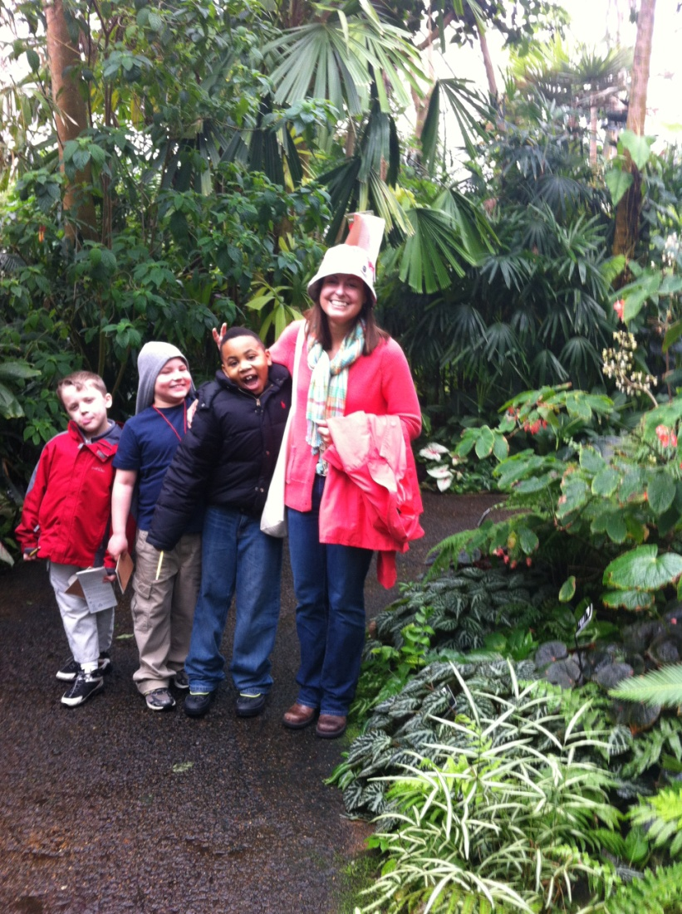
A
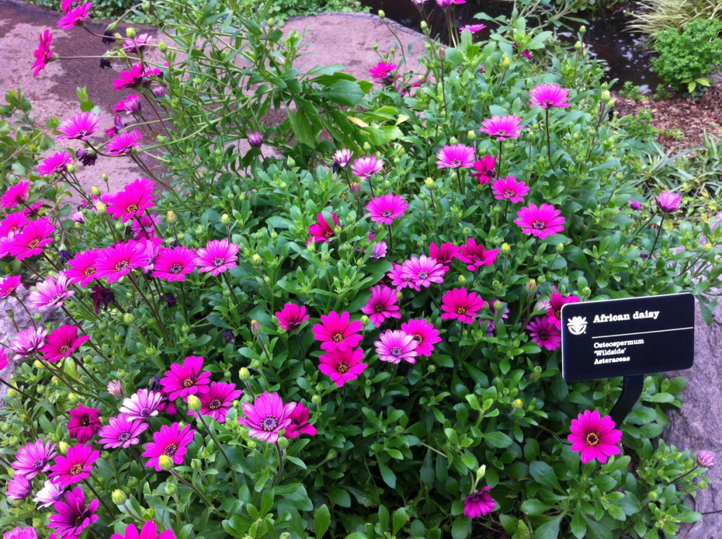

African daisy
Osteospermum
‘Wildside’
Asteraceae
Osteospermum is a genus of flowering plants belonging to the Calenduleae, one of the smaller tribes of the sunflower/daisy family Asteraceae. It has been given several common names: African daisy, South African daisy, Cape daisy and blue-eyed daisy. There are about 50 species, native to Africa, 35 species in southern Africa, and the southwestern Arabian Peninsula. They are half-hardy perennials or subshrubs. Therefore they do not survive outdoor wintry conditions. Plants prefer a warm and sunny position and rich soil, although they tolerate poor soil, salt or drought well. Modern cultivars flower continuously when watered and fertilized well. If planted in a container, soil should be prevented from drying out completely. If they do, the plants will go into "sleep mode" and survive the period of drought, but they will abort their flower buds and not easily come back into flower. Moreover, roots are relatively susceptible to rotting if watered too profusely after the dry period.

B
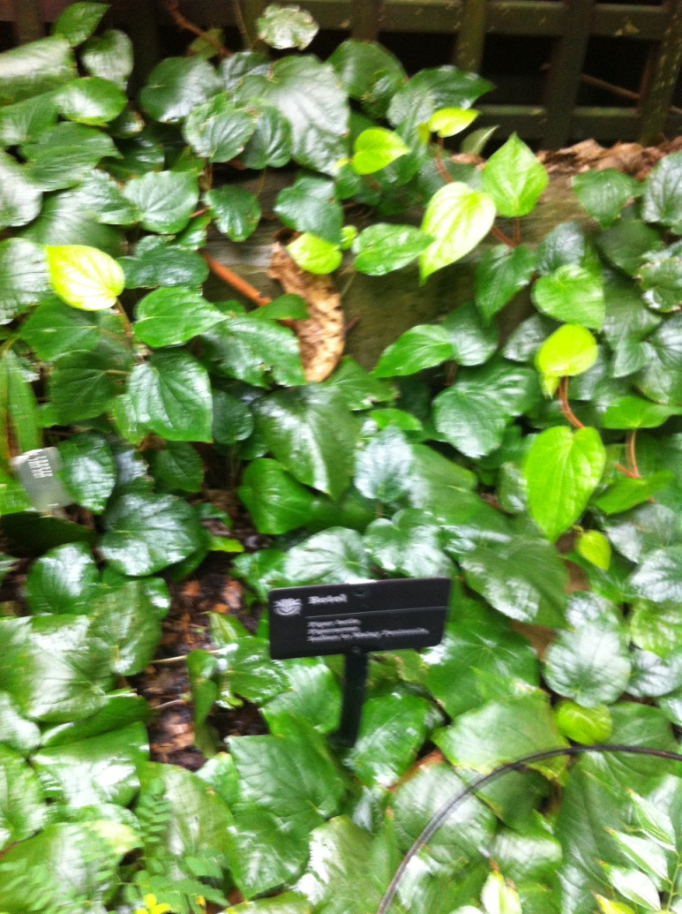

Betel
Piper betle
Piperaceae
The Betel (Piper betle) is the leaf of a vine belonging to the Piperaceae family, which includes pepper and kava. It is valued both as a mild stimulant and for its medicinal properties. Betel leaf is mostly consumed in Asia, and elsewhere in the world by some Asian emigrants, as betel quid or paan, always with tobacco, in an addictive psycho-stimulating and euphoria-inducing formulation with adverse health effects. The betel plant is an evergreen and perennial creeper, with glossy heart-shaped leaves and white catkin. The betel plant originated from South and South East Asia (India, Nepal, Bangladesh and Sri Lanka). Proper shade and irrigation are essential for the successful cultivation of this crop. Betel needs constantly moist soil, but there should not be excessive moisture. Irrigation is frequent and light and standing water should not remain for more than half an hour.
C
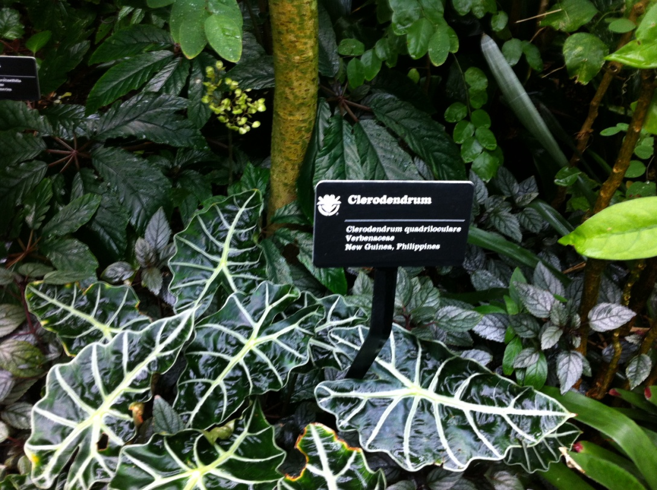

Clerodendrum
Clerodendrum quadriloculare
Verbenaceae
New Guinea, Philippines

Clerodendrum quadriloculare is a species of flowering plant in the verbena family, Verbenaceae. The genus is native to tropical and warm temperate regions of the world, with most species occurring in tropical Africa and southern Asia, but with a few in the tropical Americas and northern Australasia, and a few extending north in to the temperate zone in eastern Asia. They are shrubs, lianas, and small trees. Clerodendrum species are used as food plants by the larvae* of some Lepidoptera species, an order of insects that includes moths and butterflies. (*A larva is a distinct juvenile form many animals undergo before metamorphosis into adults. Animals with indirect development such as insects typically have a larval phase of their life cycle. The larva’s appearance is generally very different from the adult form; for example, caterpillars and butterflies do not look alike. A larva often has unique structures and organs that do not occur in the adult form, and may have a considerably different diet.)

D
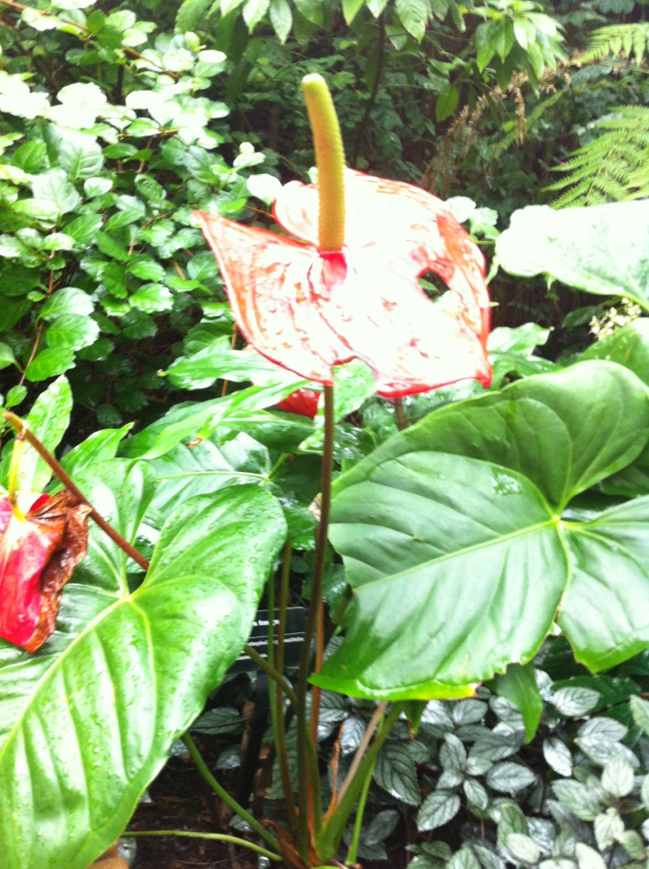

Devil’s tongue
Amorphophallus paeonifolius
Araceae
Eastern Asia

Konjac, also known as devil’s tongue, voodoo lily, snake palm, or elephant yam, is a plant of the genus Amorphophallus. It is native to warm subtropical to tropical eastern Asia, from Japan and China south to Indonesia. It is a perennial plant, grown from a large corm (underground plant stem) up to 25 cm in diameter. The single leaf is up to 1.3 m across and divided into numerous leaflets. The flowers are produced on a spathe, which is petal-like, and arranged on a type of spike called a spadix, which can be up to 55 cm long. The food made from the root of this plant is widely known in English by its Japanese name, konnyaku (yam cake). The corms are also used to create flour and jelly.
E
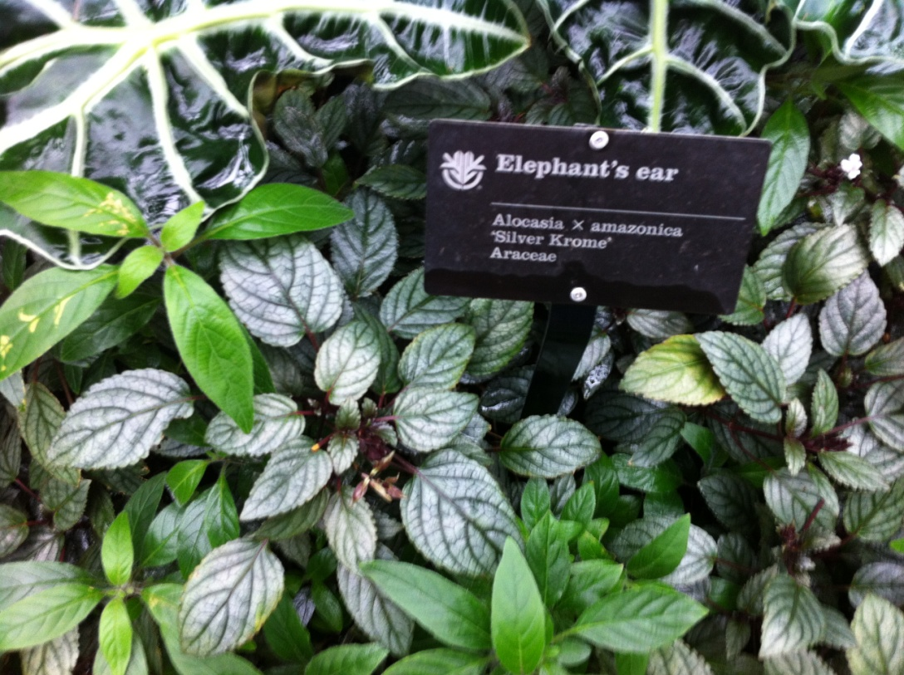

Elephant’s ear
Alocasia x amazonica
‘Silver Krome’
Araceae
Alocasia is a genus of broad-leaved rhizomatous or tuberous perennials from the family Araceae. There are 79 species native to tropical and subtropical Asia to Eastern Australia, and widely cultivated elsewhere. The stem (a corm) is edible, but contains rahid crystals of Calcium oxalate along with other irritants that can numb and swell the tongue and pharynx resulting in difficult breathing, and sharp throat pain. The lower parts contain more of the poison. Prolonged boiling before serving or processing may reduce the risks but acidic fruit such as tamarind may dissolve them. Alocasia is a distinctly exotic and tropical plants. They are typically grown as pot plants, but a better way is to grow the plants permanently in the controlled conditions of a greenhouse. They do not do well in the dark and need good lighting if inside the house. They should be cared for as any other tropical plant with weekly cleaning of the leaves and frequent fine water misting without leaving the plants wet.

F
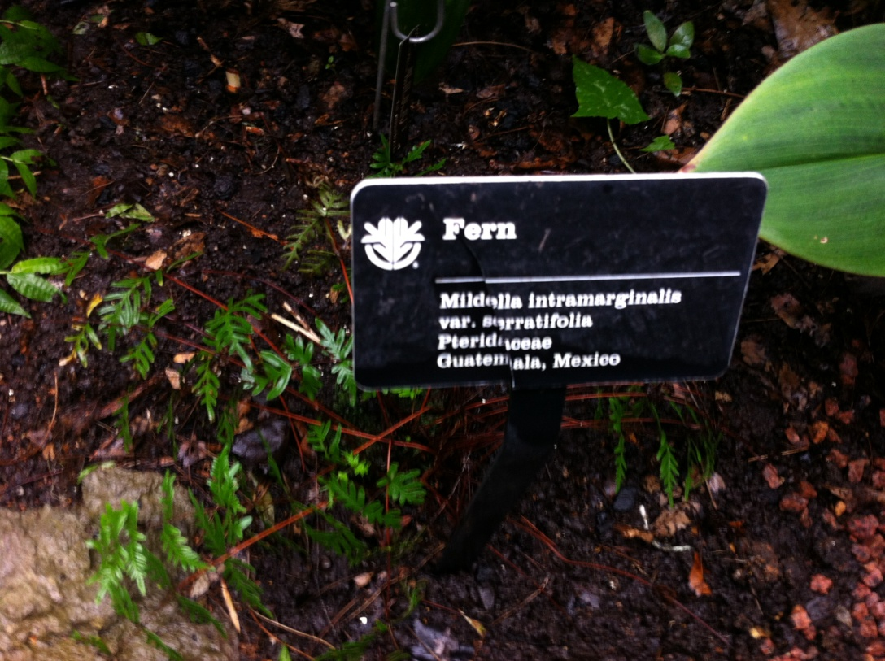

Fern
Mildella intramarginatta
var. serratifolia
Pteridaceae
Guatemala, Mexico
A fern is any one of a group of about 12,000 species of plants belonging to the botanical group known as Pteridophyta. Unlike mosses, they have xylem and phloem (making them vascular plants). They have stems, leaves, and roots like other vascular plants. Ferns reproduce via spores and have neither seeds nor flowers. Fern species live in a wide variety of habitats, from remote mountain elevations, to dry desert rock faces, to bodies of water or in open fields. There are four particular types of habitats that ferns are found in: moist, shady forests; crevices in rock faces, especially when sheltered from the full sun; acid wetlands including bogs and swamps; and tropical trees. Ferns are not of major economic importance, but some are grown or gathered for food, as ornamental plants, for remediating contaminated soils, and have been the subject of research for their ability to remove some chemical pollutants from the air. Some are significant weeds. They also play a role in mythology, medicine, and art.
G
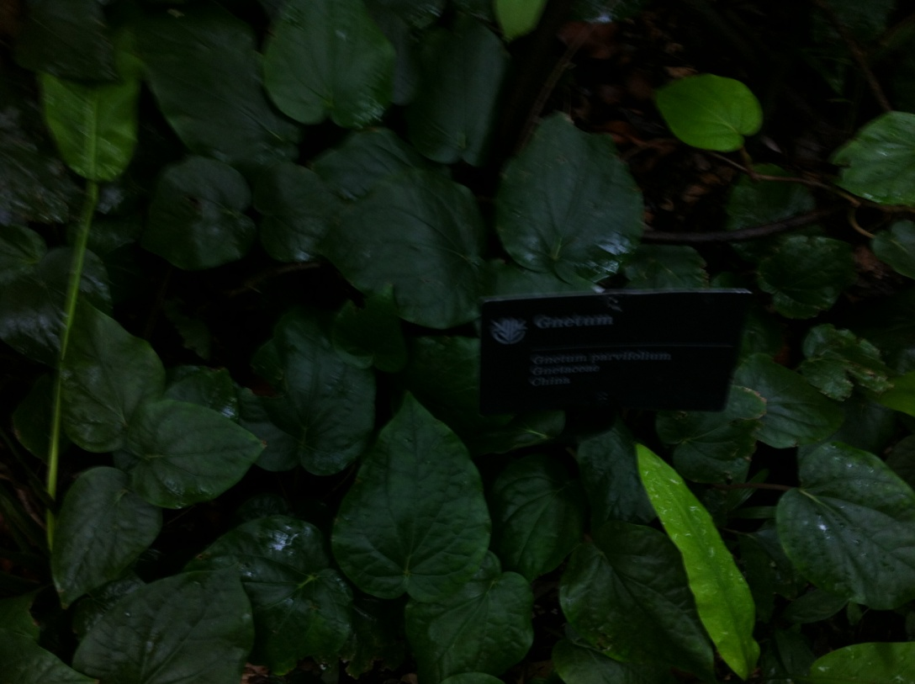

Gnetum
Gnetum parlifolium
Gnetaoceae
China
Gnetum is a genus of about 30-35 species of gymnosperms, the sole genus in the family Gnetaceae and order Gnetales. They are tropical evergreen trees, shrubs, and lianas. Unlike other gymnosperms they possess vessel elements in the xylem. Some species have been proposed to have been the first plants to be insect pollinated as their fossils occur in association with the extinct pollinating scorpionflies. There are indications of hybridization among some of the Southeast Asian species. Fossil-calibrated molecular-clocks suggest that the Gnetum lineages now found in Africa, South America, and Southeast Asia are the result of ancient long-distance dispersal across seawater. Many Gnetum species are edible, with the seeds being roasted, and the foliage used as a leaf vegetable. Some are also valued in herbal medicine.

H
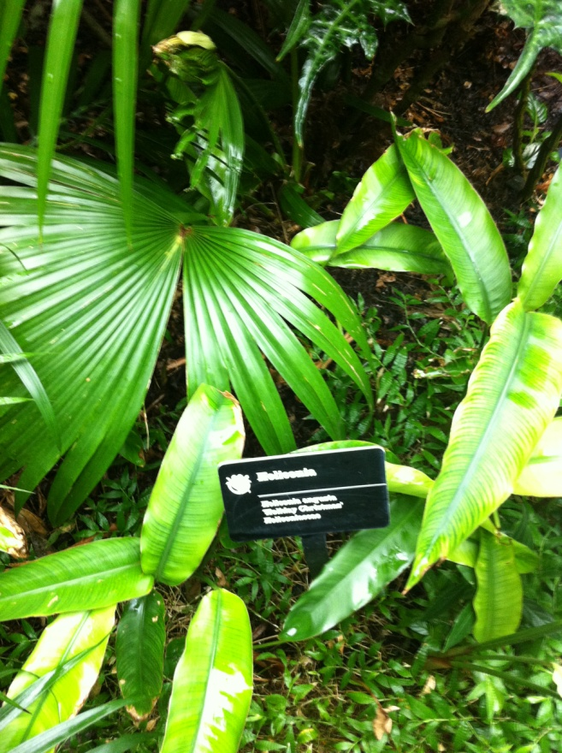

Heliconia
Heliconia angusta
‘Holiday Christmas’
Heliconiaceae

Heliconia is a genus of about 100-200 species of flowering plants native to the tropical Americas and the Pacific Ocean islands west to Indonesia. Many species are found in rainforests or tropical wet forests of these regions. Common names for the genus include lobster-claws, wild plantains, or false bird-of-paradise. These plants range from 1.5-15 feet tall depending on the species. The simple leaves of these plants are 6 in.-10 feet. These plants do not grow well in cold, dry conditions. They are very drought intolerant, but can endure some soil flooding. Heliconias need an abundance of water, sunlight, and soils that are rich in humus in order to grow well. They are an important food source for forest hummingbirds, some of which also use the plant for nesting. The Honduran White Bat also lives in tents it makes from heliconia leaves. Heliconia angusta is commonly called the Christmas heliconia because its red and white flowers usually emerge during the holiday season. Wild populations are native to southeastern Brazil. It is a popular ornamental plant in hot regions with a humid climate.
I
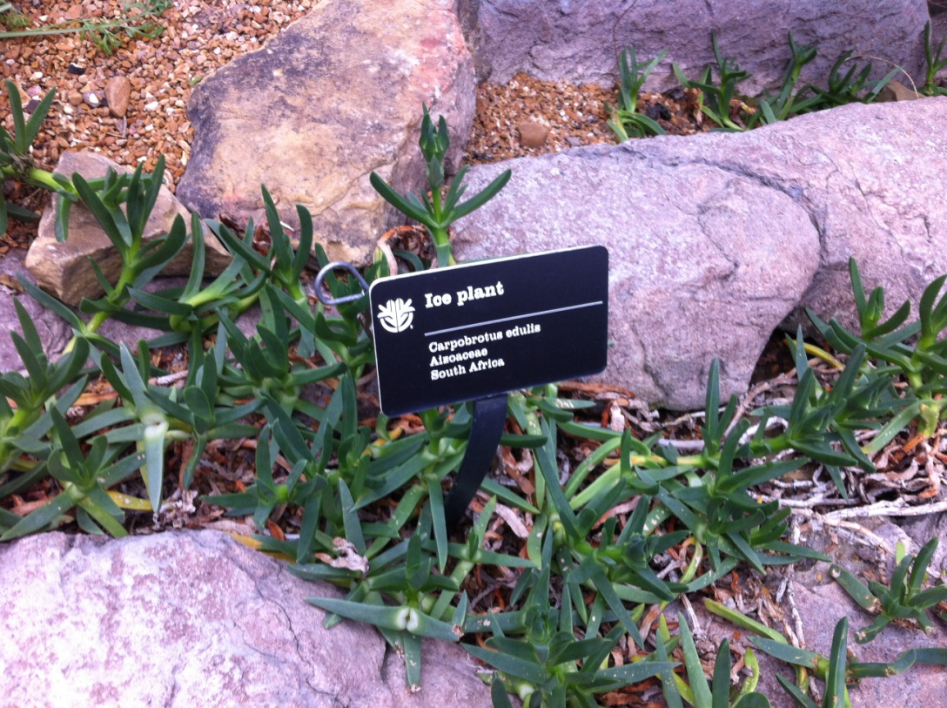

Ice plant
Carpobrotus edulis
Aisoaceae
South Africa
Carpobrotus edulis is native to South Africa. It is also known as ice plant, highway ice plant, pigface or Hottentot fig and in South Africa as the sour fig on account of its edible fruit. It is easily confused with its close relatives, including the more diminutive and less aggressive sea fig. It can, however, be distinguished from most of its relatives by the color of its flowers. Leaves are eaten by tortoises. Puff adders and other snakes, such as the Cape cobra, are often found in Carpobrotus clumps, where they ambush the small rodents attracted by the fruits. Flowers are pollinated by solitary bees, honey bees, carpenter bees, and many beetle species. Flowers are eaten by antelopes and baboons. The clumps provide shelter for snails, lizards, and skinks. Fruits are eaten by baboons, rodents, porcupines, antelopes, and people, who also disperse the seeds. Ice plants grow year round, with individual shoot segments growing more than 3 feet per year. Ice plants can grow to at least 165 feet in diameter. Flowering occurs almost year round. Seed production is high, with hundreds of seeds produced in each fruit. The fruit is edible. In South Africa the sour fig's ripe fruit are gathered and either eaten fresh or made into a very tart jam.
J
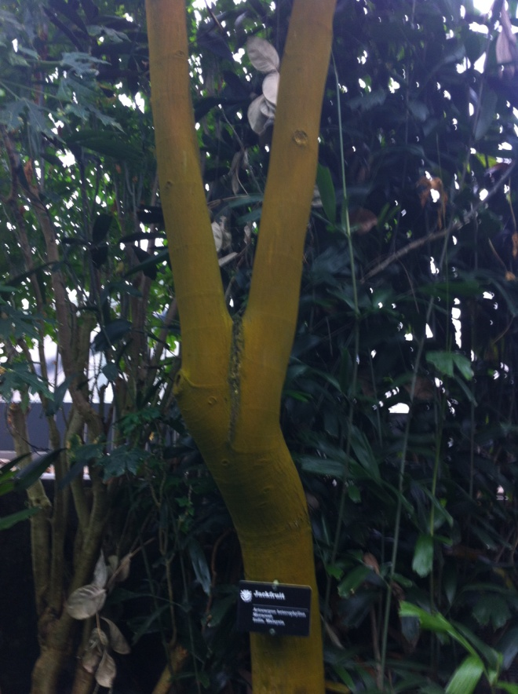

Jackfruit
Artocarpus heterophyllus
Moraceae
India, Malaysia
The jackfruit (alternately jack tree) is a species of tree in the Artocarpus genus of the mulberry family. It is native to parts of South and Southeast Asia and is believed to have originated in the southwestern rain forests of India. The jackfruit tree is well suited to tropical lowlands, and its fruit is the largest tree-borne fruit, reaching as much as 80 pounds in weight and up to 36 inches long and 20 inches in diameter. The jackfruit tree is widely cultivated in tropical regions of India, Bangladesh, Nepal, Sri Lanka, Vietnam, Thailand, Malaysia, Indonesia and the Philippines. Jackfruit is also found in East Africa as well as throughout Brazil and Caribbean nations. The flesh of the jackfruit is starchy and fibrous, and is a source of dietary fiber. The flavor is similar to a tart banana. Ripe jackfruit can be used to make a variety of dishes, including custards, cakes, halo-halo and more. Ripe jackfruit arils are sometimes seeded, fried or freeze-dried and sold as jackfruit chips. In India, when the Jackfruit is in season, an ice cream chain store called "Naturals" carries Jackfruit flavored ice cream.
K
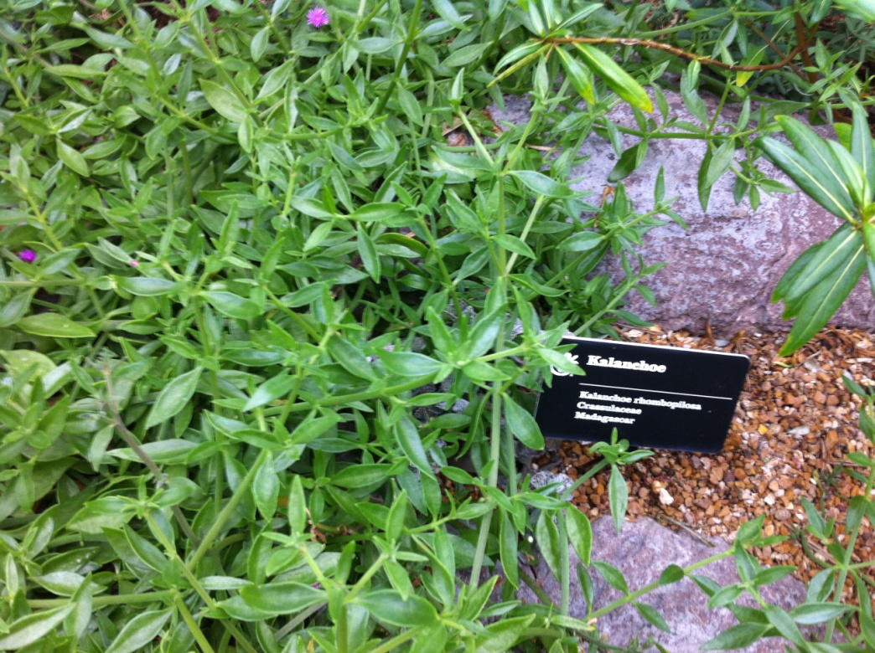

Kalanchoe
Kalanchoe rhombopilosa
Crassulaceae
Madagascar

Kalanchoe is a genus of about 125 species of tropical, succulent flowering plants in the family Crassulaceae, mainly native to the Old World but with a few species now growing wild in the New World following introduction of the species. Most are shrubs or perennial herbaceous plants, but a few are annual or biennial. The largest, Kalanchoe beharensis, from Madagascar, can reach 20 feet tall, but most species are less than 3 feet tall. Kalanchoes are characterized by opening their flowers by growing new cells on the inner surface of the petals to force them outwards, and on the outside of the petals to close them. These plants are cultivated as ornamental houseplants and rock or succulent garden plants. This plant is known to the Chinese as "thousands and millions of red and purple" (萬紫千紅), and is commonly purchased during the Chinese New Year for decorative purposes. They are popular because of their ease of propagation, low water requirements, and wide variety of flower colors typically borne in clusters well above the vegetative growth. These plants are the food plant of the caterpillars of Red Pierrot butterfly. The butterfly lays its eggs on the leaf and, after hatching, the caterpillar go inside the leaf and eat the leaf from inside.
L
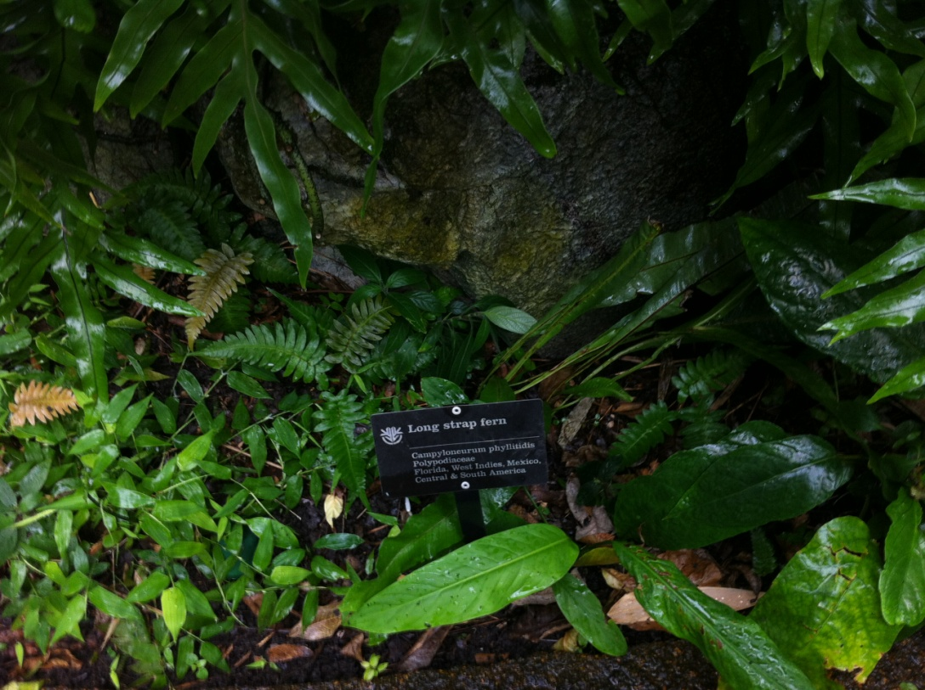

Long strap fern
Campyloneurum phyllitidis
Polypodiaceae
Florida, West Indies, Mexico,
Central & South America
Campyloneurum phyllitidis, commonly known as the long strap fern, is a species of fern in the Polypodiaceae family. It is an epiphyte, growing on other plants; generally the fern is found growing in the canopies of trees. It has a relatively large rhizome from which many fine rootlets covered in dark reddish-brown scales grow. Its leaves are simple in shape, hairless, 45–100 centimeters (18–39 in) long and 8–12 centimeters (3.1–4.7 in) wide. The sori are round and small, occurring in on both sides of lateral veins of the leaves. Campyloneurum phyllitidis is found in Central and South America, from Mexico in the North to Peru in the South and including Panama, Bolivia, Brazil, Paraguay and the West Indies. It is also present in Florida, Puerto Rico, Hawaii and the Virgin Islands. The fern is common on Barro Colorado Island, Panama. This fern grows well in well-drained soil under medium levels of light. It needs to be protected from slugs and snails.

M
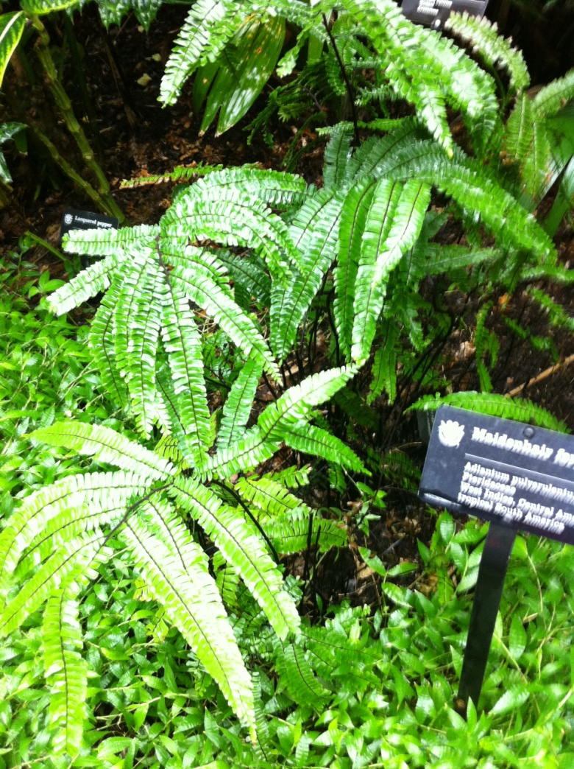

Maidenhair fern
Adiantum pulverulentum
Pteridaceae
West Indies, Central America
tropical South America
Adiantum, the maidenhair ferns, is a genus of about 200 species of ferns in the family Pteridaceae. The genus name comes from Greek, meaning “not wetting”, referring to the fronds’ ability to shed water without becoming wet. These plants are distinctive in appearance, with dark, often black stalks and stems, and bright green, often delicately cut leaf tissue. They generally prefer humus-rich, moist, well-drained sites, ranging from bottomland soils to vertical rock walls. Many species are especially known for growing on rock walls around waterfalls and water seepage areas. The highest species diversity is in the Andes.
N
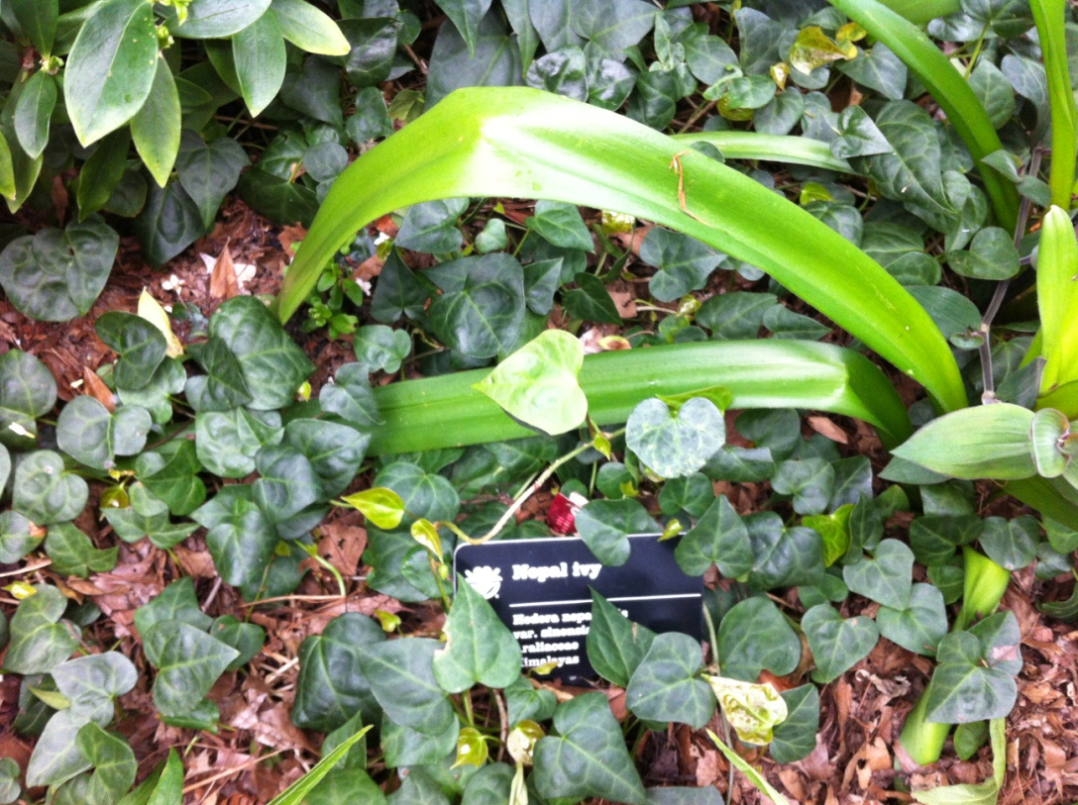

Nepal ivy
Hedera nepalensis
Araliaceae
Himalayas
Ivy, plural ivies (Hedera), is a genus of 12–15 species of evergreen climbing or ground-creeping woody plants in the family Araliaceae, native to western, central and southern Europe, Macronesia, northwestern Africa and across central-southern Asia east to Japan and Taiwan. Hedera nepalensis (Himalayan ivy, Himalaya-Efeu, chang chun teng) is a species of perennial Ivy (genus Hedera) native to Nepal and Bhutan, as well as Afghanistan, India, China, Laos, Myanmar, Thailand, and Vietnam, at altitudes of about 1000–3000 m. Plants grow up to 30 m in height with simple leaves ranging from 2–15 cm long. They produce yellow flowers. The plant blooms from October to April. This plant is toxic; all parts are poisonous because they contain saponins which are irritating to the skin, cause conjunctiva of eyes, and, after ingestion, induce gastrointestinal nervous system disturbances. They mainly are found in moist soil and shade, at the height of 1000–3000 m. This plant is largely resistant to frost.

O
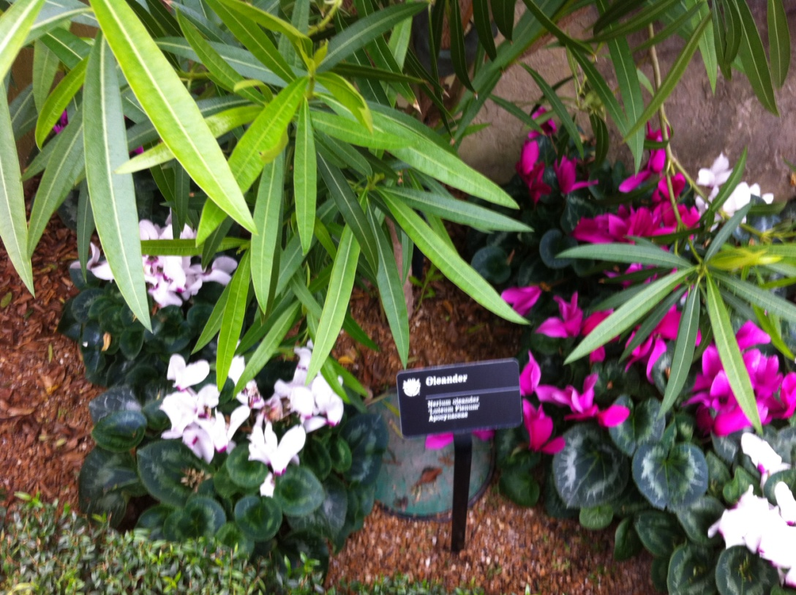

Oleander
Nerium oleander
‘Luteum Plenum’
Apocynaceae
Nerium oleander is an evergreen shrub or small tree in the dogbane family Apocynaceae, toxic in all its parts. It is the only species currently classified in the genus Nerium. It is most commonly known as oleander, from its superficial resemblance to the unrelated olive Olea. It is so widely cultivated that no precise region of origin has been identified, though southwest Asia has been suggested. The ancient city of Volubilis in Morocco took its name from the old Latin name for the flower. Oleander is one of the most poisonous of commonly grown garden plants. Some invertebrates are known to be unaffected by oleander toxins, and feed on the plants. Caterpillars of the Oleander or Polka-Dot Wasp Moth (Syntomeida epilais) feed specifically on oleanders and survive by eating only the pulp surrounding the leaf-veins, avoiding the fibers. Larvae of the Common Crow Butterfly (Euploea core) also feed on oleanders. The Common Crow larvae retain or modify toxins, making them unpalatable to would-be predators such as birds, but not to other invertebrates such as spiders and wasps.
P
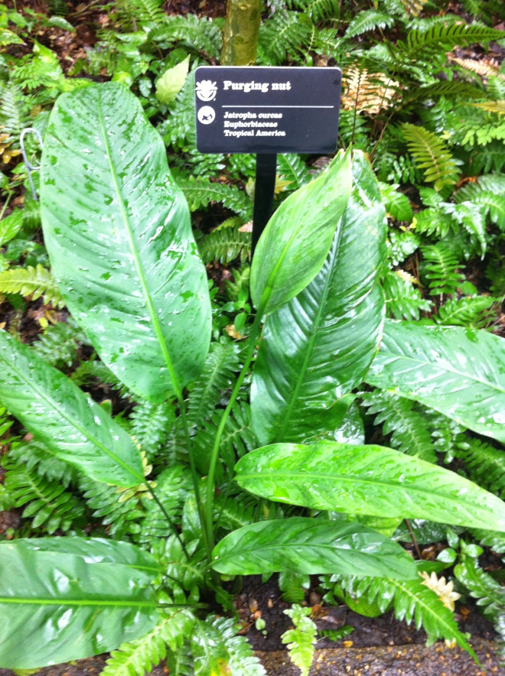

Purging Nut
Jatropha curcas
Euphorbiaceae
Tropical America

Jatropha curcas is a species of flowering plant that is native to the American tropics, most likely Mexico and Central America. Common names include Barbados Nut, Purging Nut, Physic Nut, or JCL (abbreviation of Jatropha curcas Linnaeus). It is a poisonous, semi-evergreen shrub or small tree, reaching a height of 6 m (20 ft). It is resistant to a high degree of aridity, allowing it to be grown in deserts. The seeds contain 27-40% oil that can be processed to produce a high-quality biodiesel fuel, usable in a standard diesel engine. The seeds are also a source of the highly poisonous toxalbumin curcin.
Q

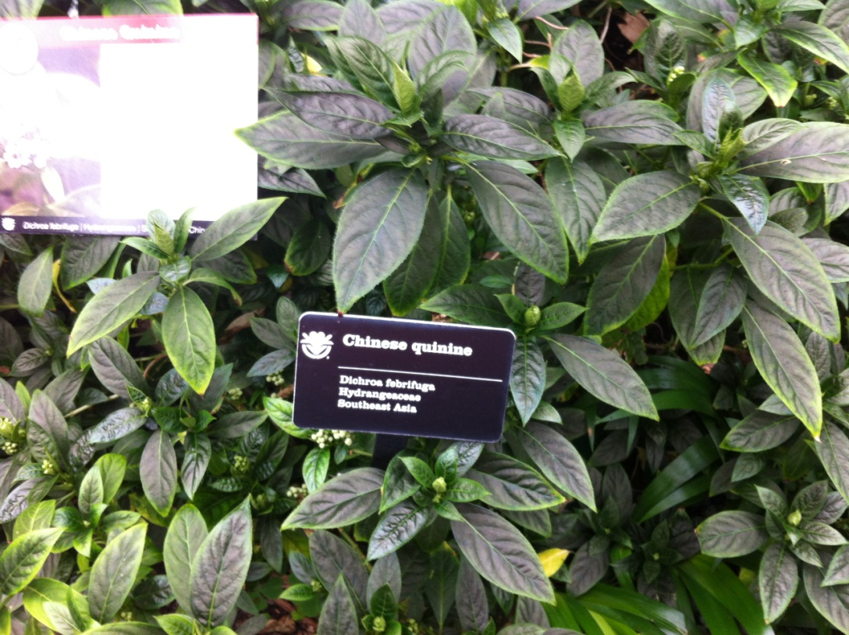

Chinese quinine
Dichroa febrifuga
Hydrangeaceae
Southeast Asia
Dichroa febrifuga (Chinese: 常山) is a flowering plant in the family Hydrangeaceae. Hydrangeaceae have a wide distribution in Asia and North America, and locally in southeastern Europe. Chinese quinine is an important herb in traditional Chinese medicine where it is considered one of the 50 fundamental herbs. In traditional preparations it is used in conjunction with other plants such as Glycyrrhiza glabra (licorice), Ziziphus jujube and Zingiber officinale (ginger).

R
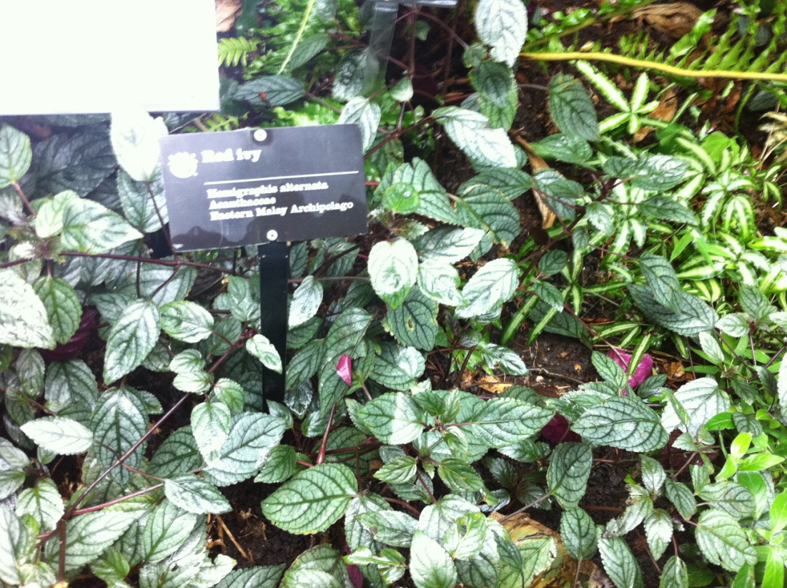

Red Ivy
Hemigraphis alternata
Acantheceae
Eastern Malay Archipelago
Hemigraphis is a genus of plants in the family Acanthaceae, consisting of about 30 species native to tropical Asia. The family Acanthaceae (or Acanthus family) is a taxon of dicotyledonous flowering plants containing almost 250 genera and about 2500 species. Most are tropical herbs, shrubs, or twining vines; some are epiphytes (plants that grow on other plants). Only a few species are distributed in temperate regions. The four main centers of distribution are Indonesia and Malaysia, Africa, Brazil and Central America. They can be found in nearly every habitat, including dense or open forests, in scrublands, on wet fields and valleys, at the sea coast and in marine areas, and in swamps and as an element of mangrove woods.

S
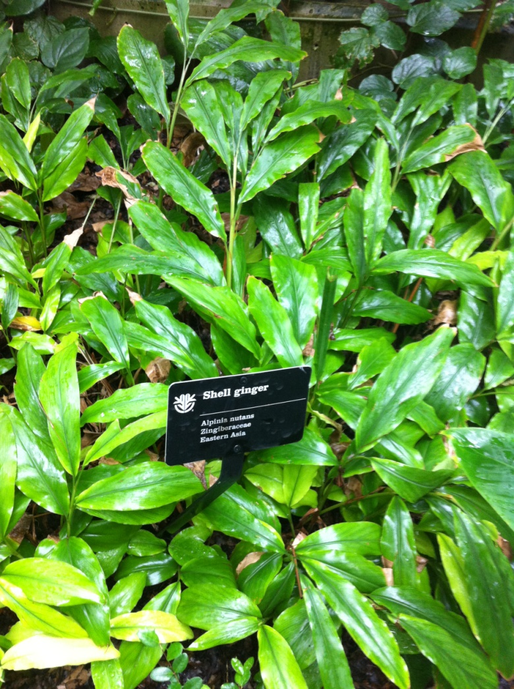

Shell ginger
Alpinea nutans
Zingiberaceae
Eastern Asia

Native to eastern Asia, this plant is a green tropical perennial that grows in upright clumps 8-10 feet tall in tropical climates. It bears funnel-formed flowers and fruit. It is called shell ginger or shell flower most commonly because its individual pink flowers, especially when in bud, resemble sea shells. It is best grown in rick medium-wet, to wet well drained soils in full sun to part shade. Afternoon shade in hot summer climates is recommended. Indoors, the plant must have bright light and humid conditions. The plant’s long leaf blades are used for wrapping zongzi (Chinese rice dumplings), sold as herbal tea, and also used to flavor noodles and wrap mochi rice cakes in Japan.
T
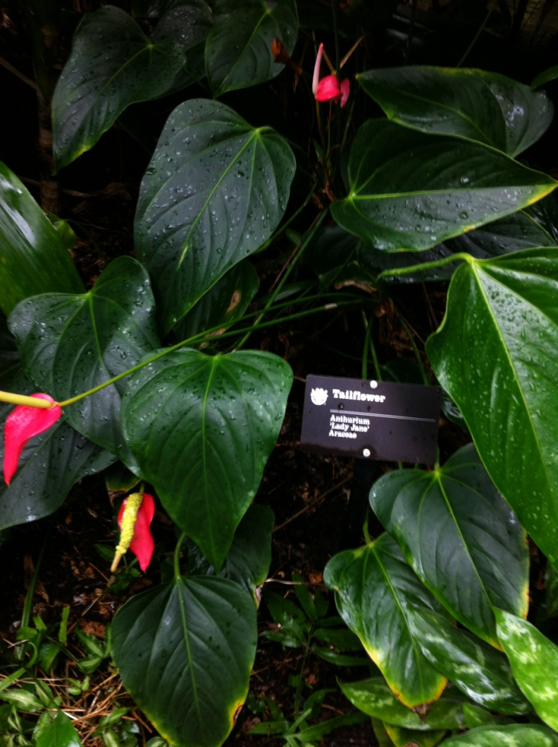

Tailflower
Anthurium
‘Lady Jane’
Araceae
Anthurium is a large genus of about 600–800 (possibly 1,000) species of flowering plants, belonging to the arum family (Araceae). The Anthurium was discovered in 1876 in Colombia. New species are being found every year. The species has neotropical distribution; mostly in wet tropical mountain forest of Central and South America, but some in semi-arid environments. Most species occur in Panama, Colombia, Brazil, the Guiana Shield and Ecuador. According to the work of noted aroid botanist Dr. Tom Croat of the Missouri Botanical Garden, no members of this genus are indigenous to Asia. Deliberately or accidentally, however, some species have been introduced into Asian rain forests, and have become established there as aliens.
U
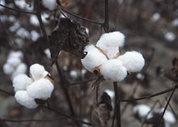

Upland Cotton
Gossypium hirsutum
Malvacaeae
Central America

Gossypium hirsutum, known as upland cotton or Mexican cotton, is the most widely planted species of cotton in the United States, constituting some 95% of all cotton production; it is native to Central America and possibly Mexico. Worldwide, the figure is about 90% of all cotton production is of cultivars derived from this species.
Archeological evidence from the Tehuacan Valley in Mexico shows the cultivation of this species as long ago as 5,800 BCE. This is the earliest evidence of cotton cultivation in the Americas found thus far. Gossypium hirsutum includes a number of varieties or cross-bred cultivars with varying fiber lengths and tolerances to a number of growing conditions. The longer length varieties are called "long staple upland" and the shorter length varieties are referred to as "short staple upland". The long staple varieties are the most widely cultivated in commercial production.

V
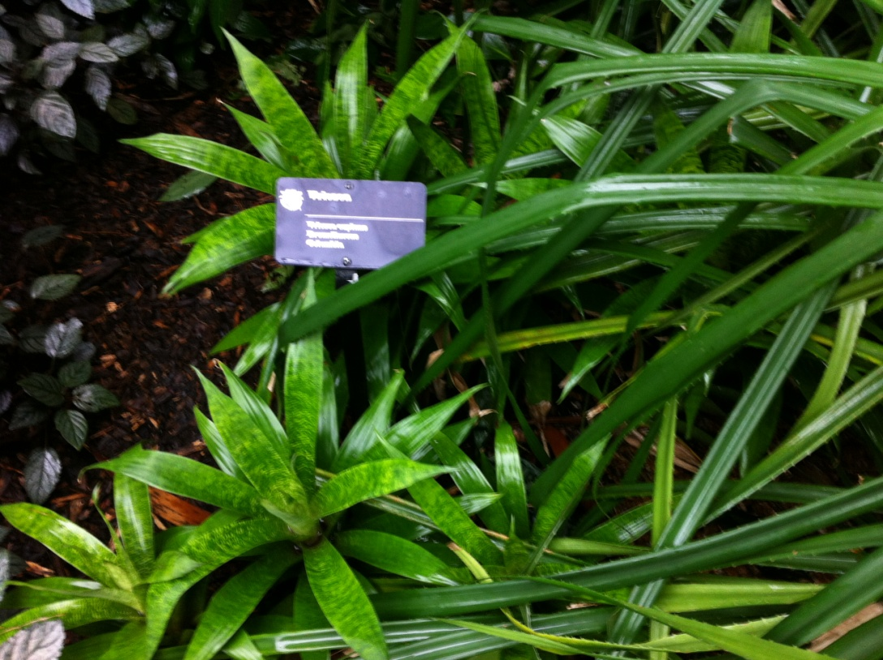

Vriesea
Vriesea Ospinae
Bromeliaceae

Vriesea is a genus of the botanical family Bromeliaceae. Containing some of the larges bromeliad species, these tropical plants harbor a wide variety of insesct fauna. In the wild, frogs may go through their whole life cycle in a bromeliad. This genus is closely related to Guzmania. Both Guzmania and Vriesea have dry capsules that split open to release parachute like seeds similar to the Dandelion. Most Vriesea are epiphytes and grow soil-less on trees. They have no roots but have special hold fasts that do not take in any nutrients. All nutrients are taken in through the center “tank” made by a rosette of leaves.

W
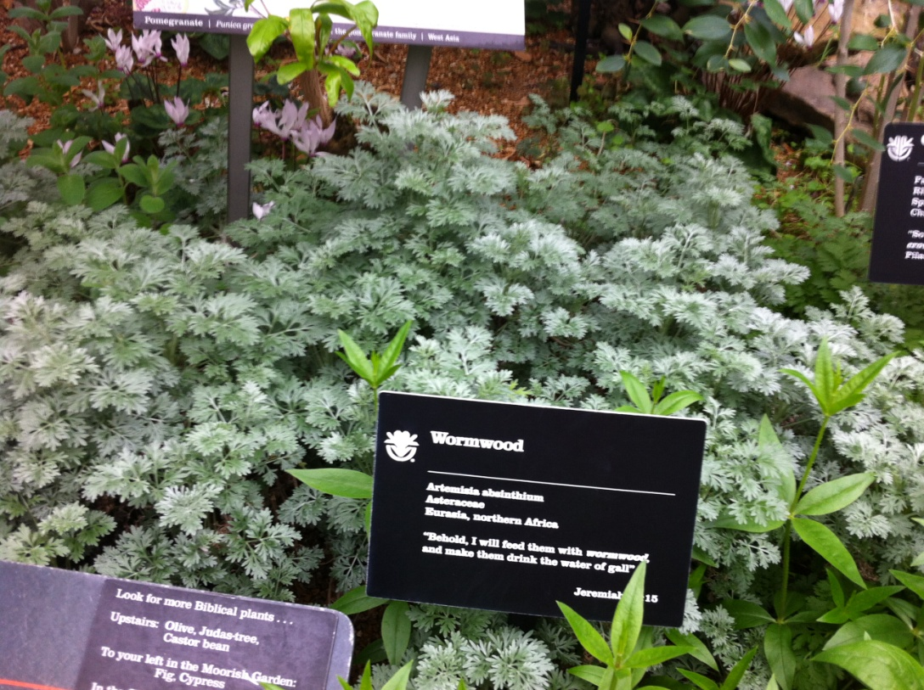

Wormwood
Artimesia absinthium
Asteraceae
Eurasia, northern Africa
Artemisia absinthium (absinthium, absinthe wormwood, wormwood, common wormwood, green ginger or grand wormwood) is a species of Artemisia, native to temperate regions of Eurasia and northern Africa. It is an herbaceous, perennial plant with fibrous roots. The stems are straight, growing to 2 feet 7 inches, tall, grooved, branched, and silvery-green. The leaves are spirally arranged. Its flowers are pale yellow, tubular, and clustered in spherical bent-down heads (capitula), which are in turn clustered in leafy and branched panicles. Flowering is from early summer to early autumn; seed dispersal is by gravity. It grows naturally on uncultivated, arid ground, on rocky slopes, and at the edge of footpaths and fields. The plant's characteristic odor can make it useful for making a plant spray against pests. It is used in companion planting to suppress weeds, because its roots secrete substances that inhibit the growth of surrounding plants. It can repel insect larvae when planted on the edge of the cultivated area. It has also been used to repel fleas and moths indoors.

X
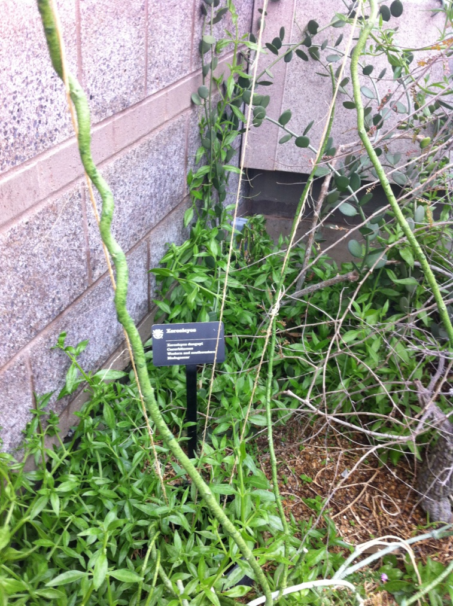

Xerosicyos
Xerosicyos danguyi
Cucurbitaceae
Western and southwestern
Madagascar
Xerosicyos is a flowering plant genus of the family Cucurbitaceae. Its name comes from Greek xeros (meaning "dry") and sicyos ("cucumber"). There are three species, all endemic to Madagascar. Xerosicyos danguyi is a large liana with thick stems and round, gray succlent leaves. It is common in cultivation and often called the "Silver Dollar" vine. Xerosicyos perrieri is also a liana with thinner stems and smaller, ovate green succulent leaves. Xerosicyos pubescens is entirely different from the previous species. It forms a large caudex from which deciduous vines emerge. The leaves are lobed and semi-succulent and die back in the dry season and during prolonged periods of drought.
Y
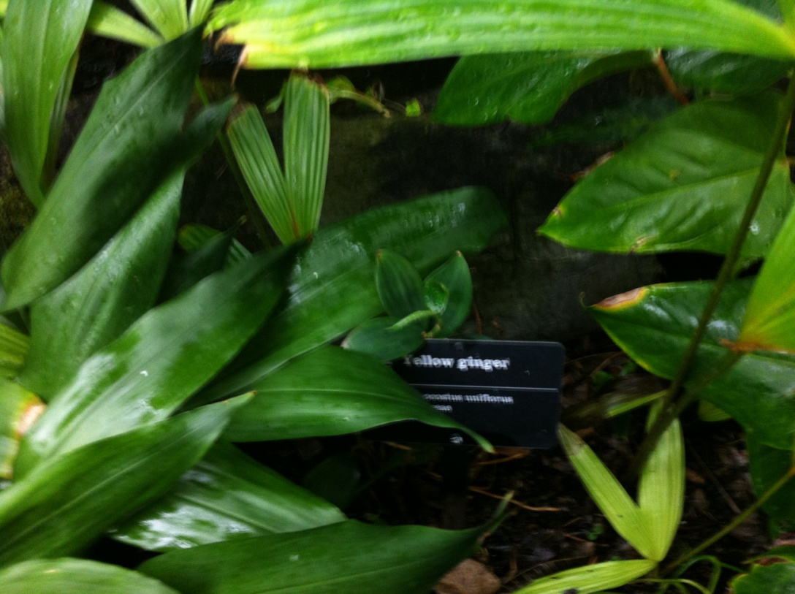

Yellow ginger
Zingiberaceae
Hedychium flavescens is a perennial flowering plant from the Zingiberaceae family (the ginger family). Also known as Yellow ginger, it grows up to 2.5 meters high. It is extremely shade tolerant, and thrives in a wide range of soils. Since it has the ability to regrow from even a small fragment of the rhizome, which survive crushing, immersion in sea water, and even years outside of soil, elimination can be a problem. It is treated as an invasive weed in New Zealand, because of its ability to take over from other species. Ginger or ginger root is the rhizome (a modified subterranean stem of a plant that is usually found underground) of the plant Zingiber officinale, consumed as a delicacy, medicine, or spice. It lends its name to its genus and family (Zingiberaceae). Other notable members of this plant family are turmeric, cardamom, and galangal. Ginger cultivation began in South Asia and has since spread to East Africa and the Caribbean. In Western cuisine, ginger is traditionally used mainly in sweet foods such as ginger ale, gingerbread, ginger snaps, parkin, ginger biscuits and speculaas. A ginger-flavored liqueur called Canton is produced in Jarnac, France. Green ginger wine is a ginger-flavored wine produced in the United Kingdom, traditionally sold in a green glass bottle. Ginger is also used as a spice added to hot coffee and tea.
Z
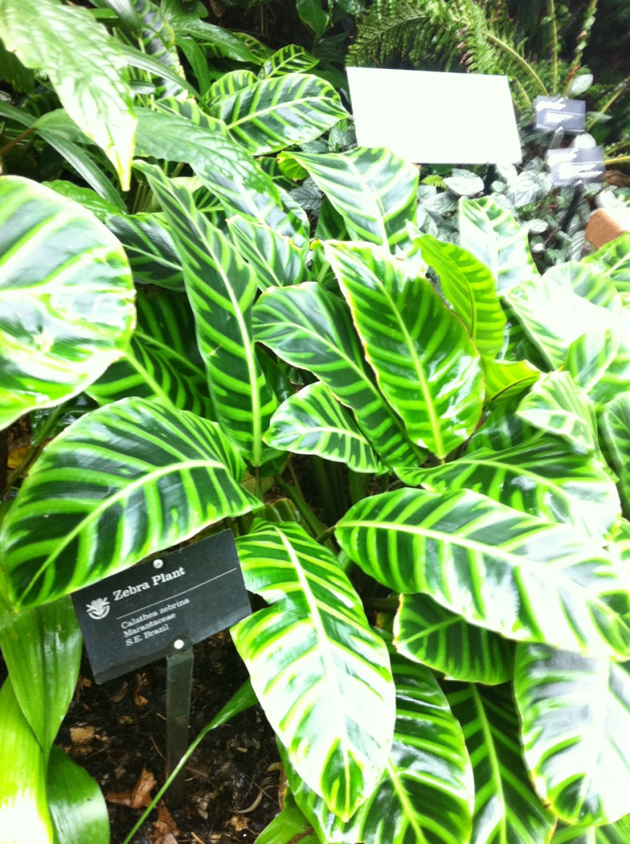

Zebra Plant
Calathea zebrina
Marantaceae
S.E. Brazil
Calathea zebrina (zebra plant) is a species of plant in the family Marantaceae, native to southeastern Brazil. It is an evergreen perennial growing to 1 m (3 ft 3 in) tall. The long stalks, up to 30 cm (12 in) in length, carry elliptical leaves that are 45 cm (18 in) or more long. The leaves are dark green above, dark red below, the spines, veins and margins etched in lime green. It is tender, with a minimum temperature of 16 °C (61 °F) required, and in temperate areas is cultivated indoors as a houseplant.

