DNA & Central Dogma Webquest
http://learn.genetics.utah.edu/
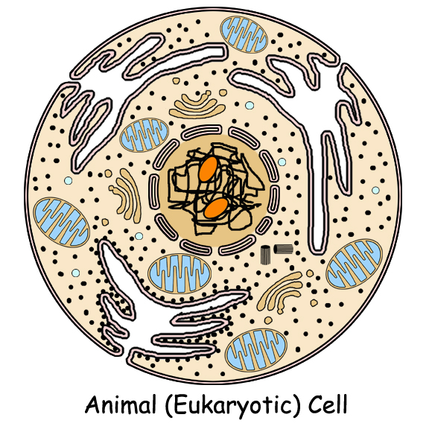
Part 1. Click Tour of Basic Genetics. What is DNA?
- Where is DNA in a eukaryotic cell?
- What does DNA tell a cell?
- What is the code of DNA?
- What are the pairing rules?
- How do the letters in DNA give the cell instructions?
6. DNA is made of building blocks of nucleotides. Draw and label a nucleotide.

7. Draw a portion of DNA below. Label the bases.

Part 2. Go to top of page and click molecules of inheritance. Click Build a Molecule of DNA. Start building by using the base pair rules.
1. Which pair has three hydrogen bonds? __________ Two hydrogen bonds?_________
How long does it say it will take you to transcribe the DNA in one human cell?
2. Your body produces how many cells everyday? ________________Do you need to copy DNA to copy your cells?___________________
3. How quickly does your body copy the strands of DNA? ________________
- What is the central dogma? Please draw & label.
- What is the special term used for the copying of DNA?

Click on the DNA Replication Basic detail link
- Name one enzyme used in replication:

Part 3. Go to top of page and click Molecules of Inheritance. Click What is a Gene?
- What is a gene?
- What protein is used to carry oxygen gas around our bodies?
- Do all of our 23,000+ genes carry information for producing hemoglobin?
- What is a mutation?
- If one of the genes for hemoglobin is mutated, what disease may occur?
Part 4. Go to top of page and click Molecules Of Inheritance. Scroll down and Click on RNA: The Versatile Molecule.
- State two similarities between DNA and RNA.

- State two differences between DNA and RNA.

Part 5. Go to top of page and click Molecules Of Inheritance. Scroll down and Click on RNA’s Role in the Central Dogma.
- DNA includes information for making which kinds of RNA?
- Where is RNA made in a eukaryotic cell?
- A strand of DNA coded: AATTGGACTACCTAGC would code for what RNA sequence?
- How are mRNA unique? They code the instructions for making what?
- Groups of three RNA nucleotides (codons) code for specific ___________________.
- What is rRNA?____________________________ What are ribosomes made of?
- How do rRNA, tRNA, and mRNA work together to form a protein?
- How many amino acids are there? How many tRNAs?

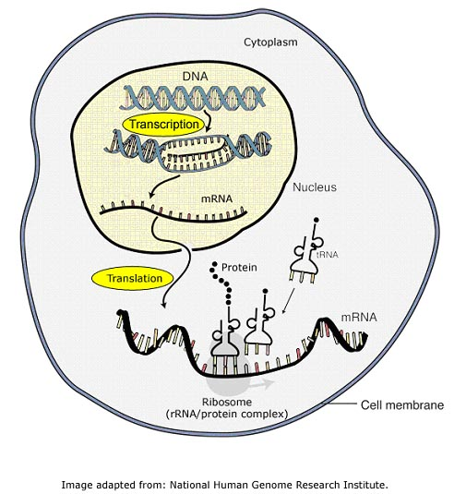
Part 6. Go to top of page and click Molecules of inheritance. Click on Transcribe & Translate a Gene.

- Write the corresponding mRNA strand for this DNA strand:
  - TACGGGATAAGGCCACCTCTGGTAGACCACATT

- Using the Universal Genetic Code Table, write the corresponding codons for the mRNA you deciphered.

Part 7. Go to top of page and click Molecules Of Inheritance. Click on What Makes A Firefly Glow?
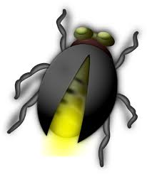

- State two enzymes and their role in light production in a firefly’s tail.
- Enzyme 1/role:
- Enzyme 2/role:
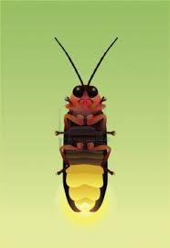
- What gene is involved?
- What binds to the molecule luciferin?
- If something speeds up a reaction, lowering the energy required for
the reaction to occur, this molecule would be considered a ______________.
- Oxygen combines with _________________ to form ______________________.
- This reaction releases_________. Evolution of these molecules in
fireflies allows them to do what?

Part 8. Go to the University of Arizona Biology Project website:
http://www.biology.arizona.edu/
Click on the link: Chemistry Of Amino Acids.
- How many amino acids can a human produce?

- Where do we get the other amino acids from?

- What happens if your body does NOT get the essential amino acids?

- State two differences between the amino acids valine and glutamic acid?

Part 9. Monster Manual Translation: You will use the monster code to build your own monster! As you decode the color dots, you will add parts/traits to your monster.
http://askabiologist.asu.edu/monster-manual

- Click the build a monster button.
- Convert the colored dots to the traits of your monster.
- Print your monster with its genome and name. Feel free to color, if you are so moved!
- Why did I call this Translation? Hint: How do RNA base codes get converted into amino acid codes of proteins?

