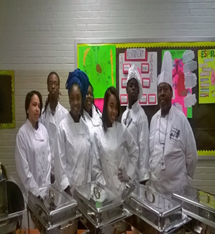

Culinary Arts

During this two-year program, students will receive professional chef’s training preparing them for the real world of work. Opportunities include restaurant, resort, dietary and other food service industries. Safety and sanitation, food prep and stylish cooking techniques will be a part of this program/pathway.

Entrance Requirements

11th and 12th grade students with 2.5 GPA, 90% daily attendance rate. Flash drive, journaling notebook $15.00 Skills USA yearly membership dues (NON-REFUNDABLE)

Class requirements

Hepatitis A, TB test, black pants, chef shoes (non- skid)

Pathway Courses

* Culinary Arts 1
* Culinary Arts 2
* Career Development
* Hospitality/Food Beverage Management

**Certifications / Credentials**

* Workforce Readiness Certification
* Servsafe Certification
* NOCTI Culinary Arts Certification

**Post-Secondary Credit**

Articulation Agreements St. Louis Community College – Forest Park

Sullivan University

**Employment Opportunities**

* Executive Chef
* Restaurant Owner
* Dietary Manager
* Pastry Chef

**Student Organization(s)**

* Skills USA
* NAMC

**Off-Campus Programs**

* Internships – Yes
* Externships – Yes
* Job Shadowing – Yes

Phone: 314-533-2410 | Fax: 314-224-1712