Pathway Courses

* Introduction to Construction Trades

**Certifications / Credentials**

* OSHA 10/30 hr.
* CPR/First Aid

**Post-Secondary Credit**

* Dual enrollment
* Ranken Technical College

**Employment Opportunities**

* Journeymen
* Apprenticeship
* Laborer

**Student Organization(s)**

* SLATE

**Off-Campus Programs**

* Internships – Y
* Job Shadowing – Y

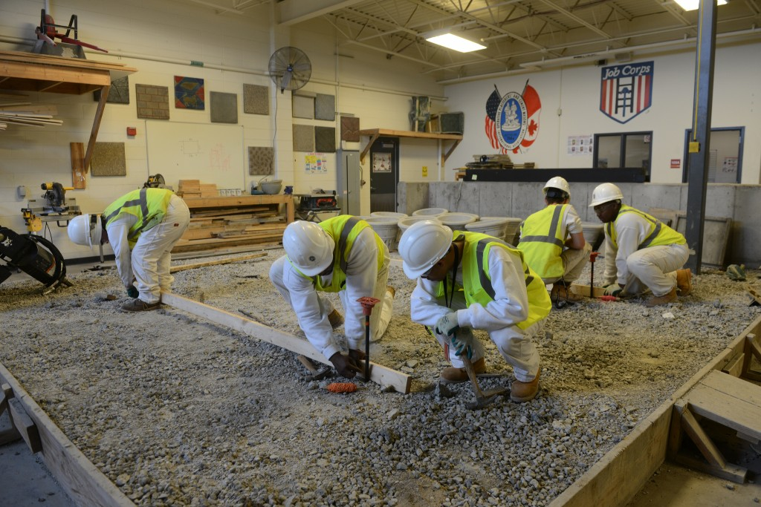

Introduction to Construction Trades/Practice & Skill Development

This course introduces students to core construction trade competencies for varying general labor/skill employment within the construction field. The course includes instruction in basic blueprint reading and application; communication and interpersonal skills; safety & OSHA requirements; computer technology and construction mathematic calculation.

Entrance Requirements

* GPA Recommendations: 2.0 or greater core subject area
* Completion of 2 pg. essay on: “Why Do You Want to Pursue a Career in the Construction field”?

Juniors

* Composition/Grammar/ American History
* Algebra
* ACT/SAT Prep

**Seniors**

* English /Government
* College Summit
* Geometry/College Algebra

Class requirements

Students can bring $50 to cover equipment/uniform requirements or provide the following on their own: steel toed safety work boots, carpenter’s pants (not cargo pants), long sleeved, collared, button up work shirt, & a hard hat.

Phone: 314-231-3720 | Fax: 314-345-4540