Beaumont High School in now Beaumont Technical Center

The History of Beaumont High School

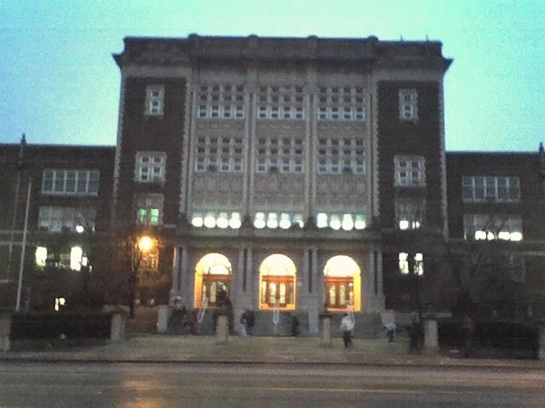

Designed by R.M. Milligan, the school was built at a cost of more than $1.5 million and opened in January 1926 with a capacity of 3,500 students. The school was named for the early St. Louis surgeon, William Beaumont, after a petition from the St. Louis Medical Society in December 1922.