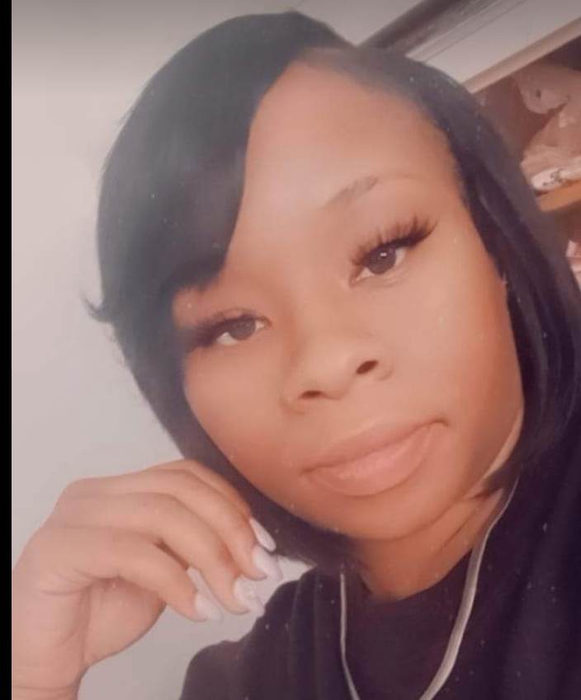 |  |  | Marjorie Quinn  Family and community specialist  What are Family/ Community Specialist?  Family and Community Specialist (FCS) are liaisons for families and schools. We help bridge the gap between home and school while developing community partners for our scholars and families. FCS also collaborates with school staff for home visits and other support services needed. We assist with family engagement activities, parent/guardian and student concerns, and help ensure our schools have a welcoming environment. FCS encourages daily attendance for scholars to achieve academic success. Our ultimate vision is full intellectual potential to give our scholars opportunities. I believe in leveraging the identities of our families and seeing them from their strengths and needs, valuing, honoring, and integrating home/ school partnerships in achieving our educational outcomes.  Yeatman 2023-2024 fcs  My name is Ms. Quinn. I just wanted to introduce myself and inform the students, staff & families that I will be your “Family & Community Specialist” here at Yeatman Middle School. I am Excited to be a part of the team, ready to assist & help our scholars to have an awesome, fun & successful 2023-2024 school year, with the involvement of the families, SLPS staff and the community. I have an open-door policy, so feel free to stop by my office or use my contact info to reach me, so I can assist you in whatever situation or need you may have. I would like for you to think of me as your “Bridge” that’s going to connect you to the resource or opportunity you need to be successful & complete your goals. Some fun fact about me is, I too went to a SLPS (Walbridge Elem.), my favorite color is purple, I have a pet rabbit, I love kids, I have children of my own, & I like to make learning FUN… I’m looking forward to working with EVERYONE.
 | 4265 Athlone Ave  Saint Louis, MO 63115
 | (314) 261-8132 ext.45624
 | Marjorie.Quinn@slps.org
 | www.slps.org/yeatman


