**Food and Nutrition Services Department**

**provides Sack Lunches for field trips!**

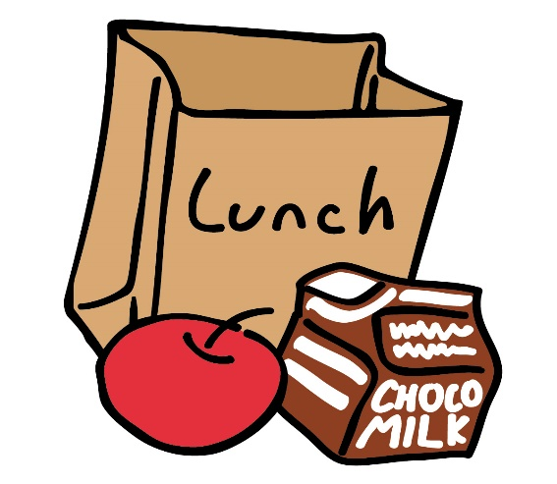



***Please* inform the cafeteria leads *two (2) weeks in advance* when these lunches will be needed**

**Menu:**

Turkey and Cheese Sandwich **Or**

Veggie Ranch Wrap

Apple

Carrot sticks

Fat Free Chocolate milk

Whole Grain Pretzels