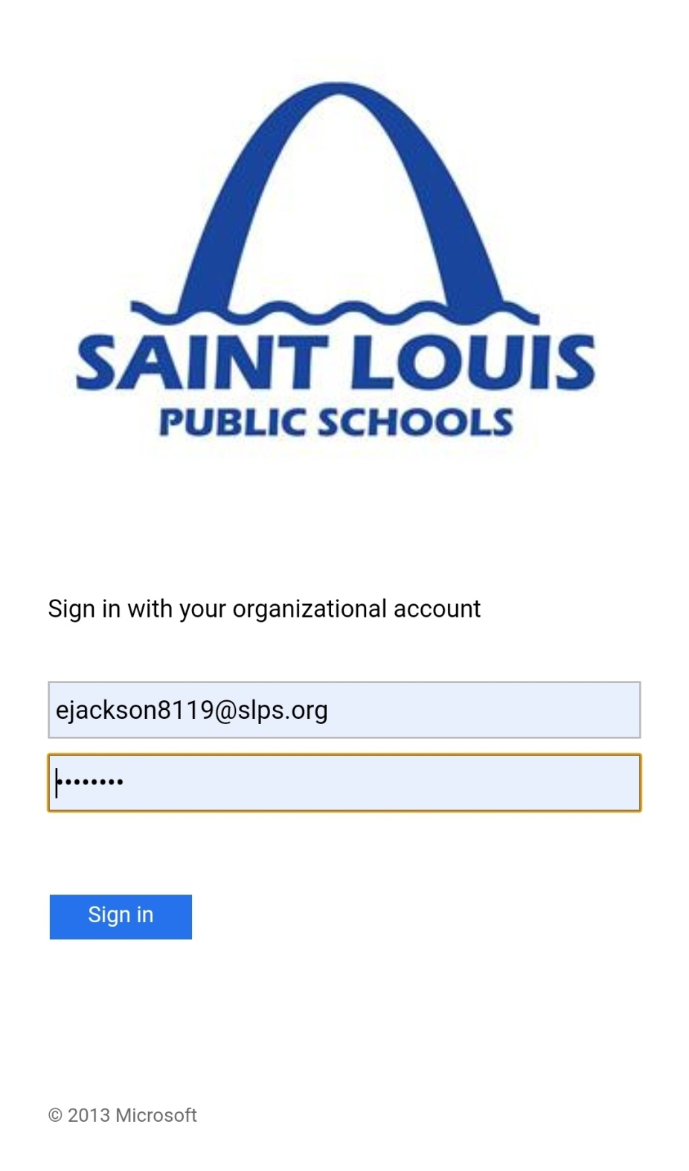

**Your email address is NOT your login**

**How To Log in to Microsoft Office Email and Teams accounts**

1. Go to: <https://www.office.com/?ref=login>
2. Click- Sign in
3. Type in your- **GatewayUsername**@slps.org
4. Type in your- Gateway Password

**To check *EMAIL*– Click on Outlook**

**To get *ASSIGNMENTS*- Click on Teams**

**Office & Teams are also both downloadable.**

**FREE APPS**