**Buder Elementary**

**School**

5319 Lansdowne

St. Louis, MO 63019

**PBIS Handbook**



**School Wide**

**Positive Behavior**

**Intervention Support**

**Be Safe**

**Be Respectful**

**Be Responsible**

**Be a Buddy**

Table of Contents

**School Mission, Values, and Pledge**

**Letter to Staff**

* + ABC's of Behavior
  + Seven phases of the “Act-Out Cycle"
  + What is PBIS?

**Scenarios**

**Guidelines for Kickboard Points**

**Guidelines to School Wide Behavior Management System (Kickboard)**

**Matrix**

**Student/Teacher of the Month**

**PBIS Lesson Plans**

**Classroom Consequence Menu**

**Guided Hand**

**Major and Minor Behaviors**

**Behavior Flow Chart**

**OUR MISSION**

One Team:

Inspiring each other every day

to grow in every way

**OUR VISION**

Students will achieve their

personal best with the support of

school, family, and community.

**BUDER SCHOOL**

**PLEDGE**

I believe in being a good student in my school and in my community. I pledge to attend school every day, to respect the rights of others, my parents, my teachers, and my fellow students.

I will do my best at all times. To these ends, I pledge to devote myself, so Buder will always be #1!

August 2017

Dear Buder Staff,

A positive school climate and behaviors are priorities at Buder Elementary School and in all St. Louis Public Schools. This handbook details our schoolwide climate and discipline plans.

**The ABC's of Behavior**

A. **Antecedents:** Conditions or circumstances that precede a behavior that increase the probability of a behavior occurring

B. **Behavior:** An observable and measurable act that follows an antecedent

C. **Consequence:** An environmental change that follows and *is contingent upon* a specific behavior (i.e., It *occurs in response* to the target behavior.)

**Seven Phases of the "Act-Out Cycle"**

1. **Calm:** Student exhibits appropriate, cooperative behavior and is responsive to staff directions

2. **Triggers:** Activities, events, or behaviors that provoke anxiety and instigate the cycle of problem behavior

3. **Agitation:** Characterized by emotional responses (e.g., anger, depression, worry)

4. **Acceleration:** Escalated behaviors; student engages in behavior that is highly likely to elicit a reaction from another person (e.g., teacher, peer, and/or staff)

5. **Peak:** Students with acting-out behavior may be a threat to themselves or others.

6. **De-escalation:** Characterized by student disengagement and reduced acting out behavior

7. **Recovery:** This is a period of regaining the equilibrium of the calm phase.

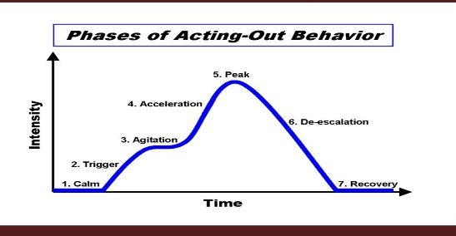

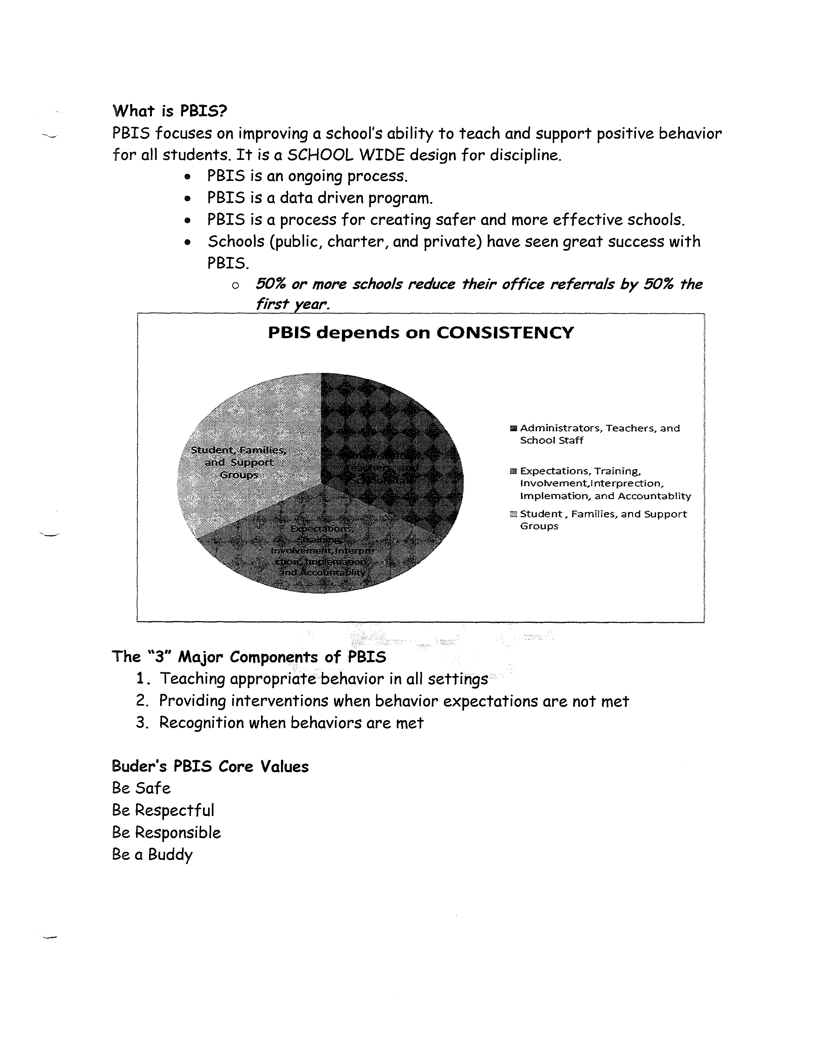

**What is PBIS?**

PBIS focuses on improving a school’s ability to teach and support positive behavior for all students. It is a SCHOOLWIDE design for discipline.

* PBIS is an ongoing process.
* PBIS is a data driven program.
* PBIS is a process for creating safe and more effective schools.
* Schools (public, charter, and private) have seen great success with PBIS.
  + *50% or more schools reduce their office referrals by 50% the first year.*

**The “3” Major Components of PBIS**

1. Teaching appropriate behavior in all settings
2. Providing interventions when behavior expectations are not met
3. Recognition when behaviors are met

**Buder PBIS Core Values**

Be Safe

Be Respectful

Be Responsible

Be a Buddy

*Thank you for your continued support!*

**Scenarios**

**#1 The Talker**

* The student is either talking under his or her breath or is talking very loudly in an attempt to insult or distract others.
* **PBIS Strategies To Try:**
  + - Quietly address the student without yelling or drawing attention to the student.
    - Quietly move the student to an alternate seat, and explain that you are doing so in order to provide them with an opportunity to refocus/settle down.
    - Be sure the students are actively engaged in work (or reading if they have finished the current task).
      * Have alternate activities available for students who finish early.
    - If these strategies don’t work, continue on to the PBIS suggestions for Level 1 or 2.

**#2 Inappropriate Language**

* The student says an inappropriate word or phrase (i.e., a curse word or suggestive/ sexual word).
  + **PBIS Strategies To Try:** 
    - Be sure to present yourself as calm and patient even if you feel angry.
    - Quietly address the student without yelling or drawing attention to the student.
    - Let them know that their choice of words is unacceptable.
    - Log the behavior, and if it qualifies as a major behavior, notify parent.
    - If at all possible, don’t let this event interrupt the flow of your lesson. Address it calmly and quickly, and come back to it later if needed.

**#3 Refuses to finish work/homework**

* The student takes an inordinately long time to finish any work, refuses to do any work, or never brings homework back to school.
  + **PBIS Strategies To Try:**
    - Recall that this is not a reflection on you as a teacher.
    - Quietly address the student without yelling or drawing attention to the student.
    - Let them know that their work must be in order for them to grow as a student, and because it’s their job to complete assignments.
    - If the student catches up by the end of the day, write a small log entry of the event/behavior (in case instances of the behavior suggest a pattern), and wipe the slate clean.
    - If it becomes a day to day struggle, escalate consequences as shown (contact the parents, have them complete the work during fun/choice times, etc.,) on the PBIS Matrix.

**Guidelines for Awarding**

times , et c on th e PBIS matrix) .

**Buder Bucks**

Buder Elementary School has partnered wit h t o trac k our Buder Bucks. This system allows students t o earn Buder Bucks fo r attendance, following th e PBIS school wide system, and othe r distric t rules and policies. Each week are allowed a weekly incentive obtaining $7 5 or more Buder Bucks. Students also have a chance t o partake in th e monthly PBIS incentive. The incentives vary t o extr a recess, movie, popcorn, t o othe r school wide activities .

**Student/Teache r of the Month**

Each month, staf f nominates one and one th e month. The and studen t goes above and beyond th e Buder expectations and follows th e school wide PBIS values. Staf f and students are allowed t o vote th e Monday o f each month. The winner receives thei r pictur e in th e school newsletter , thei r photo posted on th e PBIS Pawsitive

bulletin board, and a gif t

**Kickboard Points*/Buder Bucks***

**What?**

Kickboard Points are a positive behavior recognition program that encourages our students to ***consistently demonstrate*** Buder’s core values: Be Safe, Be Respectful, Be Responsible, and Be a Buddy.

**Who?**

All Staff (teaching, office, building service, cafeteria, bus driver, and substitute teachers) should be awarding students Kickboard Points.

**Where?**

Kickboard Points should be linked to the appropriate behavior based on the locations in the Buder Expectations Matrix.

**When?**

Kickboard Points should be given immediately to students when a behavior in the Buder Expectations Matrix is ***consistently demonstrated***.

|  |  |  |  |  |  |  |  |  |
| --- | --- | --- | --- | --- | --- | --- | --- | --- |
|  | **Playground** | **Restroom** | **Hallway/Stairs** | **Cafeteria** | **Office** | **Bus** | **Computer Labs** | **Assembly** |
| **Be Safe** | * Stay on the blacktop or playground * Be aware of activity around you * Ask an adult to get a ball out in the street or before going into the building | * Keep hands and feet to yourself * Get a teacher if help is needed * Walking feet | * Stay to the right * One hand on the railing * One step at a time * Keep your eyes ahead * Walking feet | * Keep hands and feet to yourself * Walking feet | * Keep hands and feet to yourself * Follow office staff directions | * Walk to the bus room and the bus * Sit seat to seat and back to back * Keep your hands and feet to yourself * Use quiet voice * Keep hands and feet out of aisle and window * Go directly to the bus room * Be ready to leave with materials packed away * Listen to directions * Follow the directions of the bus driver * Assist the teacher to help the younger students | * Stay seated * Report any incidents * Walking feet | * Stay in one spot * Walking feet * Sit on your bottom * Keep hands and feet to yourself * Keep eyes on speaker |
| **Be Responsible** | * Follow directions given * Wait your turn * Bring in all playground materials at the end of recess | * Return to class quickly * Flush the toilet * Wash hands; get 1 pump of soap * Dry hands | * Walk in a straight line * Walk quietly | * Remain seated * Throw trash in the trash can * Wait for your row to be called to be dismissed | * Walk quietly * Return to class quickly * Be patient | * Get on and off at correct stops * Remember all belongings * Follow the directions of the bus driver | * Put away headphones * Treat materials with care * Log off correctly * Push chairs in * Only go to assigned websites | * Follow directions * Be a good audience * Clap and cheer when appropriate |
| **Be Respectful** | * Keep hands and feet to yourself * Treat equipment with respect | * Knock on stall door * Clean up after yourself * Treat equipment with care | * Leave space between you and the person in front of you * Keep hands and feet to yourself | * Listen to the teachers | * Voice Level 2 * Say please, thank you, and excuse me | * Keep the bus clean * Listen to the bus driver and teachers in the bus room * Keep voices at 0 in the bus room. | * Follow directions * Use quiet voices * Raise your hand | * Keep eyes on speaker * Listen to the speaker |
| **Be a Buddy** | * Use kind words * Include everyone in your game * Bully free zone | * Wait your turn * If you must talk, use a Voice Level 1 * Bully free zone | * Use kind words * Smile * Bully free zone | * Use manners * Voice Level 2 * Bully free zone | * Bully Free Zone | * Use quiet voices * Bully Free Zone | * Use kind words * Bully Free Zone | * Use kind words * Keep hand and feet to yourself * Bully Free Zone |

**Buder School-wide Matrix**

**Voice Levels**

0 Silent

1 Whisper

2 Table Talk

3 Strong Speaker

4 Outside

**Staff and Student of the Month**

**Buder Student & Staff Honors**

Buder administration and the PBIS team recognize students and staff monthly who exemplify the characteristics of that month’s target PBIS Character Trait. Students of the Month are recognized at a special breakfast to which their families are invited. The Staff of the Month receives a gift card of his or her choice.

**Kickboard**

Kickboard is a student behavior management software program that tracks the success of our Amazing Buder Bulldogs. Each week, the students start with a balance of 50 Buder Bucks in their Buder bank accounts. Students may earn additional Buder Bucks from teachers and other staff members. In order for students to receive Buder Bucks, they must consistently demonstrate Buder expectations (Being safe, respectful, and responsible, and being a Buddy). Buder Bucks can be used to gain entrance into one of the many PBIS celebrations that occur throughout the week.

**PBIS recess**

Each week, the students are given the opportunity to participate in a PBIS extra recess if they’ve earned 75 Buder Bucks. Periodically, they are given an extra award for their total Buder Bucks.

|  |  |  |
| --- | --- | --- |
| TStaff ad Student of the Month  Fall/ October Haunted Buder House (PBIS Buder Booster)  Spring/ Spring Fling Spring Buder Booster  September Responsibility Michelle Gaskin- Staff Thomas Flier-Student  October Safety Anna Savio-Staff Maryam Sabab-Student  November Kindness Jennifer Cole-Staff Fatima Barlov-Student  January Cooperation Julie  Selina Alimanovic-Student  February Effort  March Perseverance  Apri l Honesty  May |  |  |
|  |  |  |
|  |  |  |
|  |  |  |
|  |  |  |

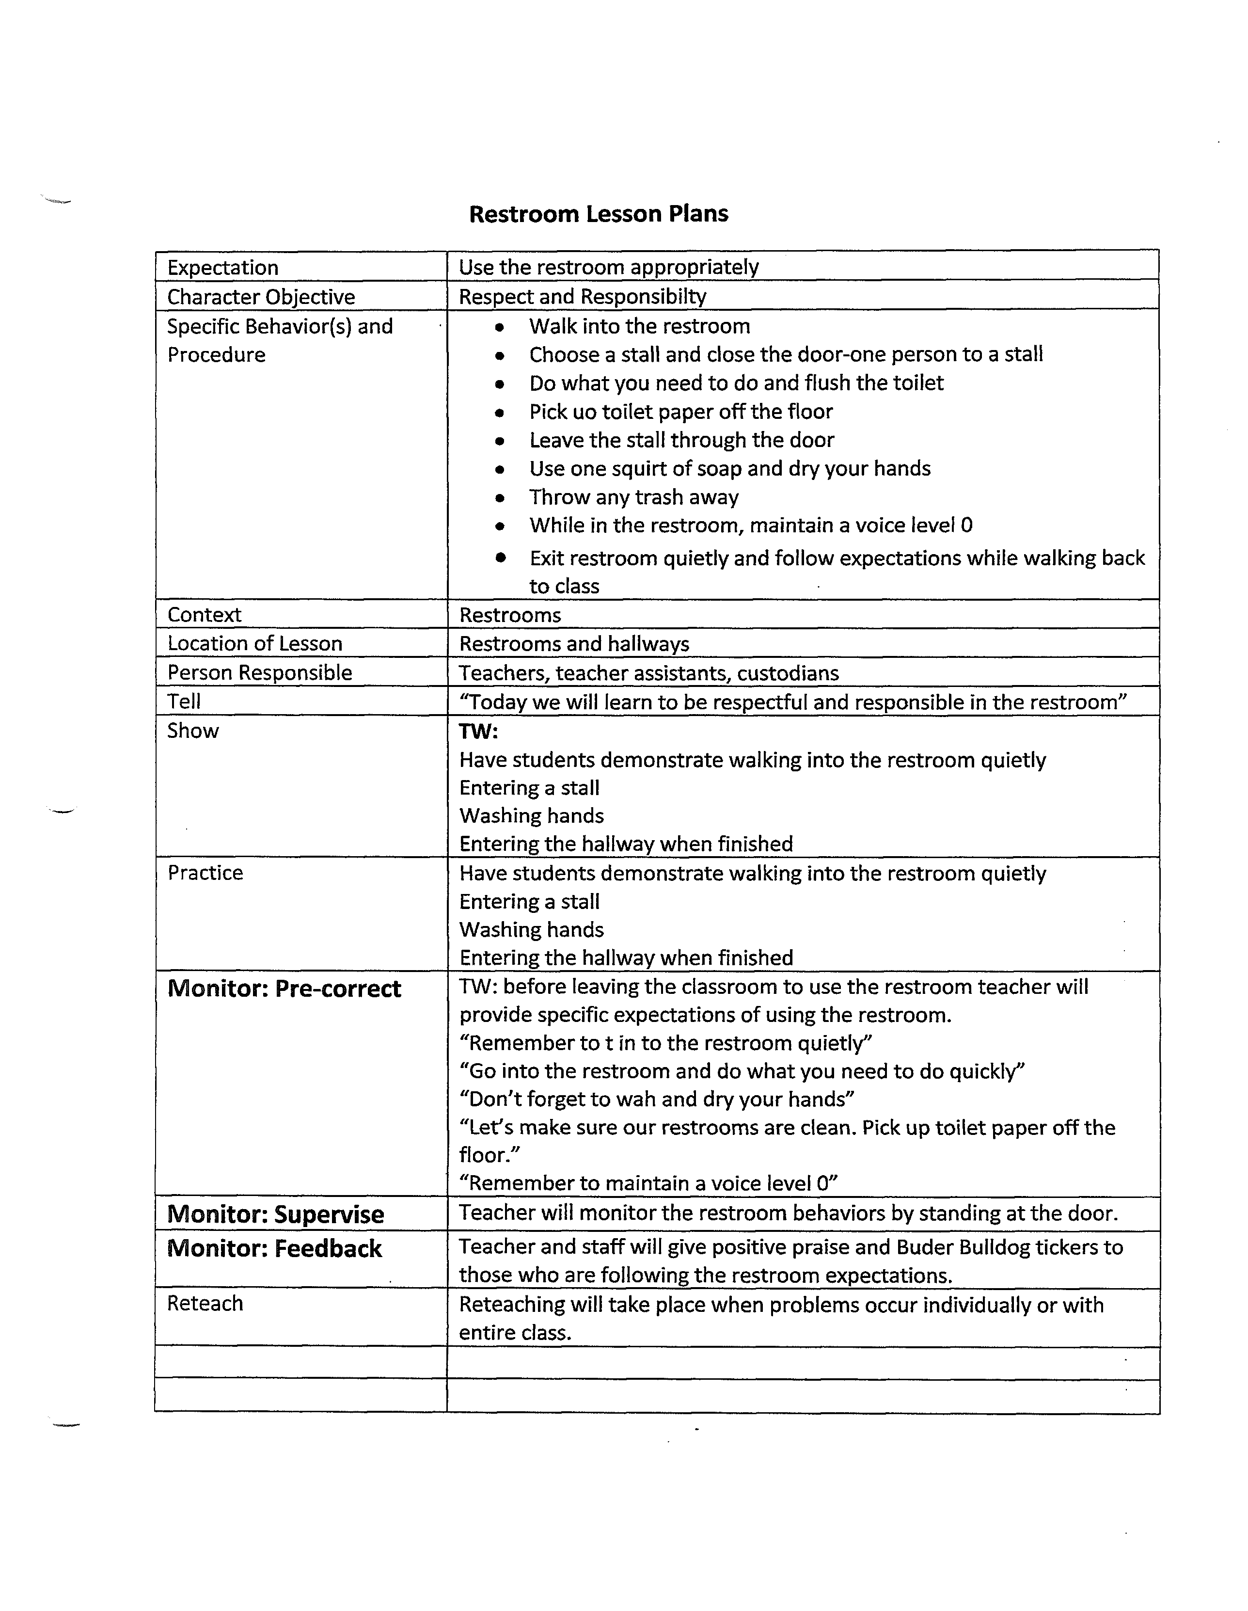

|  |  |
| --- | --- |
|  |  |
|  |  |
|  |  |
|  |  |
|  |  |
|  |  |
|  |  |
|  |  |
|  |  |
|  |  |
|  |  |
|  |  |
|  |  |

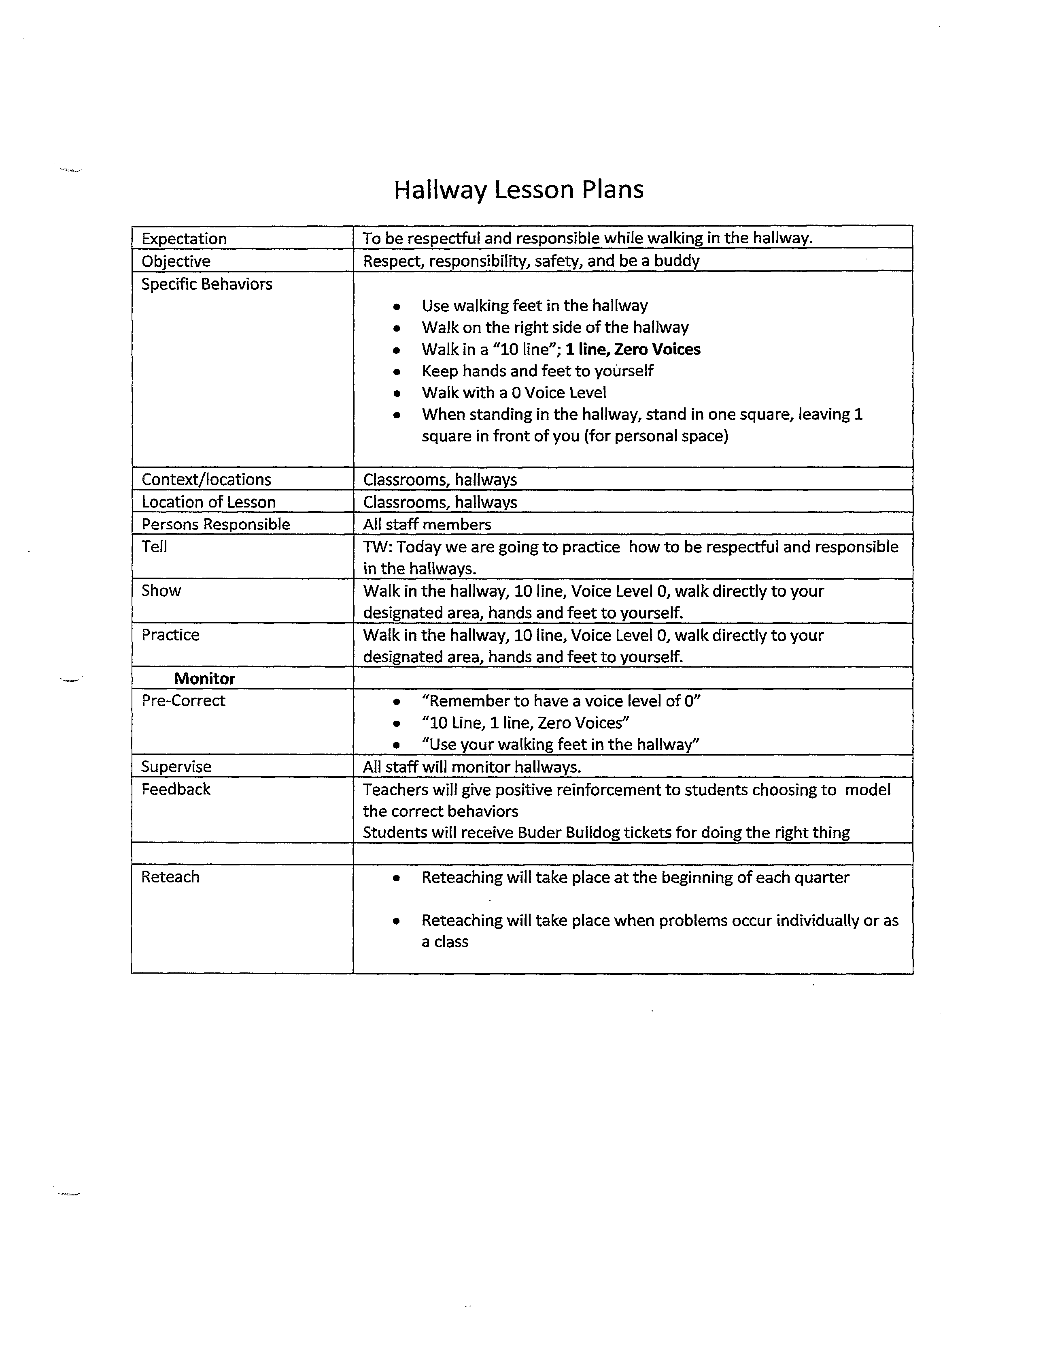

|  |  |
| --- | --- |
|  |  |
|  |  |
|  |  |
|  |  |
|  |  |
|  |  |

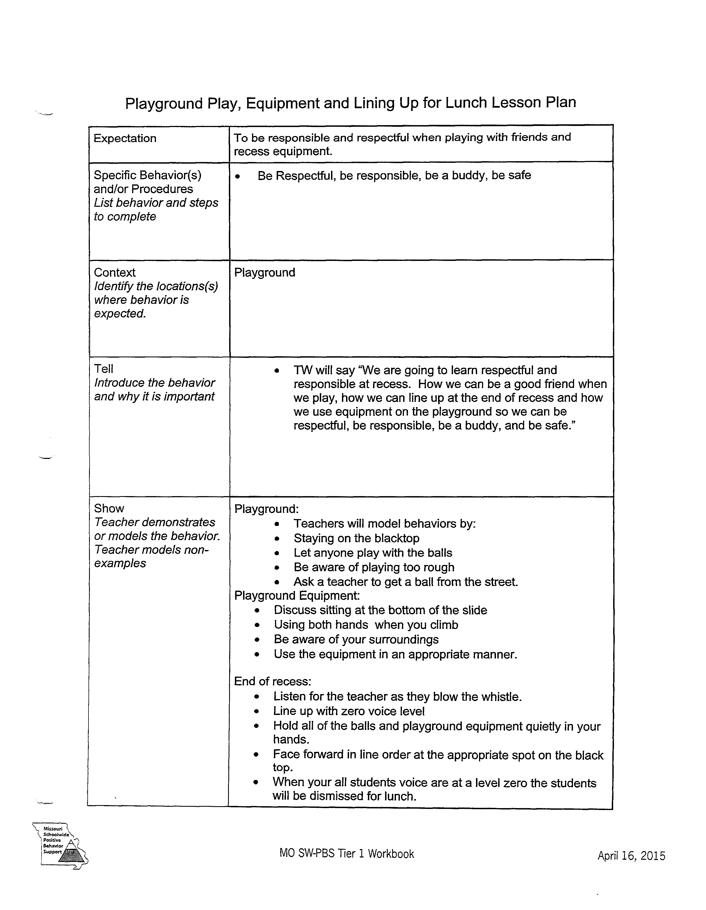

|  |  |
| --- | --- |
|  |  |
|  |  |
|  |  |
|  |

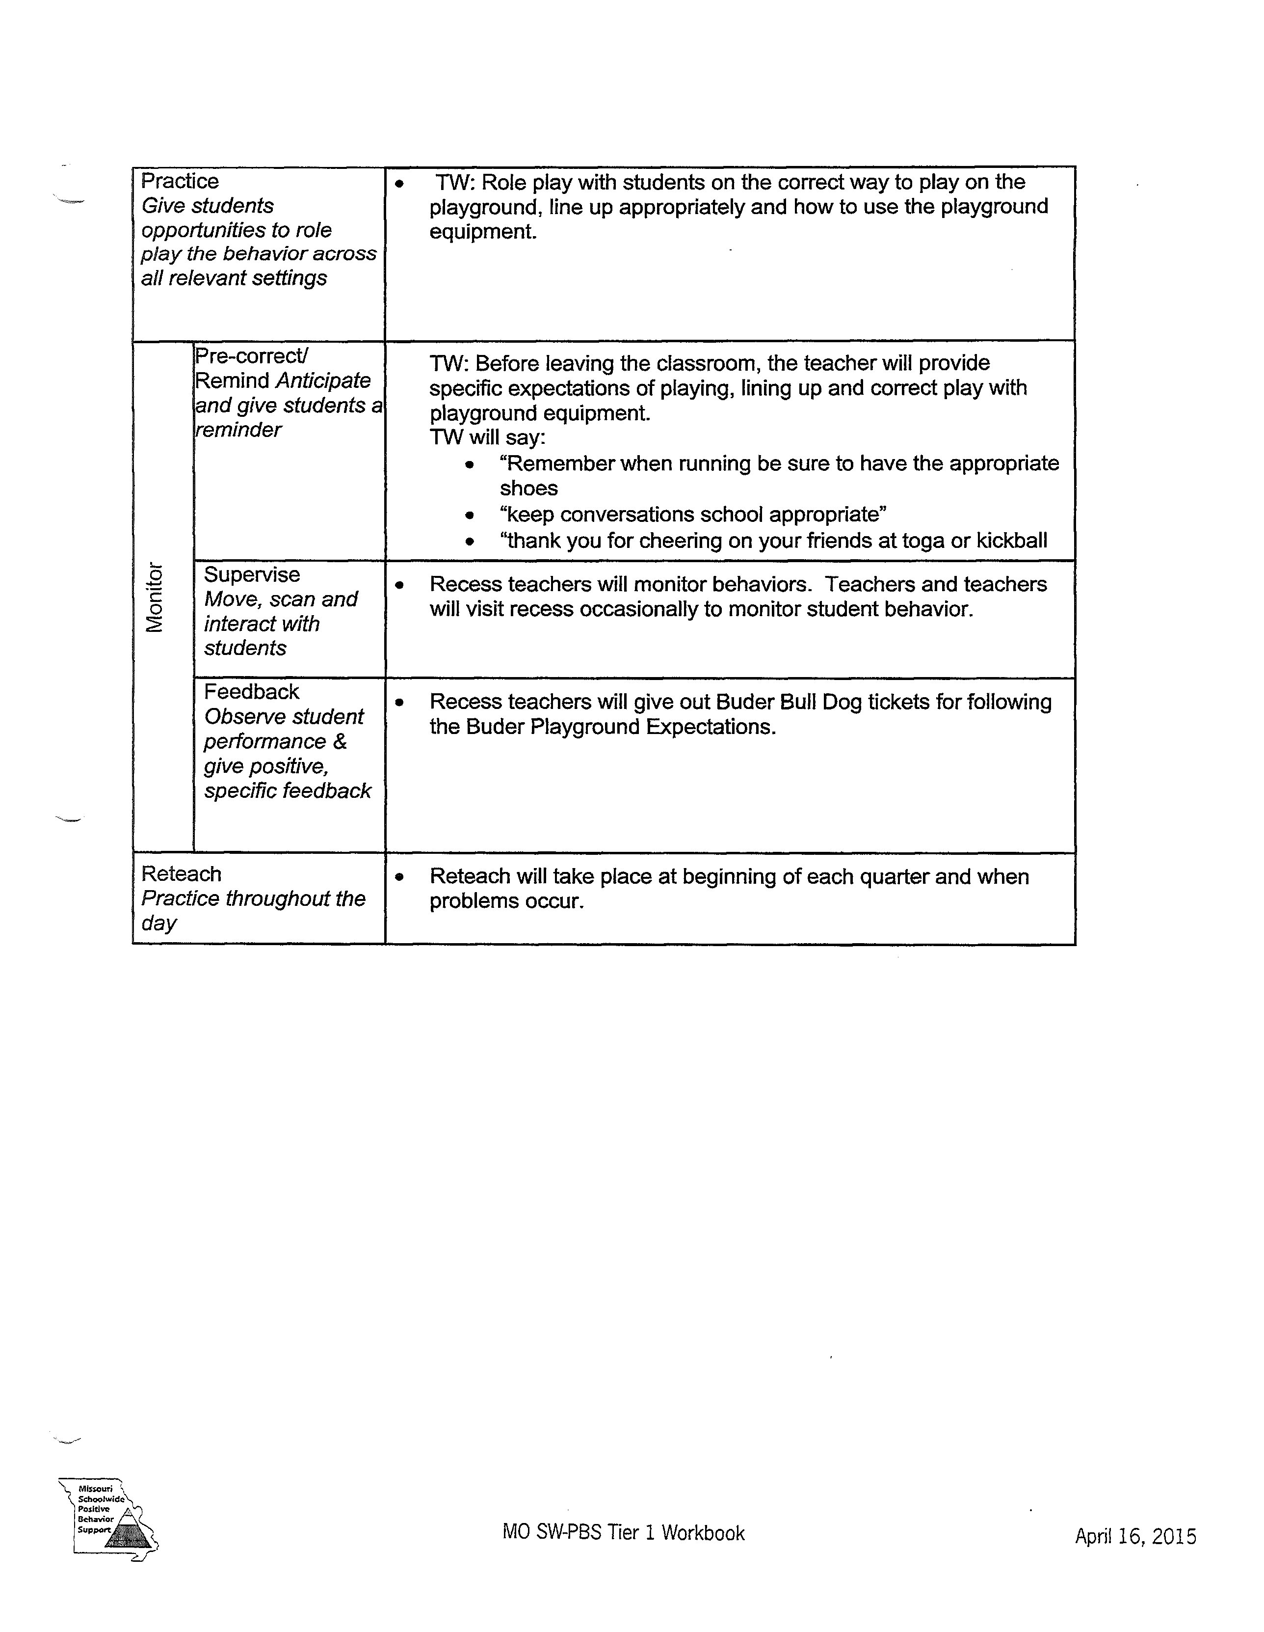

|  |  |  |
| --- | --- | --- |
|  | |  |
|  |  |  |
|  |  |  |
|  |  |  |
|  | |  |

Sample Lesson Plan on Teaching Respect:

SKIT for Whole School Assembly or Grade Level Assembly

1. **Focus:**

Play Aretha Franklin’s “R-E-S-P-E-C-T” recording.

Have several teachers in costume dressed as Aretha with microphones as if they are singing to the audience: (Gowns, gloves and handbags, old fashioned school bell, school books, random school supplies, sign)

Lyrics:

What you want, baby, I got. **(Hold up books.)**  
What you need, you know I got it. **(Point to your heads for knowledge.)**  
All I’m askin' is for a little respect **(Have one teacher take another’s hand as if they are helping them across the street.)**   
When you come home, baby. **(Ring old fashioned school bell.)**When you come home,   
respect.  
  
I ain't gonna do you wrong while you gone, **(Wag fingers at students.)**  
I ain't gonna do you wrong 'cause I don't wanna.  
All I’m askin' is for a little respect **(Hold up a sign that looks like a road sign that says “Two-Way Street on one side and R-E-S-P-E-C-T” on the other.)**when you come home, baby, **(Ring old fashioned school bell.)**when you come home,   
respect.  
  
I'm out to give you all my money **(Open up pocket books that are empty, and hold up school supplies that you bought with your money.)**  
but all I'm askin in return, honey,   
is to give me my proper respect **(One teacher drops books, and another picks them up.)**when you get home, yeah baby,  
when you get home.  
  
Ooh, your kisses sweeter than honey **(Blow kisses at the students.)**   
but guess what, so here's my money.  
All I want you to do for me is give me some here **(Motion for the students to blow kisses back.)**when you get home, yeah baby,   
when you get home.  
  
R-E-S-P-E-C-T, (**Everybody sing. You can put the words up on an overhead for all to see, and have everyone chant along)**   
find out what it means to me.  
R-E-S-P-E-C-T,   
Hey Boy, T-C-B.  
  
A little respect...

2) **Objective:**

Note: (The more you make this a fun experience, the more the students will “buy in.” If this comes across as a demand, they will not be as quick to incorporate the message).

Tell the audience that the school has a new discipline policy. Give the students the 3-5 behavioral expectations that your school has adopted. Tell them that today you are focusing on *Be Respectful*. Tell them you are going to help them see what respect looks like in all areas of the school. Explain the matrix to them by showing it on a large screen projection.

At this time, have a teacher come in dressed like a spy (trench coat, hat, sunglasses) carrying a briefcase. They will say: “My mission, and I choose to accept it, is to catch you….being good.” All of the staff at _______________ middle school have accepted this mission. We will be out in the halls looking for students who are exhibiting the appropriate behaviors. If we catch you, you will get a ___________ (whatever your school is using). These can be redeemed for: ______________ (whatever your school has chosen as rewards--drawings, etc.) Tell them “There are spies everywhere.” **(At this point have all staff take out a pair of sunglasses and put them on, and point at someone who is sitting nicely.)**

3) **Input:**

Present the matrix for Be Respectful. Discuss what it looks like in each of the areas that you have on your matrix.

4) **Modeling:**

Show a movie that you made of teachers being respectful in all of the areas on your matrix. Have the teachers who perform in the movie dress like students. Here’s a movie example:

Dick and Jane are running down the hall, pushing each other, and hollering. From out of nowhere appears fairy godmother (a teacher dressed as a fairy godmother--preferably one who is hair challenged with a braid of yarn taped to his/her head, a pair of wings, and maybe a tee shirt and shorts with a tutu over the top and a magic wand.) and the fairy godmother says: “Time freeze: (Dick and Jane freeze in a funny position) Dick and Jane you are heading down the wrong path. You will never get anywhere in life if you don’t show respect. I’m going to sprinkle you with respect from a role model adult. (Sprinkles glitter on Dick and Jane). Now, I know you’ll both grow up to be respected members of society.” (Fairy Godmother disappears shouting “Time unfreeze” as (s)he goes). Dick and Jane walk side by side down the hallway, using a quiet voice. Jane bends down and picks up litter that is on the floor and puts it in a trash can and Dick holds open the door for her going into class. From nowhere a teacher steps out in the hall with an angel halo and wings and hands Dick and Jane a “gotcha being good” pass, and tells them to take it to the office for the daily drawing for a trip to the Bahamas. - Teacher turns to camera: “And that boys and girls is how you show respect in the hallway.”

You can do skits like this for all the areas you have on your matrix. Show the good, the bad, and the ugly- ☺ Don’t forget the bus. I’m sure the bus drivers would be willing to come over with a bus and let you film because they certainly want better behavior.

5) **Guided Practice:**

Call several students out of the audience to show respect. Have them show it the wrong way and then the right way. You can give them scenarios (You are in the bathroom and you see that one of your friends is getting ready to write a joke on the bathroom stall. What could you do? A) find him a bigger pen, B) get him a dictionary so he spells the words correctly, or C) ask him not to do it out of respect for the building.) As the students perform the correct task or give the correct answer, give them one of the first “gotcha being good” passes in front of the student body.

6) **Checking For Understanding:**

Make a PowerPoint Quiz to show the students: Ask them questions about what respect looks like in different areas: Example: Is it respectful to throw litter on the school grounds? When you are finished, tell them that they did so well on the test that everyone’s home-room teacher will be giving them a “gotcha pass for the day.” Make sure this first day that you make a really big deal out of the passes and have the drawing at the end of the day. Make the prize really special, like a pizza lunch with the principal at a special table in the cafeteria and they get to choose one friend to eat with them…or something like that.

7) **Independent Practice:**

The key to this is to make sure every staff member is out there catching students being good. Make sure in the beginning to tell them exactly how they are showing respect.

8) **Close:**

This can be a variety of activities, but one could be some artwork that can be put up around the school that focuses on what respect looks like, or poems, songs, stories, etc. Let them be creative. It will be time well spent because the displays will be constant reminders.

**Here are some other ideas:**

PowerPoints developed by the students on what respect looks like; these can be shown on the school website

Skits to be performed during morning announcements

A school song written by a student, sung by one of your students

Interview community members about what respect would look like in different community areas. For example, report that the manager at JC Penney’s saw two ___________ middle school students picking up some clothing that had fallen on the floor and he wanted to compliment the school on their respect for his store.

Once a week, it would be fun to play Aretha Franklin’s song as the students are coming into school or leaving school.

### Follow up Classroom Lesson

1. **Focus:** Ask the students why people take off their hats at ball games when the Star Spangled Banner is played. Hopefully, you will elicit the response that it is out of respect for the flag. You can go into a short discussion about why we choose to show respect for the American flag.
2. **Objective:** The objective of this lesson is to further identify what respect means at your school and in your classroom.
3. **Input:** Give each student a copy of the matrix. (Some schools are printing it in the agenda books) Go over the matrix with the students for the respectful section--not the whole matrix.
4. **Modeling:** Give examples of how you (the teacher) show respect at home, in the teacher’s lounge, at the grocery store, in church, etc. Make this personal so they can see that adults use respect. Then ask the students how they think you respect them. Talk to them about you respect them by spending your summers planning lessons, shopping for items to make the room pretty, taking time to grade their papers, etc. Ask one of them to be the teacher for a moment. Ask them to teach something that you know they will be able to teach the class. While they are teaching, you will take a seat as a student and then raise your hand, but blurt out the answers without waiting to be called on, run up to the board and write the answer on the board, etc. Then stop the class and ask them if they’ve ever been in a class where someone acted like that. Ask them to model the correct behavior. Choose another student to be the teacher and then have another student model the correct way to answer the questions, etc.
5. **Guided Practice:**
   1. Take your class out in the hallway and ask two students to show you non**-**respect and respect in the hallway.
   2. Take your class to the bathroom and (don’t go in) but have two students give scenarios of not showing respect in the bathroom and showing respect in the bathroom. (Always give the positive last, so it is fresh in their mind)
   3. Take your class to the lunchroom, office, nurse’s office, etc. Discuss all of the places on your matrix with non-examples and examples.
6. **Checking for Understanding**: Give your class a quick quiz (oral) on the right and wrong way to show respect. You can ask them to show you thumbs up or thumbs down when you give scenarios.
7. **Independent Practice**: Make a contest in your class (Everyone will participate.) Tell them that you are having a contest to see how many “Gotchas” each class can get. The class with the most “Gotchas” for showing respect at the end of the week will get an ice cream break, music break, go outside and read on the lawn break--anything you think will be rewarding.
8. **Close**: Have them write down a short paragraph about what they learned and how they will carry that over to home and community.

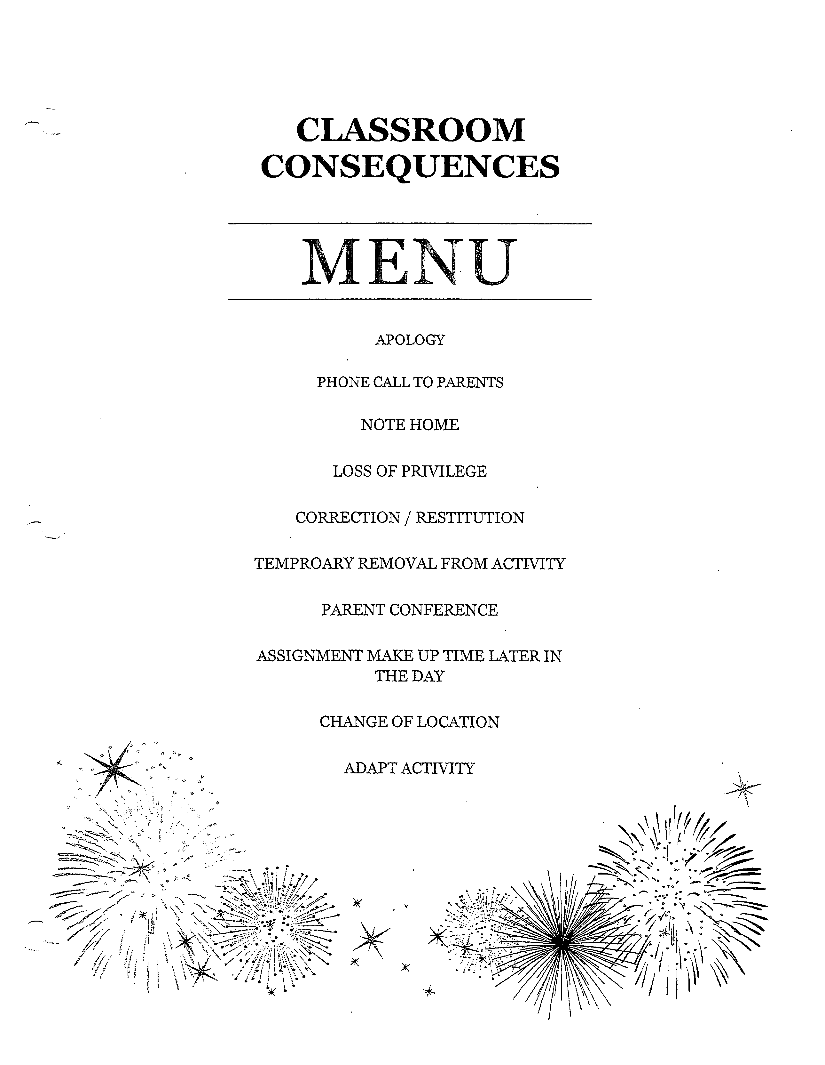

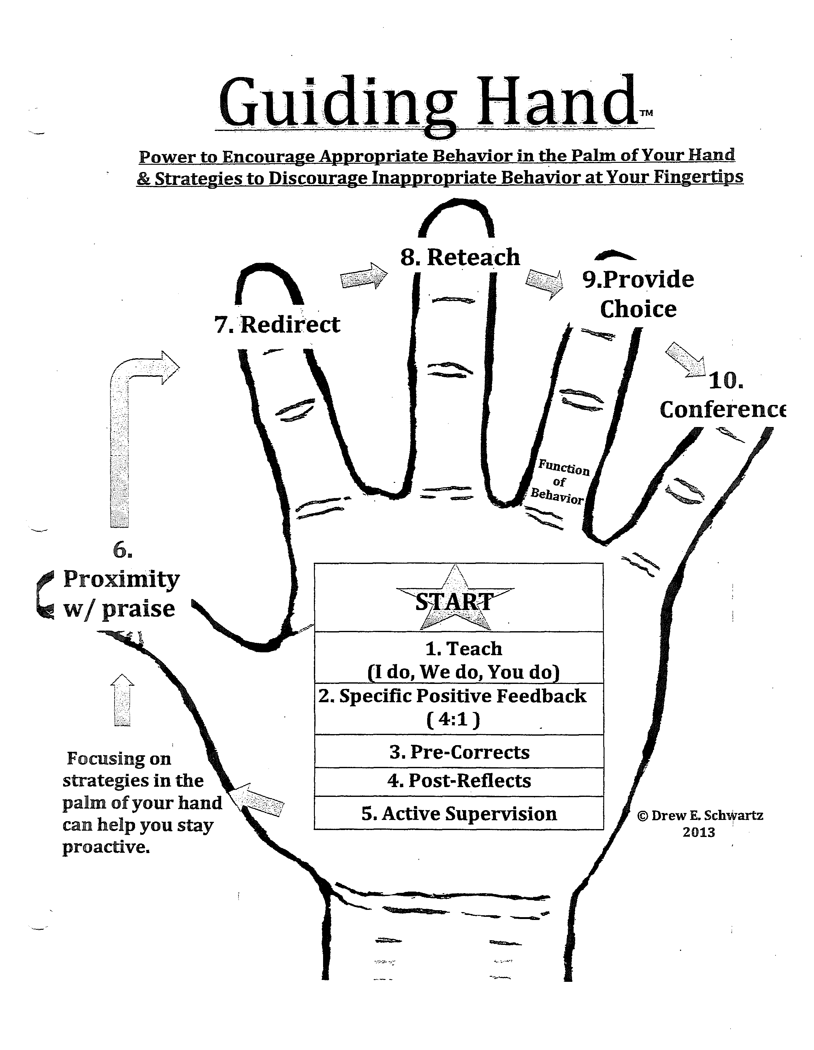

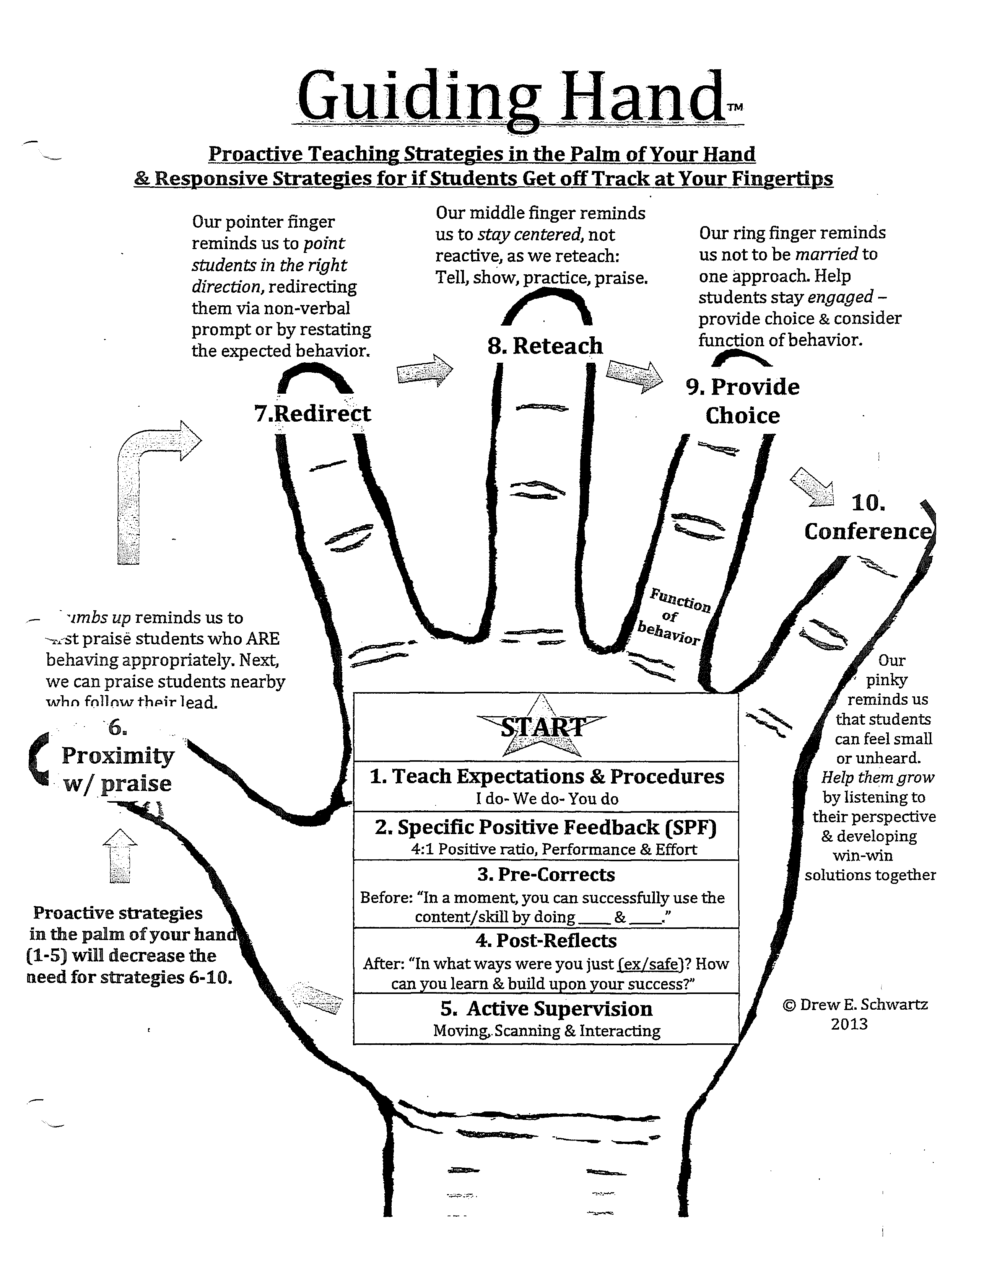

**Major and Minor Behaviors**

**Minor Major**

|  |  |
| --- | --- |
| * **Stealing:** Student is in possession of someone else’s property | * **Stealing:** Student is in possession of someone else’s property; repeated behavior or major offense |
| * **Inappropriate Language:** Student engages in low-intensity instance of inappropriate language | * **Abusive Language:** Student delivers verbal messages that include swearing, name calling, or use of words in an inappropriate way |
| * **Disruption:** Student engages in low intensity, but inappropriate disruption | * **Fighting/Physical Aggression Toward Others:** Student engages in actions involving serious physical contact where injury may occur (e.g. hitting, punching, hitting with an object, kicking, scratching...) |
| * **Defiance:** Student engages in brief low-intensity failure to respond to adult requests | * **Repeated Defiance:** Student engages in refusal to follow directions, talks back and/or rude interactions |
| * **Property Misuse:** Student engages in low-intensity misuse of property | * **Property Damage:** Student participates in an activity that results in the destruction or disfigurement of property. |
| * **Cheating/Lying:** Student delivers message that is untrue and/or deliberately violates a rule. | * **Harassment/Bullying:** Student delivers disrespectful messages (verbal or gestures) to another person that includes threats and intimidation, obscene gestures, pictures or written notes. Disrespectful messages include negative comments based on race, religion, gender, age and/or national origin, and/ or sustained or intense verbal attacks based on ethnic |
| * **Other:** Student engages in any other minor problem behaviors that do not fall within the above categories |  |

**Minor and Major Behaviors**

Minor Major

## Behavior Flow Chart

School Wide Expectations (Buder Matrix) has been:

***Taught, Modeled, and Practiced***

*One team, inspiring*

*each other everyday*

*to grow in every way!*

**Problem**

Behavior

**Positive**

Behavior

**Minor:**

Kick-Board

entry for each minor behavior

**Major**

* 4:1 Positive Statements
* Buder bucks: Kick-Board
* Positive Note or Call home
* Student of Month
* Shout outs!
* PBIS weekly recess
* Buder Honors breakfast
* Participation in modeling PBIS lessons
* Positivity reports

**SIS Referral**

**Antecedent recorded in comment section**

***Administrative review***

***Consequences*:**

-Conference w/ student

-Recovery room

-ISS

-Loss of Privileges

-Individualized Instruction in

Social Skills

-BIP

-PAN

-OSS

