Download and Install Office 365
These directions demonstrate how to both download and install Microsoft Office 365. The directions were created using the Google Chrome browser.
- Go to https://portal.office.com. If you're not already signed in, sign in with your SLPS account.
- From the Office home page, select Install Office.
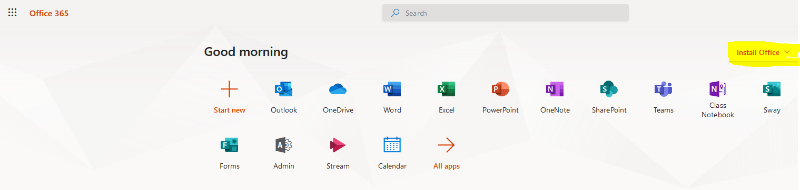

- Select the Office 365 apps option.
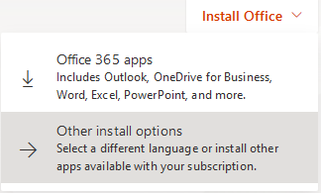

- Press the “Install Office” button on the right side of the page.
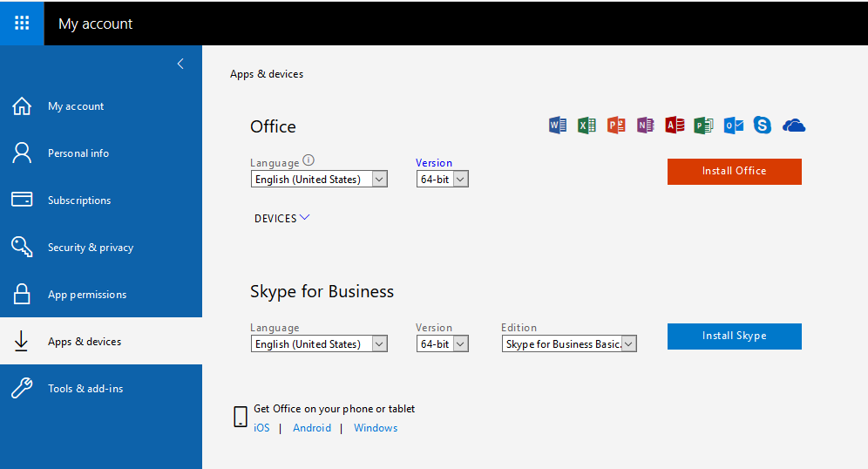
- The Office installation file will download to your computer. You will see it on the lower-left hand side of your screen. Click the file.
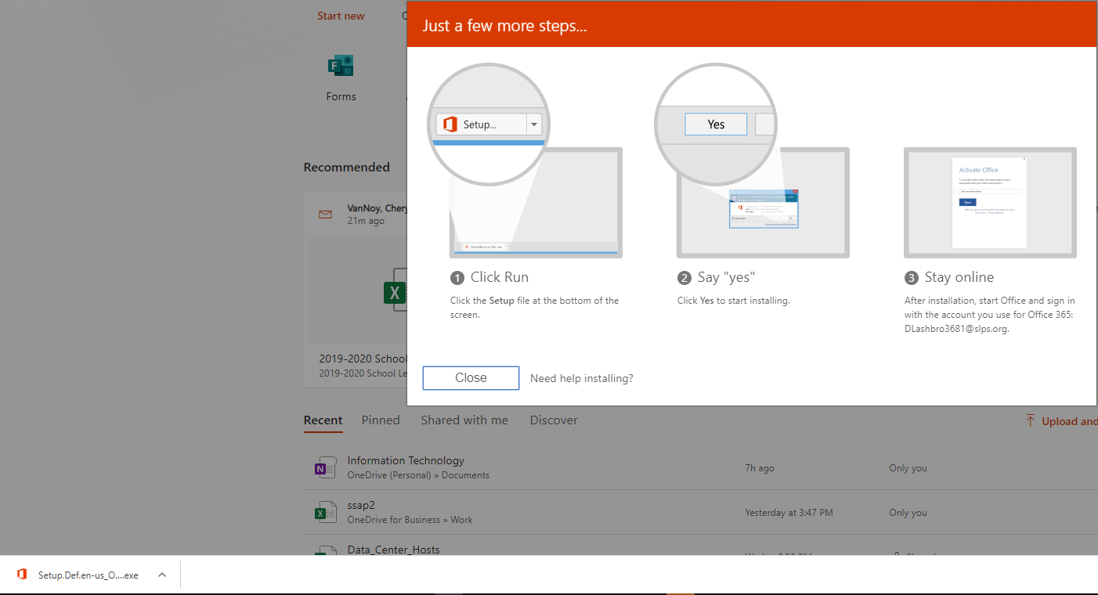

- Microsoft Office will now install. The following screenshots will show the process.
