**SLPS Accountability Plan Template 2021**

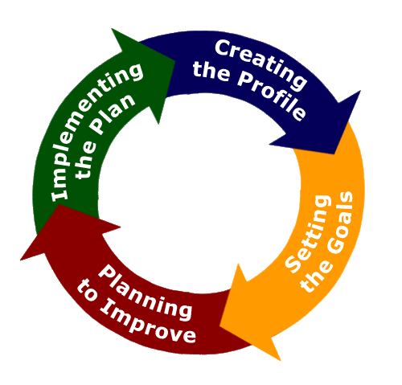

**The Accountability Plan Template embodies requirements set by the Missouri Department of Elementary and Secondary Education (DESE) relative to Schoolwide Planning and the completion of the Consolidated Application and Comprehensive School Improvement Plan. It also supports the continuous improvement of all St. Louis Public Schools.**

**We are committed to a Continuous Improvement System based on the Theory of Action: Improved student learning for every student in every school, with the primary goal of having all Missouri students graduate ready for success. This Accountability Plan Template has as its foundation the following five pillars of the SLPS Transformation 3.0 Plan, which support the Continuous Improvement Theory of Action:**

**Pillar 1: The District creates a system of excellent schools**

**Pillar 2: The District advances fairness and equity across its system**

**Pillar 3: The District cultivates teachers and leaders who foster effective and culturally responsive learning environments**

**Pillar 4: All students learn to read and succeed**

**Pillar 5: Community partnerships and resources support the District’s Transformation 3.0 Plan**

**School Name: Hamilton Elementary**

**2021 ACCOUNTABILITY PLAN TEMPLATE Table of Contents**

|  |  |  |
| --- | --- | --- |
| **Section** | **Contents** | **Due Dates** |
| **1** | School Profile, Mission, Vision, School Improvement Planning Committee |  |
| **2** | Comprehensive Needs Assessment: Student Demographics; Student Achievement; Curriculum and Instruction; High Quality Professional Development; 2021-2022 Priorities; Root Cause Analysis; School Parent and Family Engagement: Program Evaluation Results; Policy Involvement; Shared Responsibilities for Student Achievement (School Parent Compact); School Capacity for Involvement; Summary Statements |  |
| **3** | The Goals and the Plan: Goal 1-Leadership Development Plan; Goal 2-Reading Plan; Goal 3-Mathematics Plan |  |

**SECTION 1**

**School Profile**

**Accountability Plan Template**

**(**[**DESE’s Consolidated Application**](https://dese.mo.gov/sites/default/files/qs-fc-Consolidated-Fed-Prog-Plan.pdf) **and** [**DESE’s LEA/School Improvement Guide**](https://dese.mo.gov/sites/default/files/LEA-School-Improvement-Guide-2019.pdf)**)**

|  |  |  |
| --- | --- | --- |
| **Improvement/Accountability Plan** | | |
| **Focus of Plan (check the appropriate box):**   * **LEA**   **X School** | **Name of LEA:** Starlett S. Frenchie  **Name of School:** Hamilton Elem.  **School Code:** 0478 | **Check if appropriate**   * **Comprehensive School  ***Requires a Regional School Improvement Team** * **Targeted School**   **X Title I.A**   * **Autonomous** |
| **Date: June 11, 2021** |  | |
| **Purpose: To develop a plan for improving the top 3 needs identified in the needs assessment.** | | |
| **School Mission:** We are committed to…  Hamilton Elementary School is an environment where all stakeholders are inspired to contribute to a positive, safe and caring learning atmosphere. We promote a learning community that encourages a respect for lifetime learning so that individuals are cultivated to compete on a world wide scale. We empower our students to become academically and technologically successful. We are committed to employing a solution focused approach to learning and achieving individual success. Our academic program is innovative, infused with technology and data driven. Our school community is committed to promoting high expectations and goals, to encourage the building of foundations needing to support life-long learning in an ever changing society. | | |
| School Vision: We Aspire to… Hamilton Elementary is a school community, in which all stakeholders are committed to promoting high expectations and achieving goals in order to encourage the building of foundations needed to support life-long learning in an ever changing society. | | |
| **One plan may meet the needs of a number of different programs. Please check all that apply.**  **X Title I.A School Improvement**   * **Title I.C Education of Migratory Children**   **X Title I.D Prevention and Intervention Programs for Children and Youth who are Neglected, Delinquent or At-Risk**   * **Title II.A Language Instruction for English Learners and Immigrant Children**   **X Title IV 21st Century Schools**   * **Title V Flexibility and Accountability**   **X Individuals with Disability Education Act**   * **Rehabilitation Act of 1973** * **Carl D. Perkins Career and Technical Education Act** * **Workforce Innovation and Opportunities Act**   **X Head Start Act**  **X McKinney Vento Homeless Assistance Act**   * **Adult Education and Family Literacy Act**   **X MSIP**   * **Other State and Local Requirements/Needs __________________________________________________________** | | |

**Districts, charters and/or schools should engage in timely and meaningful discussions, with a broad range of stakeholders, to examine relevant data to understand the most pressing needs of students, schools and/or educators and the potential root causes for each need. By inviting all stakeholders to participate in the needs assessment process you are establishing a unified understanding of the LEA and/or school(s), identifying goals that reflect the vision of the entire learning community and promoting buy-in for improvement efforts. The following chart identifies stakeholders who may participate in the needs assessment process.**

|  |  |  |  |
| --- | --- | --- | --- |
| **School Planning Committee** | | | |
| **Position/Role** | **Name** | **Signature** | **Email/Phone Contact** |
| Principal | Starlett Frenchie | Signature Page on Site | [Starlett.Frenchie@slps.org](mailto:Starlett.Frenchie@slps.org)  314-367-0552 |
| Assistant Principal |  |  |  |
| Academic Instructional Coach | Vrhonnee Brown | Signature Page on Site | [Vrhonnee.brown@slps.org](mailto:Vrhonnee.brown@slps.org)  314-367-0552 |
| Family Community Specialist | Kimberly Roach-Trice | Signature Page on Site | [Kimberly.Roach-Trice@slps.org](mailto:Kimberly.Roach-Trice@slps.org)  314-367-0552 |
| ESOL Staff (if applicable) |  |  |  |
| SPED Staff (if applicable) | Nikola Turnbull | Signature Page on Site | [Nikola.Turnbull@slps.org](mailto:Nikola.Turnbull@slps.org)  314-367-0552 |
| ISS/PBIS Staff (if applicable) | John Moore | Signature Page on Site | John.Moore@slps.org |
| Teacher | Chevelle Stewart | Signature Page on Site | [Chevelle.Stewart@slps.org](mailto:Chevelle.Stewart@slps.org)  314-367-0552 |
| Teacher | Shaina Costello | Signature Page on Site | [Shaina.Costello@slps.org](mailto:Shaina.Costello@slps.org)  314-367-0552 |
| Parent | Caprice Turner | Signature Page on Site | 314-320-1478 |
| Parent | Shekita Hilton | Signature Page on Site | [shekita.hilton@slps.org](mailto:shekita.hilton@slps.org)  314-367-0552 |
| Support Staff | Easter Love | Signature Page on Site | [Easter.Love@slps.org](mailto:Easter.Love@slps.org)  314-367-0552 |
| Community Member/Faith Based Partner | Anitra Mahari | Signature Page on Site | [anitra.mahari01@gmail.com](mailto:anitra.mahari01@gmail.com) |
| Network Superintendent | Karen Jones | Signature Page on Site | [Karen.jones@slps.org](mailto:Karen.jones@slps.org) |
| Community Member/Faith Based Partner | Ozella Fleming | Signature Page on Site | New Cote Brilliant Church  6195 Washington Blvd.  St. Louis, Mo. 63112 |

**SECTION 2**

**Comprehensive Needs Assessment**

|  |  |  |
| --- | --- | --- |
| **Comprehensive Needs Assessment \***[**DESE’s Consolidated Application**](https://dese.mo.gov/sites/default/files/qs-fc-Consolidated-Fed-Prog-Plan.pdf) | | |
| **Student Demographic** | | |
| **Data Type** | **Current Information** | **Reflections** |
| **Student Enrollment as of 3/1** | 262  -133 Male  -129 Female | Hamilton’s 2020/21 enrollment during the Covid19 Pandemic decreased by approximately 100 students. |
| **Grade Level Breakdown** | -Pre K 3---5--- 1.9%  -Pre K 4---21---8%  -KG ---50 ---19%  -1st --- 44--- 16.8%  -2nd --- 42 --- 16%  -3rd --- 33 ---12.6%  -4th --- 30 --- 11.5%  -5th --- 37 --- 14.1% | 38.1% of Hamilton students will participate in state assessments.  9.9% of the student population enrolled in the Pre-K Program. |
| **Ethnicity** | -Black --- 259 --- 98.9%  -Hispanic--- 2--- .8%  -White --- 1--- .4% | Hamilton has a majority African American student population with one White ECSE student. |
| **Attendance** | -90/90 --- 33.7%  -ADA --- 72.81% | Hamilton school community has failed to meet the states 90/90 expectation as it relates to attendance. Due to COVID19 approximately 49% of enrollment were Virtual learners. Participation in learning has been inconsistent due to pandemic. School staff exhausted district resources, implemented strategies and expectations of the district. |
| **Mobility** | 20.6% --- Students less than during the 20/21 academic year | As a result of the COVID19 pandemic Hamilton school community has transitioned from in person learning to some virtual students and some students working from work packets. Parent contact and student engagement has been inconsistent affecting overall academic programming. Typically, Hamilton student clientele are residents from approximately 100+ apartment buildings and/or apartment complex’s within the area.  73.7% of enrolled students have assigned bus routes.  17% of enrolled students are daily pickups.  1% of enrolled students are Cab Riders.  2% of enrolled students are walkers |
| **Socioeconomic status** | -Free Reduced Lunch --- 262 --- 100%  -McKinney Vento/Homeless | Hamilton has identified 10%+ of students enrolled as being affected by factors under the McKinney Vento/ Homeless Act. All students enrolled participate in the free breakfast and lunch program. |
| **Discipline** | Documented Incidents in SIS  66 Total Incidents  41% Intent to Distract  23% Fight-Horse Play, Play Fight  9% Refusal to stay seated  6% Violation of acceptable usage | Hamilton is a PBIS school in its 9th year. In 2018 Hamilton began Trauma Informed Programming in Schools (TIPS) for all staff. As a result of the COVID19 pandemic discipline concerns have shifted to student engagement concerns. As we moved into the new year we are reviewing programs, vendors and their impact to ensure the partnerships support the school culture. |
| **Limited English Proficiency** | 1%- 0.3 ESOL Students | Hamilton has one ECE student speaking dual languages. Teachers and staff utilize the ESOL office for support. |
| **Special Education** | 44 --- 16.8% | Hamilton provides services to 44 special needs students via: one ECSE, two cross category and one resource teacher. There are three classrooms and one office to support the SpEd program. |

|  |  |  |
| --- | --- | --- |
| **Strengths** | **Weaknesses** | **Needs** |
| -Hamilton staff is supportive and flexible in their attempts to provide quality academic programming to students and families during the COVID 19 Pandemic. | -COVID19  -staffing inconsistencies  -staff attendance  -academic achievement  -student attendance  -student engagements  -parental responsiveness  -tech issues or concerns | -In Person Hands On Learning  -Professional Development  -Best Practices for concurrent instruction  -Friendlier platform to support instructional programming  -Interventionist to support with reading and math.  -Highly qualified staff  -Increase Parental Engagement  -Increase Student Engagement |

|  |  |  |  |  |
| --- | --- | --- | --- | --- |
| **Student Achievement**  ***(Please analyze your achievement data for 18-19 and provide an explanation for the current performance data.)*** | | | | |
| **Goal Areas** | **19-20 performance** | **21-22 Goal** | **Current Performance** | **Explanation/Rationale for Current Performance** |
| **ELA** | 2213.877 | 255 MPI | 170 MPI | COVID19 Impact |
| **Reading** | 2222.541 | 255 MPI | 165 MPI | COVID19 Impact |
| **Math** | 2214.648 | 245 MPI | 157 MPI | COVID19 Impact |
| **Science** | 2320.594 | 365 MPI | 190 MPI | COVID19 Impact |
| **Social Studies** |  |  |  |  |
| **CCR** |  |  |  |  |
|  |  |  |  |  |

\**Please include any data tables, charts, graphs, etc. to support your current performance below\**

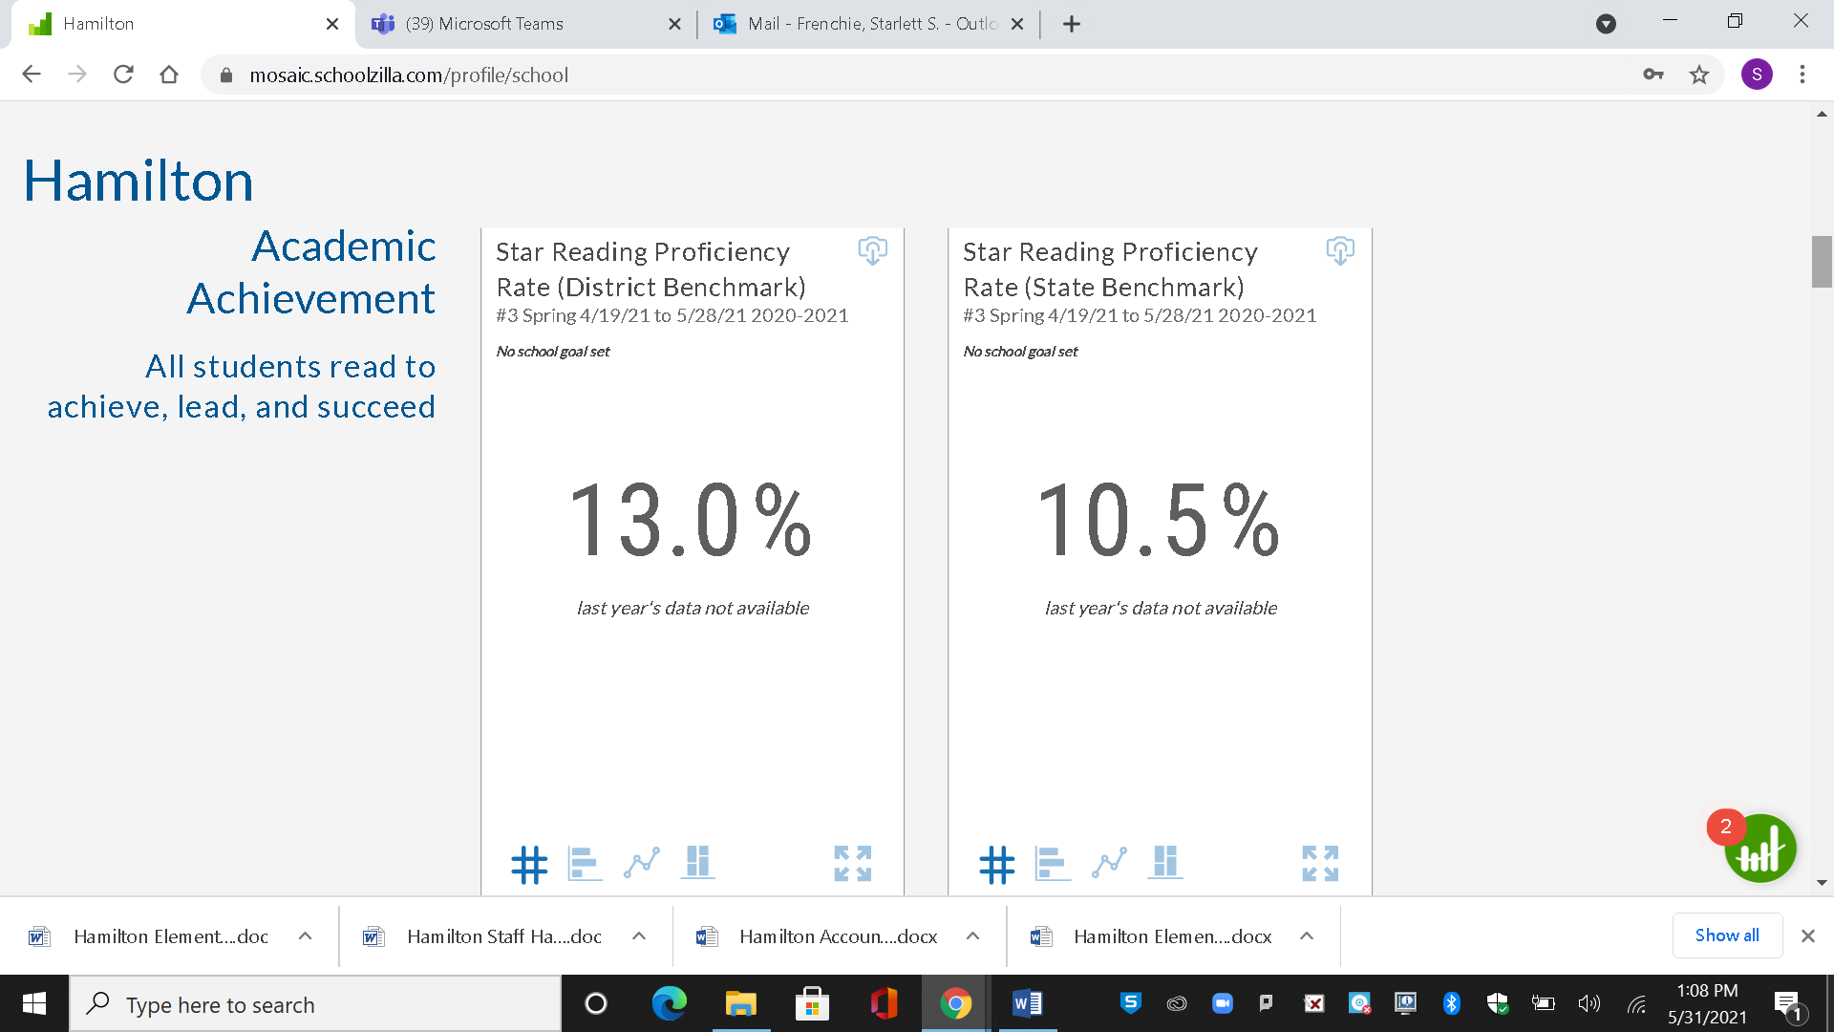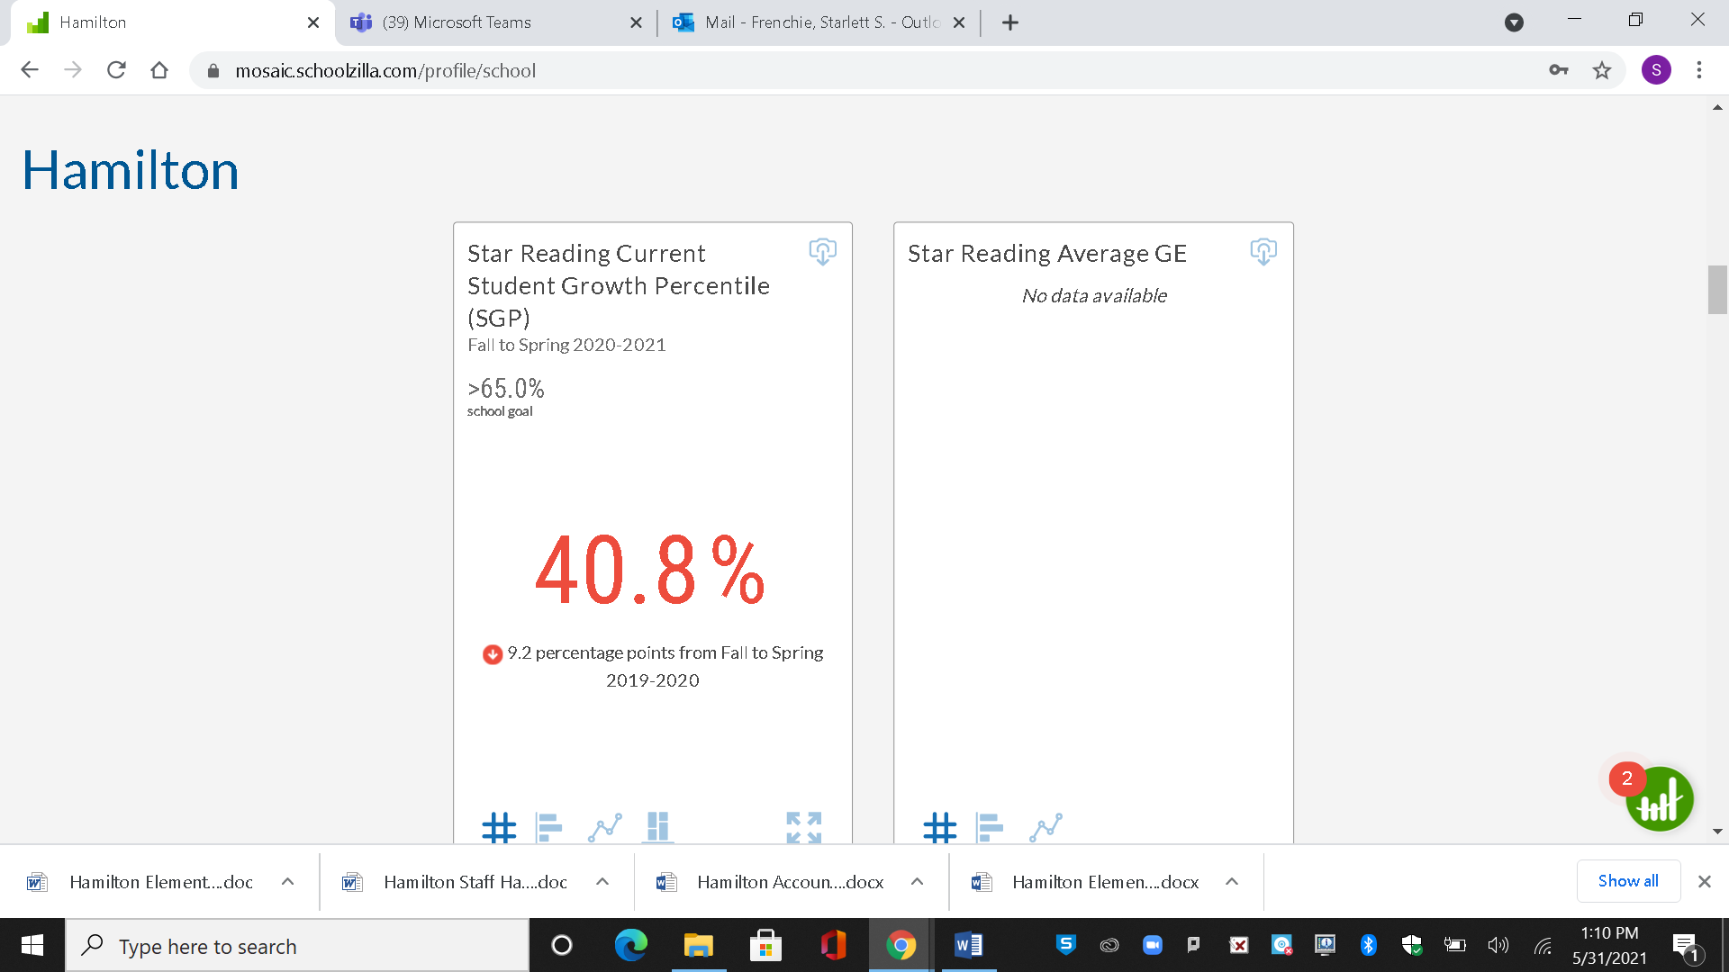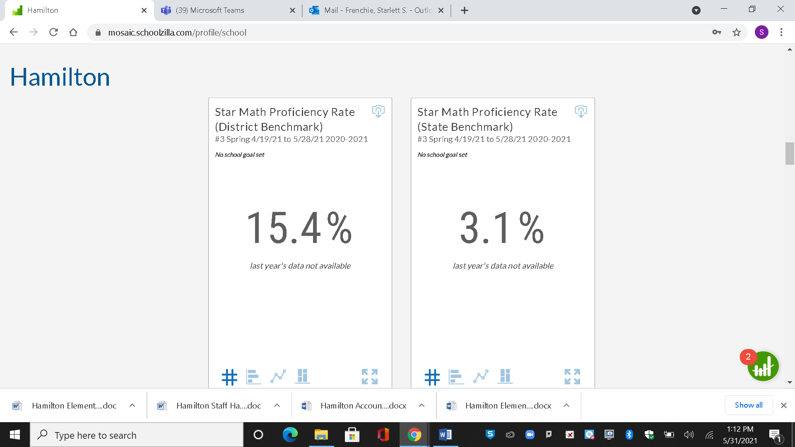

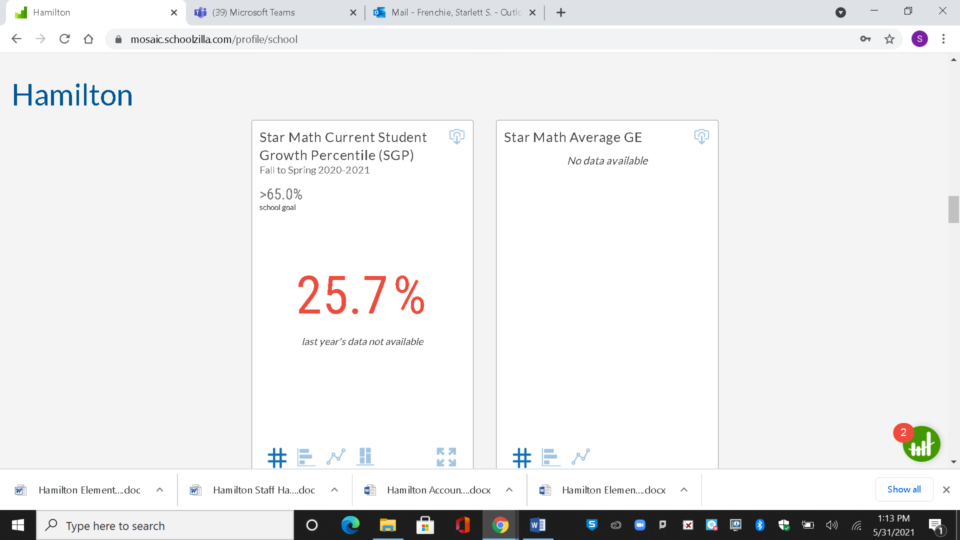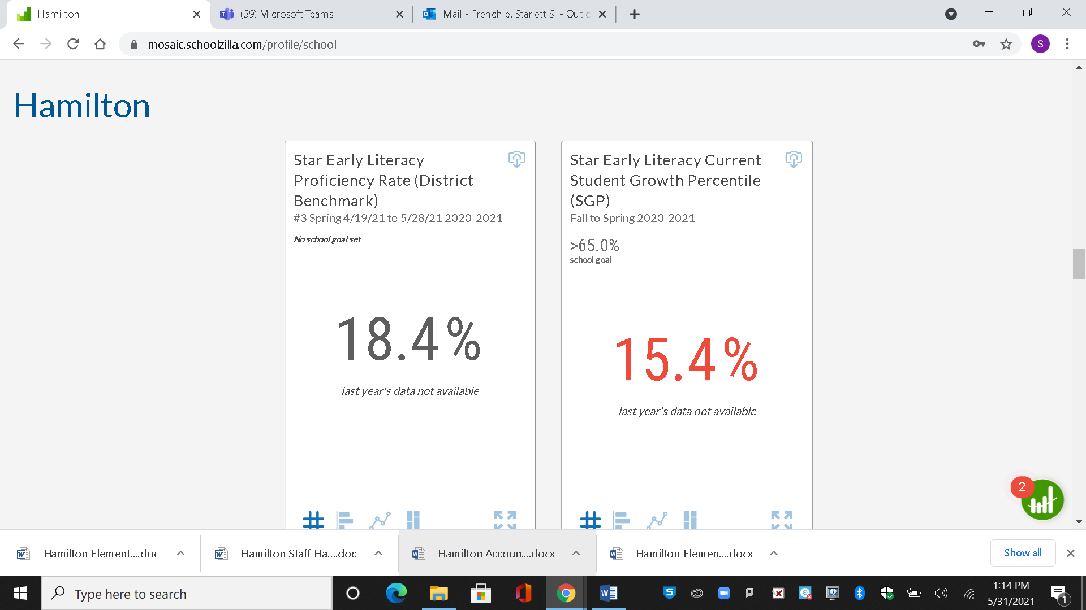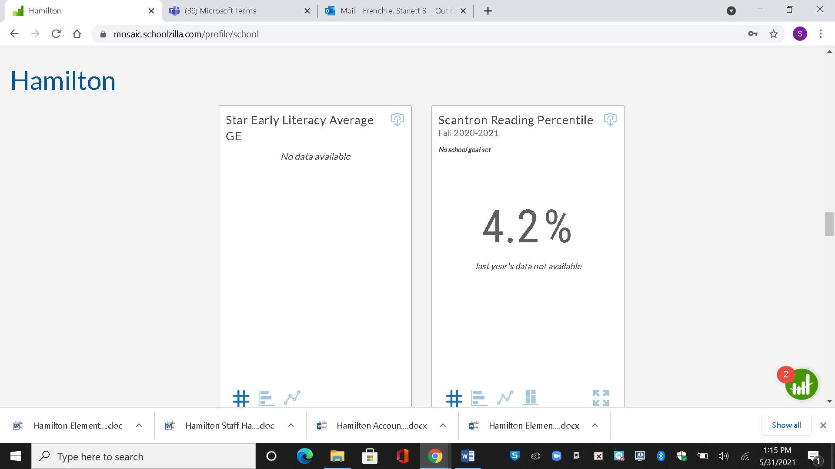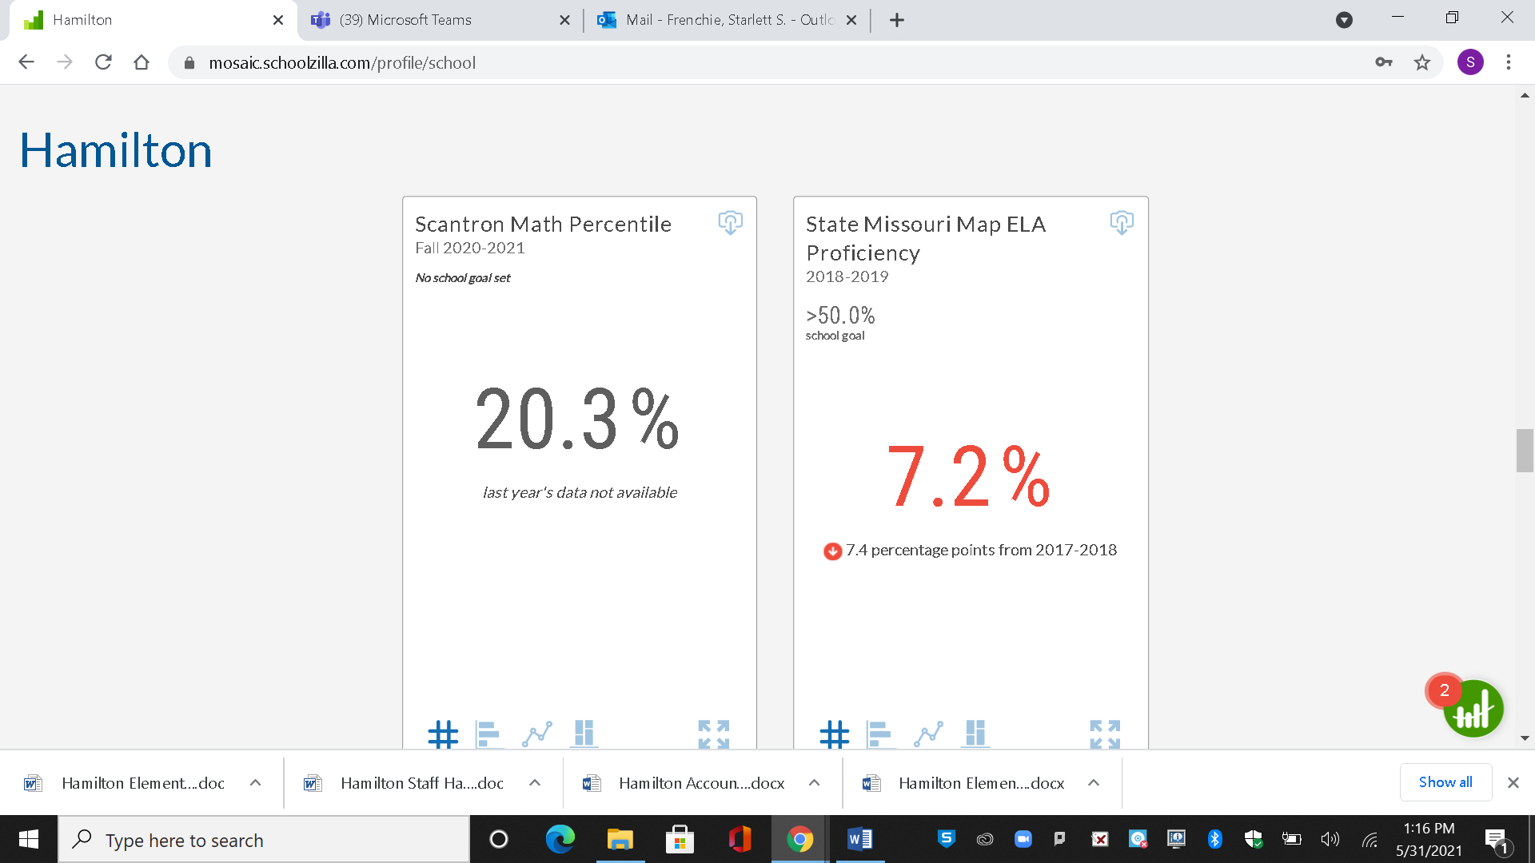

|  |  |  |
| --- | --- | --- |
| **Strengths** | **Weaknesses** | **Needs** |
| -Available resources | -Covid19  -Student Attendance  -Student Engagement  -Staff Attendance | -Interventionist to support with reading and math.  -Consistent implementation of guided reading  -Consistent implementation of guided math  -In Person Hands On Learning Environment  -Increase student engagement |

|  |  |  |
| --- | --- | --- |
| **Curriculum and Instruction**  ***(Please use the boxes below to describe how your school supports the following factors of curriculum and instruction)*** | | |
| **Data Type** | **Current Information** | **Reflections** |
| **Learning Expectations** | Standards are identified based on district and statewide recommendations. | Hamilton uses priority standards identified by the district to track student achievement in data cycles (pre & post assessments). We also ensure other grade level standards are taught throughout the year based on district pacing calendar. |
| **Instructional Programs** | The instructional programming at Hamilton is aligned with the recommended learning expectations from the district and state. Implementation of instructional programing during COVID19 has been the concurrent model. | Content specific planning that support implementation of instructional strategies to improve student achievement. Programming at Hamilton is aligned with the recommended learning expectations from the district and state. |
| **Instructional Materials** | Instructional materials are aligned with the learning expectations identified by the district. However per individualized planned lessons, pacing guides or scope and sequence staff has the option of presenting proposals to support their need for resources. Due to the concurrent learning model students at home have been provided supplies to ensure equitable access to supplies. | Hamilton provides materials and supplemental materials identified by teachers that support lesson planning developed to improve student achievement. |
| **Technology** | Hamilton has individual iPad access for students in grades PreK 3-5th, two computer labs, Smart or promethean in each classroom. Technology plans have changed- Families who opt in are provided full time access via district provided technology. | Hamilton will provide support in navigating and access to technology, support with smooth transition and lesson planning to provide easier access to resources for students. |
| **Support personnel** | Hamilton has the following full time staff:  Nurse, Family Community Specialist, Social Worker, Counselor, In School Suspension Monitor  Hamilton also has a part time Library Aide. | Hamilton provides services to students who suffer from emotional trauma and stress. The school culture is in need of support personnel to address the student behaviors that impact the climate and culture of the school. |

|  |  |  |
| --- | --- | --- |
| **Strengths** | **Weaknesses** | **Needs** |
| Various Professional Development  Academic Resources  Support personnel | Parameters of COVID19  Mental Health Supports  Student encouragement  Student engagement  Novice teachers  Consistency  Virtual Learning | In Person Hands On Learning Model  Consistency in academic programming  Relationship/team building  Scope for Professional Development  Staff & Students wellness activities |

|  |  |  |
| --- | --- | --- |
| **High Quality Professional Staff**  ***(How are you ensuring that all students are taught by a high-quality teacher?)*** | | |
| **Data Type** | **Current Information** | **Reflections** |
| **Staff Preparation** | All staff have a minimum of 60 credits hours.  Several teachers have completed advanced degrees. | Hamilton Instructional Leadership team will continue provided support to develop all staff in the areas of ELA, Reading, Math and Science. |
| **Staff Certification** | Certificated Staff  3 Pre – K teachers  2 KG Teachers  10 Classroom Teachers  3 SpEd  Art, Music, (FMLA), PE (Vacancy) | Hamilton’s building leader worked with human resources to ensure vacancies were posted and filled. |
| **Staff Specialist and other support staff** | FCS, Counselor, Social Worker, Library Aide, Nurse, Pre School Teacher Assistant’s, Instructional Care Attendant’s, In School Suspension Monitor, Building Substitutes, Academic Instructional Coach, Secretary, custodial, café workers, Trauma Therapist | Hamilton staff and students are supported by an array of professionals to ensure students are receiving supports to ensure academic success within a safe environment. |
| **Staff Demographics** | 13 Caucasian  20 African American | Hamilton staff is very flexible and tolerant in supporting students and families. Twenty-seven staff have two or more years at Hamilton. |
| **School Administrators** | 1 Principal | Hamilton has 1 building administrator to support Attendance, Academics and Discipline. The current building administrator has been with the school community for 10 years. |

|  |  |  |
| --- | --- | --- |
| **Strengths** | **Weaknesses** | **Needs** |
| * Flexibility * The will to development * Team work * Resources | * Classroom management * Using resources with fidelity * Consistency | * Professional Development * Review Trauma Informed Programing in Schools information * Team Building * Accountability |

|  |
| --- |
| **21-22 Priorities Prioritized areas of *Need* for 21-22 based on needs assessment/data analysis** |
| School leaders will retain at least 90% of teachers rated proficient or above on the PBTE from 2021-2022  School leaders will retain at least 90% of first year-teachers. |
| All students will demonstrate growth in the areas of reading fluency as measured by Fountas and Pinnell Running Record Data by the end of the 2021-2022 school year.  Students 2 years or more below grade level will demonstrate 1.5 year growth in the areas of reading accuracy and fluency. |
| 100% of students will demonstrate growth as measured by the August/May baseline assessment data. 70% of all students will demonstrate mastery in identified math power standard as measured by the August /May baseline and/or district assessment data. |

|  |
| --- |
| **Root Causes**  ***Determine the Root Causes of the needs listed above using the 5 Whys:*** |

|  |  |
| --- | --- |
| **Root Cause Analysis #1** | |
| Need #1- Please describe the need: | Classroom Management/Student Behaviors |
| Why? | Students exhibiting behaviors as a result of trauma adversely impact the instructional environment |
| Why? | Teachers are not consistently implementing strategies to support students via TIPS |
| Why? | Teachers are not consistently implementing PBIS and/or schoolwide systems. |
| Why? | All staff has to be consistent in expectations and responses to desired and undesired behavior. |
| Why? | Staff has to be kind and develop meaningful relationships with students. |
| **Root Cause** | Classroom management is one reason staff leave the district. It is my intent to support them to the best of my ability, and create an environment where staff enjoy their work. Lastly compensation continues to be an issue for staff. When other districts or charter offer more money, it is highly likely staff will leave when faced with certain barriers. SLPS needs to competitively pay teachers to support the efforts of building leaders. |

|  |  |
| --- | --- |
| **Root Cause Analysis #2** | |
| Need #2 - Please describe the need: | All students will demonstrate growth in the areas of reading fluency as measured by Fountas and Pinnell Running Record Data by the end of the 2021-2022 school year.  Students 2 years or more below grade level will demonstrate 1.5 year growth in the areas of reading accuracy and fluency. |
| Why? | Teachers are not implementing guided reading consistently and with fidelity |
| Why? | Hamilton needs a reading interventionist to support students |
| Why? | Additional programs interrupt classroom instruction |
| Why? | Reading tutors are not consistent or novice with little impact |
| Why? | Student’s engagement and/or lack of encouragement to do better. |
| **Root Cause** | Principal needs to be available to consistently follow up on learning expectations and meet with teachers to discuss. The principal is consumed with student discipline as a result of some inconsistency in implementing schoolwide systems or TIPS within classroom. School staff is concerned about student’s lack of and/or will to do better. |

|  |  |
| --- | --- |
| **Root Cause Analysis #3** | |
| Need #1- Please describe the need: | *100% of students will demonstrate growth as measured by the August/May baseline assessment data. 70% of all students will demonstrate mastery in identified math power standard as measured by the August /May baseline and/or district assessment data.* |
| Why? | Novice, not prepared and fearful teachers in Math. |
| Why? | Teacher not affectively implementing lesson plans with fidelity |
| Why? | Teachers not utilizing resources provided to support math instruction |
| Why? | Student’s engagement and/or lack of encouragement to do better. |
| Why? | Teachers not consistently reviewing data to support instructional practices (exit tickets, TMA assessments) to reteach skills. |
| **Root Cause** | Principal does not have the time to effectively support staff as instructional leader. Principal needs to be available to consistently follow up on learning expectations and meet with teachers to discuss concerns and academic data. The principal is consumed with student discipline from classroom teachers, ISS, recess, gym, and/or music. School staff is concerned about student’s lack of and/or will to do better and academic engagement. |

See page 11of DESE’s LEA/School Improvement guide for sample info: <https://dese.mo.gov/sites/default/files/LEA-School-Improvement-Guide-2019.pdf>

|  |
| --- |
| **School Parent and Family Engagement Policy \***[**DESE’s Consolidated Application**](https://dese.mo.gov/sites/default/files/qs-fc-Consolidated-Fed-Prog-Plan.pdf) |
| ***In addition to the LEA’s Parent and Family Engagement Policy (P1230), each Title I.A school must jointly develop with parents of participating children a written Parent and Family Engagement Policy. The school policy shall be distributed to parents and made available to the local community. The school policy must be reviewed annually and updated as needed to meet the changing needs of parents, families and the school. Parents shall be notified of the policies in an understandable and uniform format. To the extent practicable, the policy shall be provided in a language the parents can understand. If the school has a Parent and Family Engagement Policy, that policy may be amended to meet the federal policy requirements.*** |
| **Program Evaluation Results** |
| How does your school seek and obtain the agreement of parents to the parent and family engagement policy? |
| The parent and family engagement policy is made available and explained at enrollment, open house, meet the teacher, PTO meetings and sent home to be signed on the students first day of class. Hamilton provides each family with a school handbook. Hamilton has morning informational meetings, school programs and events the monthly calendar and newsletter emails and phone calls. Hamilton school host parent meetings, open house, meet the teacher and PTO to expose parents to the pertinent information from the office of the Family Community Specialist. During the meetings Title I requirements are made available to each school community member. During the academic year parents receive the parental involvement policy, school-parent compacts, resolution, procedure, school choice, supplemental education services, and parent’s right know. Hamilton Elementary School communicates with parents through the school handbook, morning meetings, school programs and events, monthly newsletters, school calendars, parent meetings, PTO meetings, family/community activities and event, e-mails and phone calls. |
| What are the strengths of family and community engagement? |
| The strengths of family and community engagement is the relationships that are formed between families and the schools community. The engagement exposes families to new opportunities guided by the relationship or involvement with the school. Students are more likely to excel academically if their parent is involved and parents are more likely to visit the school, once they see the school shares their goal which is to ensure their students have a quality education. Family and community engagement also displays its strength through the school and community relationships that evolve into partnerships. The partnerships that have been established are strong and they continue to support home and school. The ability to communicate with both families and community Hamilton bridges the gaps between home, school and community. Our students have an opportunity though partnerships that the otherwise would not receive. |
| What are the weaknesses of family and community engagement? |
| Family and community engagement displays its weakness as it relates to access to resources that can be provided for families. Families are reluctant to ask for resources, and when they are in need we would like to be able to provide them with solutions that would be appropriate. Hold times, repeating traumatic events, time constraints make it difficult. |
| What are the needs identified pertaining to family and community engagement? |
| One of the major needs identifies is access to resources, money to assist families, time for events and academic supports. |
| **Policy Involvement** |
| How are parents involved in the planning, review, and improvement of the Schoolwide plan? |
| Parents are actively invited to be in involved in the Schoolwide Plan. They provide feedback for every event or activity. Parents are surveyed often, and petitioned for suggestions on initiatives to start, stop and continue in support of strengthening the academic programing and planning for the academic year. We listen to the concerns of the parents. We provide parent teacher organization meetings, parent teacher conferences and open house. There are a host of other events and activities in efforts to provide informational for parents and yield an opportunity for feedback. |
| How are parents involved in the planning, review, and improvement of the school parent and family engagement policy? |
| Parents are actively involved in the annual review and revision of the school’s parent and family engagement policy. Parents are provided with the opportunity to review during parent teacher meetings, parent teacher organization meetings and upon request. |
| How is timely information about the Title I.A program provided to parents and families? |
| Title I information is shared consistently during the first few weeks of the school and as scheduled during the remaining of the academic year. There is also updated Title I information on the parent board in the building as changes are necessary and the school will use the Newsletter platform to support the efforts. |
| What are the methods and plans to provide an explanation of curriculum, assessments and MAP achievement levels to parents and families? |
| In an effort to provide an explanation of curriculum, assessments and MAP achievement levels to parents and families; I would include school staff on parent meeting agendas to address specific topics of their individual expertise and include identified topics in monthly newsletter to support and expose parents to pertinent information. Parents are always given an opportunity to ask questions in parent teacher organization meetings and on our school application class dojo. |

|  |
| --- |
| **Shared Responsibility for Student Achievement-School Parent Compact** |
| ***Purpose: The school-parent compact outlines how parents, the entire school staff, and students will share the responsibility for improved student academic achievement and the means by which the school and parents will build and develop a partnership to help children achieve the state’s high standards.*** |
| What are the ways in which all parents will be responsible for supporting their children’s learning? |
| Parents will assure their student comes to school every day and on time. Parents will encourage positive behavior. Parents will establish communication with teachers and we also ask parents to pledge to be responsible and advocate for their children’s academic success. Parents will support their child’s learning by committing to the school/district mission, vision and schoolwide expectations. Each parent will partner with the school and surrounding community to support the child’s development as a life-long learner in an ever changing society. |
| Describe the school’s responsibility to provide high quality curriculum and instruction in a supportive and effective learning environment. |
| Hamilton school community is committed to promoting high expectations while working towards achieving goals in order to encourage the building of foundations needed to support life-long learning. Our academic program is innovative, infused with technology and data driven. Our school community is committed to promoting the high expectations within our academic program and to encourage the building of the necessary foundations. The administration and teachers will provide a safe positive and creative environment. An atmosphere that is creative for students to learn. Both teams will collaborate to maintain high curriculum standards. |
| Please provide assurance that the school is:   * Conducting parent-teacher conferences at least annually, during which the compact shall be discussed * Issuing frequent reports to parents on their children’s progress * Providing reasonable access to staff, opportunities to volunteer, and observation of classroom activities * Ensuring regular two-way, meaningful communication between family members and school staff and, in a language that family members understand |
| Hamilton has parent teacher conferences twice a school year. Interim Progress reports are provided every five weeks, and notices of academic concern are also provided to parents via USPS. We have Parent Teacher Organization meetings, open house, meet the teacher, our annual grandparent’s day celebration, moments with mom and date with dad. Our annual spring informational. |

|  |
| --- |
| **School Capacity for Involvement** |
| How does the school provide assistance to parents in understanding the following items?   * Missouri Learning Standards * Missouri Assessment Program * Local Assessments * How to monitor a child’s progress * How to work with educators to improve the achievement of their children |
| In an effort to provide an explanation of curriculum, assessments and MAP achievement levels to parents and families; I would include school staff on parent meeting agendas to address specific topics of their individual expertise and include identified topics in monthly newsletter to support and expose parents to pertinent information. |
| How does your school provide materials and trainings to help parents work with their children to improve achievement? |
| Hamilton has training materials, pamphlets in side of the family and community specialist office. There are reading materials available in the main office as well. Each event there is time slated for training and academic information provided. |
| How does your school educate school personnel (*teachers, specialized instructional support personnel, principals, and other school leaders, and other staff*) in the value and utility of contributions of parents, and in how to reach out to, communicate with, and work with parents as equal partners? |
| Training is provided during opening session of school, staff meeting, before parent teacher conferences. And as needed throughout the school year. |
| How does your school implement and coordinate parent programs, and build ties between parents and the school? |
| Parents of the Hamilton School community respond to activities were their children are highlighted (i.e. holiday programs, educational game night, family fun days, Date with Dad lunch and Spring Soiree Informational, etc).  It is my intent to ensure parents are presented with such opportunities to show support to their students in an effort to strengthen communication between home and school.  I will continue to attempt parent engagement activities. |
| Describe plans to coordinate and integrate, to the extent feasible and appropriate, parental involvement programs and activities with other programs, such as parent resource centers that encourage and support parents in more fully participation in the education of their children. |
| Our plans to coordinate and integrate are under review. Covid19 will limit parents and community access to our building and our students. Our hope is that our parents and partners continue to utilize the school’s dojo app and the school website. |
| **Accessibility Assurance** |
| In carrying out the parent and family engagement requirements, the school, to the extent practicable, provides opportunities for the informed participation of parents and families including:   * Parents and family members who have limited English proficiency * Parents and family members with disabilities * Parents and family members of migratory children * Provides information and school reports in a format and language parents understand |

**Summary Statements**

|  |
| --- |
| **Summary of the strengths and weaknesses relative to Family and Community Engagement.** |
| Family and Community Engagement is essential to families and the community. It helps to bridge the gap between home, school and the community. It is the belief at Hamilton that when parents are involved students excel academically.  Hamilton struggles to engage parents at the site level. We utilize other methods to garner their support by sending paper work home that require their attention or participation, home visits, school reach phone calls and invitations to come visit. We provide laundry services for families that have a need we provide bread per our Panera partnership. |

|  |
| --- |
| **Summary of the strengths and weaknesses relative to the school context and organization.** |
| This school year, our true strengths were identifying our student’s specific needs and providing targeted instruction. As a school community we intentionally focus on the intervention areas of our students to support their growth in the foundations of early learning. With a transient population and high mobility rate it has been a priority to support academic programing to strengthen the foundations of learning at the baseline level in an effort to build a proficient capacity.  Hamilton Elementary School is committed to creating a safe and conducive environment for learning. In an effort to do so we will continue to promote, support and implement our Positive Behavior Supports curriculum. Our school community struggles with a transient population and high mobility rate which adversely impacts our school climate. Mobility at such a high rate impede the orientation of new students to the schools climate culture and expectations. When orientation to the school culture is facilitated with fidelity students are less likely to have negative experiences within their tenure. We will consider alternative options or program to better support the identified students.  Hamilton continues to have a high trend of novice teachers each year due to teachers transitioning out of the St. Louis Public School District. The top reasons teachers’ transition out of Hamilton are: pay, student discipline, relocation/location and stress. The intent for professional development will be based on the priorities needs per the trend data of the building. Trend data to include staff/student transition, student discipline and closing the academic achievement gap through providing quality instruction in every aspect of our school day.    After school programing at Hamilton will continue in accordance with the 21st Century grant. |

|  |
| --- |
| **Summary of Needs Assessment and Priorities for 2021-2022** |
| *Summarize your current progress as a school, what is going well, where there is room for growth. Outline your* ***2*** *priority areas of focus/programmatic shifts you will make to ensure success during the 2020-21 school year.*  Currently Hamilton is not meeting district or state expectations as it relates to attendance and academics. As we transition into the 2021 academic year there will be a laser focus on teaching children to read building relationships within the school community. Teachers will participate in professional development to support in guided reading and balanced literacy. Teachers will also participate in mock guided reading and balanced literacy lessons to clear up any misconceptions. Teacher will be responsible for creating lessons to support students in their effort. In supporting teachers efforts to teach in conducive environments Hamilton will participate in PBIS and TIPS training. Teachers will implemented strategies to support schoolwide systems, PBIS and TIPS. We will research various methods to meet the needs of those students impacted by trauma whom cause disruption and distraction throughout the school day that impede the learning of others and the teachers ability to teach. In our attempts of being effective in supporting students and creating an environment of rapport d respect, we foster a climate of learning and it is also our hope to increase teacher retention and student enrollment. In building relationships within our school community it is our desire to create a safe space where students, staff and families want to be. In creating a safe space where students and families are excited about the opportunity student attendance will increase. |

**SECTION 3**

**The Goals and the Plan**

|  |  |  |  |  |
| --- | --- | --- | --- | --- |
| **The Goals and the Plan \***[**DESE’s LEA/School Improvement Guide**](https://dese.mo.gov/sites/default/files/LEA-School-Improvement-Guide-2019.pdf) | | | | |
|  | | | | |
| **Goal #1 - Check the appropriate Transformation 3.0 Pillar this goal falls under:** | | | | |
| * **Pillar 1:**   **The District creates a system of excellent schools** | * **Pillar 2:**   **The District advances fairness and equity across its system** | **Pillar 3:**  **The District cultivates teachers and leaders who foster effective, culturally responsive learning environments** | **X Pillar 4:**  **All students learn to read and succeed** | * **Pillar 5:**   **Community partnerships and resources support the District’s Transformation 3.0 Plan** |
| **SMART (Specific, Measurable, Achievable, Relevant and Timely) Goal #1: Leadership**  Create an overarching SMART goal that reflects your Leadership Development Plan. Please ensure that your goal reflects an emphasis on equitable practices for all students and staff. | | | | |
| 1. School leaders will retain at least 90% of teachers rated proficient or distinguished on the PBTE from 2021-2022. 2. School leaders will retain at least 90% of first- year teachers | | | | |
| **Leadership Development Plan** | | | | |
| Based on your needs assessment and evaluation, what are two areas of growth that you should spend your time developing? The areas you choose should be intentional and be the key levers that allow you to drive toward achieving your leadership goal. *Please select two of the following areas of focus that most align with this goal.*   * Providing high-quality professional development to teachers * Supporting first year teachers   **X** Creating systems to establish a clear focus on attaining student achievement goals   * Creating a collaborative and data-driven culture through PLCs   **X** Establishing a positive culture and climate   * Becoming an effective instructional leader | | | | |
| **Priorities:**   1. Trauma Informed Programing and School-wide Positive Behavior Intervention Supports Professional Development to provide supports and strategies to address behavior of students impacted by trauma. 2. Establishing expectations and non-negotiables of instructional program to promote student achievement | | | | |
| **Funding source(s):** Title I | | | | |

|  |  |
| --- | --- |
| **Priority # 1** | Trauma Informed Programing and Schoolwide Positive Behavior Intervention Supports Professional Development to provide supports and strategies to address behavior of students impacted by trauma. |
| **Evidence-based strategy** | * PBIS Professional Development * TIPS Professional Development * Incentives for school community * Wellness activities for staff and students * Plans for implementation * Partnership with Trauma Informed Programming In School * Website: * <https://www.moacts.org/> |
| **Cost to support implementation of strategy:** | **$5,000**  The cost is estimate based off of previous academic year expenditures to support Trauma Informed Practices, implementation schoolwide and resources. |

|  |  |  |  |  |
| --- | --- | --- | --- | --- |
| **Priority # 2** | | Establishing expectations and non-negotiables of instructional program to promote student achievement | | |
| **Evidence-based strategy** | | * Creating the Environment to maximize students learning - Professional Development * Keeping the Momentum Strong -Professional Development * Building Better Learners -Professional Development * How to finish the year strong -Professional Development * Response to Intervention- Professional Development | | |
| **Cost to support implementation of strategy (Optional if schools funds are available) :** | | **$2,500**  The cost is an estimate based off of previous academic year expenditures to support Team Building and creating a positive school culture. | | |
| **Indicators of Success** | | | | |
|  | **August** | **December** | **February/March** | **May** |
| **Students** | 100% of students will participate in 1st day of school seminars on expectations and PBIS Lessons | 100% Student data will show student progress towards individual academic goals | 100% Student data will show student progress towards individual academic goals | 100% Student data will show student progress towards individual academic goals |
| **Teachers** | 100% of staff will participate in  Professional Development to support academic program with fidelity | 100% of staff will participate in Professional Development to support academic program with fidelity. Evidence will be TMA, Exit Tickets, District qtrly assessment in Reading and Math. | 100% of staff will participate in Professional Development to support academic program with fidelity. Evidence will be TMA, Exit Tickets, District qtrly assessment in Reading and Math. | 100% of staff will participate in Professional Development to support academic program with fidelity. Evidence will be TMA, Exit Tickets, District qtrly assessment in Reading and Math. |

|  |  |  |  |  |
| --- | --- | --- | --- | --- |
| **Goal #2- Check the appropriate Transformation 3.0 Pillar this goal falls under:** | | | | |
| * **Pillar 1:**   **The District creates a system of excellent schools** | * **Pillar 2:**   **The District advances fairness and equity across its system** | * **Pillar 3:**   **The District cultivates teachers and leaders who foster effective, culturally responsive learning environments** | **X Pillar 4:**  **All students learn to read and succeed** | * **Pillar 5:**   **Community partnerships and resources support the District’s Transformation 3.0 Plan** |
| **SMART (Specific, Measurable, Achievable, Relevant and Timely) Goal #2: Reading** | | | | |
| All students will demonstrate growth in the areas of reading fluency as measured by Fountas and Pinnell Running Record Data by the end of the 2021-2022 school year.  Students 2 years or more below grade level will demonstrate 1.5 year growth in the areas of reading accuracy and fluency. | | | | |
| **Reading Plan** | | | | |
| Based on your needs assessment and Reading data, what are your two reading priorities? The areas you choose should be intentional and be the key levers that allow you to drive toward achieving your Reading SMART Goal. *Please identify two areas of focus that most align with this goal.* | | | | |
| **Priorities:** | | | | |
| 1. Implementing Guided Reading to provide targeted reading supports for all students within the classroom.  2. Implementing Balanced literacy approach to strengthen reading strategies and skills for all students within the classroom. | | | | |
| **Funding Source(s): Title 1 or GOB** | | | | |

|  |  |
| --- | --- |
| **Priority # 1** | Implementing Guided Reading to provide targeted reading supports for all students within the classroom. |
| **Evidence-based strategy** | Schoolwide Implementation of Guided Reading. |
| **Cost to support implementation of strategy:** | $10,000  The cost is an estimate based off of previous academic year expenditures to support Balanced Literacy & Guided Reading implementation schoolwide. |

|  |  |  |  |  |  |
| --- | --- | --- | --- | --- | --- |
| **Priority # 2** | | Implementing Balanced literacy approach to strengthen reading strategies and skills for all students within the classroom. | | | |
| **Evidence-based strategy** | | Balanced Literacy Implementation | | | |
| **Cost to support implementation of strategy:** | | $10,000  The cost is an estimate based off of previous academic year expenditures to support Balanced Literacy & Guided Reading implementation schoolwide. | | | |
| **Indicators of Success** | | | | | |
|  | **August** | | **December** | **February/March** | **May** |
| **Students** | 100% of 1st through 5th grade students will be assessed for the instructional reading level  100% of 1st through 5th grade students know their beginning reading level and know their reading goal for the year | | KG students will be assessed for their instructional reading levels  1st through 5th grade students track their reading level growth  100% of students are reassessed for their instructional reading level  Reading goals are updated | 100% of students are reassessed for their instructional reading level  75% of students are on track to meet their individual reading level goal  Reading goals are updated for all students | All students know their end of the year reading level and are able to articulate their overall progress  All students demonstrate growth |
| **Teachers** | 100% of teachers participate in professional development on Guided Reading and Balanced Literacy.  100% of teachers develop their instructional schedules for Guided Reading and Balanced Literacy.  1 Reading Teacher will focus specifically on Reading intervention of k-5 students per pacing developed by admin staff. | | Follow up from professional development is conducted through observations and feedback is given to 75% of teachers.  75% of teachers are implementing Balanced Literacy and Guided Reading with fidelity  Complete Running record and compare data | Follow up from professional development is conducted through observations and feedback is given to 100% of teachers.  90% of teachers are implementing Balanced Literacy and Guided Reading with fidelity  Complete Running record and compare data | Follow up from professional development continues through observations and feedback is given to 100% of teachers.  100% of teachers are implementing Balanced Literacy and Guided Reading with fidelity  Complete Running record and compare data |

|  |  |  |  |  |  |
| --- | --- | --- | --- | --- | --- |
| **Goal #3 - Check the appropriate Transformation 3.0 Pillar this goal falls under:** | | | | | |
| * **Pillar 1:**   **The District creates a system of excellent schools** | * **Pillar 2:**   **The District advances fairness and equity across its system** | | * **Pillar 3:**   **The District cultivates teachers and leaders who foster effective, culturally responsive learning environments** | **X Pillar 4:**  **All students learn to read and succeed** | * **Pillar 5:**   **Community partnerships and resources support the District’s Transformation 3.0 Plan** |
| **SMART (Specific, Measurable, Achievable, Relevant and Timely) Goal #3: Mathematics** | | | | | |
| *100% of students will demonstrate growth as measured by the August/May baseline assessment data. 70% of all students will demonstrate mastery in identified math power standard as measured by the August /May baseline and/or district assessment data.* | | | | | |
| **Mathematics Plan:** | | | | | |
| Based on your needs assessment and Mathematics data, what are your two mathematics priorities? The areas you choose should be intentional and be the key levers that allow you to drive toward achieving your Mathematics SMART Goal. *Please identify two areas of focus that most align with this goal.* | | | | | |
| **Priorities:** | | | | | |
| 1. Provided professional development to support PLCs on math instruction.  2. Implement tiered interventions to provide supports for all students based on Hamilton’s calendar of identified mathematics skills to assess through pre and post assessments. | | | | | |
| **Funding Source(s): Title 1 or** | | | | | |
| **Priority # 1** | | Provided professional development to support PLCs on math instruction. | | | |
| **Evidence-based strategy** | | **High-quality PLCs** | | | |
| **Cost to support implementation of strategy:** | | **$5,000**  The cost is estimate based off of previous academic year expenditures to support guided Math implementation school-wide and math instructional strategies, supports and resources. | | | |

|  |  |  |  |  |
| --- | --- | --- | --- | --- |
| **Priority # 2** | | Implement tiered interventions to provide supports for all students based on Hamilton’s calendar of identified mathematics skills to assess through pre and post assessments. | | |
| **Evidence-based strategy** | | Data Team Cycles | | |
| **Cost to support implementation of strategy:** | | **$5,000**  The cost is approximate to support organization of data team cycles and professional development resources. | | |
| **Indicators of Success** | | | | |
|  | **August** | **December** | **February/March** | **May** |
| **Students** | All 1st through 5th grade students will take beginning on the year Math Baseline Assessment  All 1st through 5th grade students will know their percentage of grade level knowledge in math | All students have completed the beginning of the year Math Baseline Assessment (KG takes in December).  All students participate in pre/post assessments for identified math skills.  Students will know their goals for identified math skills and be able to communicate which skills they have mastered. | All students will continue to participate in pre/post assessments for identified math skills.  Students will continue to know their goals for identified math skills and communicate which skills they have mastered. | Students complete the end of the year Math Baseline Assessment and can articulate their overall progress  Students know their end of the year percentage of grade level knowledge in Math.  All students will make growth based on the beginning/end of the year MA baseline. |
| **Teachers** | 100% of teachers participate in professional development on Math Instruction, Curriculum and Pacing.  100% of teachers develop their instructional schedule for math instruction.  Teacher receive calendar of targeted skills to instruct for data cycles. | Teacher will participate in high quality PLCs reviewing math data, strategies and implementation of instruction.  Teachers will communicate their SMART Goals for specific Math skills and the class levels of proficiency. | Teacher will participate in high quality PLCs reviewing math data, strategies and implementation of instruction.  Teachers will communicate their SMART Goals for specific Math skills and the class levels of proficiency  Teachers will review calendars, revisit cycles of SMART Goals not met and develop re-teaching plans and pre/post assess for identified skills | Teachers will participate in high quality PLCs throughout the year and be able to communicate which skills students mastered |

**______________________________________________________ ______________________________________________________**

**Principal Date**

**______________________________________________________ ______________________________________________________**

**Network Superintendent Date**

**______________________________________________________ ______________________________________________________**

**Superintendent Date**

**_______________________________________________________ ______________________________________________________**

**State Supervisor, School Improvement Date**