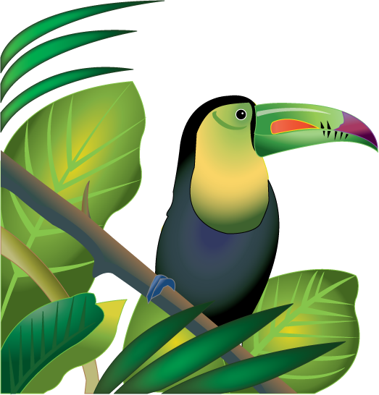
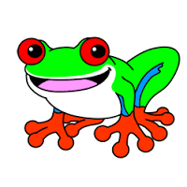
Gifted News
Mrs. Brown’s Class October-December 2016
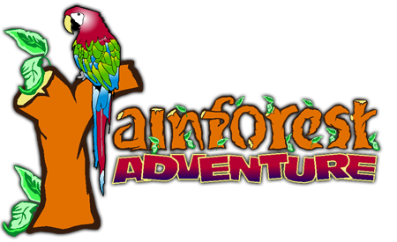
Theme: Rainforest Adventures
Did you know that the country of Brazil, where the 2016 Olympics were held, has one of the largest rainforests in the world? What is a rainforest and why are they important? The students are going to go on an adventure as they explore, gather, analyze and apply information about the rainforest including geography, climate, animal and plant life. We are also going to dig in deep as we try and figure out what is happening to the rainforest and come up with ways we can help!
Supplies Needed:
Please search your house or save the following supplies to send in with your child for some of our rainforest activities.

Empty paper towel rolls
Decorative old wrapping paper or scrapbook paper.
White paper plates

Thank You!!!!

Homework!
Just a reminder that homework is optional, but can be very beneficial. Work together as a family to complete the assignment.

Choose your favorite plant or animal from the rainforest to research. Create a poster, book, song, brochure, or poem about the plant or animal that tells which layer it is found in, what it eats (or how it gets its food), adaptations, the day in the life of this plant or animal.

Homework is due the week of November 14th.

