Name:__________________________________ Hour:______ Date:_____________

AMERICAN HISTORY DIAGNOTIC TEST 2016-17

Standard | Questions | Number Correct | Total Number | Mastery Level
Chapter 4: Reconstruction  3a I: Political development in the United States | 1-5 |  | 5 | %
Chapter 5: Westward Expansion  3a A: migrations of people from many regions of the world and the interactions of cultures and religious traditions that have contributed to America's history from Reconstruction to the present: motivations for immigration | 6-9 |  | 4 | %
Chapter 6: Industrialization  3a N: historical development of the American economy, including: impact of technological change and urbanization on land, resources, society, politics and culture | 10-15 |  | 6 | %
Chapter 7: Immigration and Urbanization  3a U: Distinguish major patterns and issues with regard to population distribution, demographics, settlements, migrations, and cultures in the US | 16-22 |  | 7 | %
Chapter 8: Turn of the 20th Century and Segregation  3a V: Explain how and why regions change; List and explain criteria that give regions their identities in different periods of United States history | 23-27 |  | 5 | %
Chapter 9: Progressive Era  3a M: Analyze the roles and influence of political parties and interest groups since Reconstruction to the present. | 28-33 |  | 6 | %
Chapter 10: Imperialism  3a W: Describe and evaluate the evolution of United States domestic and foreign policies from Reconstruction to the present, including: 4. Imperialism | 34-38 |  | 5 | %
Chapter 11: World War I  3a X: Causes, comparisons, and results of major twentieth-century wars | 39-47 |  | 9 | %
TOTAL | 47 |  |  | %

AMERICAN DIAGNOTIC TEST 2016-17
Directions: Choose the best answer and fill in the bubble on your Scantron.
DO NOT WRITE ON. CLASS COPY

Chapter 4: Reconstruction (5 questions)
Standard 3a I: Political development in the United States

1. The Reconstruction Era was from:
a. 1865-1900 b. 1865-1877
c. 1862-1880 d. 25 BCE- 2014 CE

2. This group was formed by white southerns to help them regain power and to keep African Americans and White Republicans out of office.
a. The Ku Klux Klan b. Carpetbaggers
c. Democrats d. Radical Republicans

3. While Lincoln's Emancipation Proclamation officially freed the slaves in the South this amendment officially ended Slavery in the United States:
a. the Thirteenth Amendment b. the Second Amendment
c. the Nineteenth Amendment d. the Fourteenth Amendment

4. This is a person who farms land owned by another in exchange for a share of the crops. Many ex-slaves and poor whites in the south had this job and were locked in a cycle of poverty.
a. sharecropper b. scalawag
c. farmer d. planter
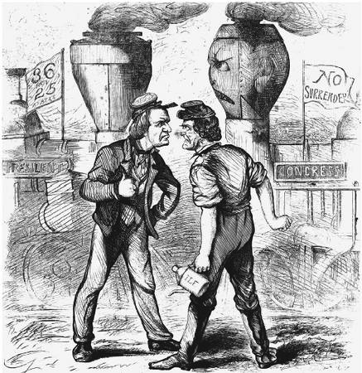
5. This political cartoon represents political
tension during the Reconstruction era between:

a. The Union and the Confederacy

b. Democrats and the Presidents

c. President Andrew Johnson & the Radical
Republicans in congress

d. Republicans and the Klu Klux Klan

Chapter 5: Westward Expansion (4 questions)
Standard 3a A: migrations of people from many regions of the world and the interactions of cultures and religious traditions that have contributed to America's history from Reconstruction to the present: motivations for immigration

6. "[Buffalo hunters] have done more in the last two years, and will do more in the next year, to settle the . . . Indian question than the entire regular army has done in the last thirty years. . . . For the sake of peace let them kill, skin, and sell until the buffalo are destroyed.” —General Philip Sheridan
What was the result of the process described in this quotation?

a. Native American Indians were granted farmland under the Homestead Act.
b. The disappearance of their economic base (buffalo) helped drive Native American Indians onto reservations.
c. Many Native American Indians moved to Eastern cities to work in factories.
d. Most Native American Indians migrated to Canada to find new ways to earn a living.

7. In the period from 1860 to 1890, which experience was shared by most Native Americans living in western states?
a. They maintained control of their traditional lands.
b. They benefited economically from government policy.
c. They became farmers and small business owners.
d. They were forced to live on reservations.

8. The passage of the Homestead Act and the completion of the transcontinental railroad helped to fulfill the United States commitment to
a. Reconstruction b. racial equality
c. manifest destiny d. conservation of natural resources

9. In the following quote Black Elk is referring to this 1890 event that signified the end of the wars between some Plains Native Americans and the U.S. government.

“I did not know then how much was ended. When I look back...I can see the butchered women and children lying heaped and scattered...and I can see that something else died there in the bloody mud, and was buried in the blizzard. A people's dream died there.”

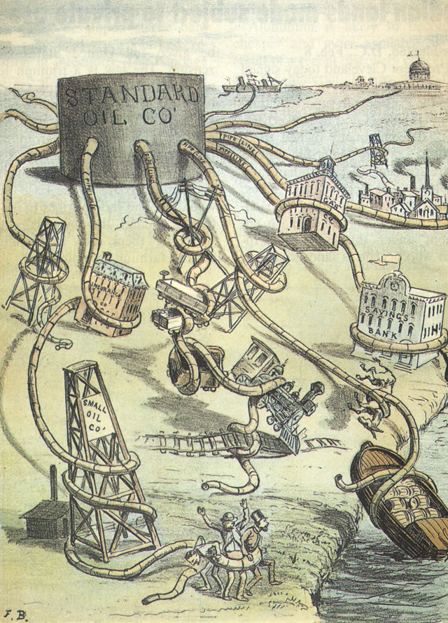
a. Battle of Wounded Knee b. signing of the Dawes Act c. Custard's Last Stand d. The Indian Removal Act (Trail of Tears)

Chapter 6: Industrialization (5 questions)
3a N: historical development of the American economy, including: impact of technological change and urbanization on land, resources, society, politics and culture

10. Which economic concept is best illustrated by the cartoon?

a. supply and demand c. monopoly
b. mercantilism d. trade

11. _____________ used electricity to power new inventions like the incandescent light bulb
a. Andrew Carnegie b. Christopher Sholes
c. Sitting Bull d. Thomas Edison

12. Why were scabs unpopular with striking workers during the late 1800s?
a. They were socialists. b. They were federal troops.
- They were part of management. d. They were workers used to break strikes.

13. Andrew Carnegie became rich off using this new way of manufacturing steel.
a. Skyscrapers b. Firing the Steel
c. Carnegie Process d. Bessemer Process

14. This is the name for the process of a society's economy moving from being based on farming to being based on production in factories.
a. Urbanization b. Industrialization
c. Democratization d. Segregation

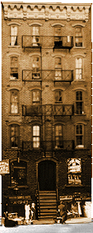
15. Which of the following resulted from the investigation of the Triangle Shirtwaist fire?
a. the imprisonment of company officials
b. the passage of the Sherman Antitrust Act
c. the adoption of equal wages for men and women
d. changes in local labor laws for women and children

Chapter 7: Immigration and Urbanization (7 questions)
3a U: Distinguish major patterns and issues with regard to population distribution,
demographics, settlements, migrations, and cultures in the US

16. This building, in the Lower East Side neighborhood of New York City,
had over ten thousand people living there between the years
1870 and 1915. This is an example of a ________________.

a. Skyscraper b. Urban Log Cabin
c. Tenement d. Apartment building

17. This journalist shocked many in the US by exposing the grinding conditions of the slums in which many immigrants lived in with photography of tenements.

a. Jacob Riis b. Andrew Carnegie
c. Upton Sinclair d. Jane Addams

18. A “new” European immigrant (late 19th and early 20th century) would most likely come from which of the following countries

a. England b. France
c. China d. Italy

19. “Give me your tired, your poor, your huddled masses yearning to breathe free, The wretched refuse of your teeming shore. Send these, the homeless, tempest-tossed, to me: I lift my lamp beside the golden door.”
This quote on the State of Liberty represents the United States' _______________

a. attitude of “nativism” b. reputation for accepting immigrants
c. Feminist ideology d. Respect for the French

20. Why did the United States follow a policy of unrestricted immigration for Europeans during most of the 1800s?
a. Business and industry depended on the foreign capital brought by immigrants
b. The American economy needed many unskilled workers.
c. Most Americans desired a more diversified culture.
d. The United States wanted to help European nations by taking in their surplus population.

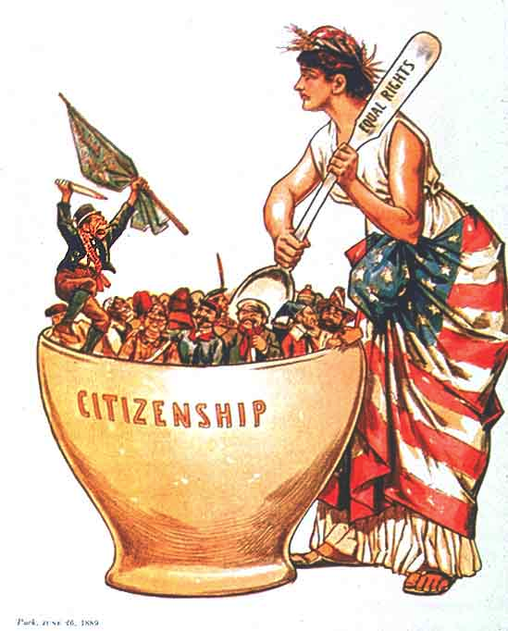
21. The following political cartoon represents which
metaphor for the assimilation of immigrants in the United States?

a. Salad Bowl

b. Mixing Cup

c. Melting Pot

d. Big Spoon

22. The Jungle by Upton Sinclair focuses on the plight of immigrants in the USA with a fictional story about workers in ________________.

a. Steel Factories b. Textile Factories
c. Meat Packing Plants d. Agriculture

Chapter 8: Turn of the 20th Century and Segregation (5 questions)
3a V: Explain how and why regions change; List and explain criteria that give regions their identities in different periods of United States history

23. The decision of the Supreme Court in the 1896 Plessy v. Ferguson case is important because it
a. upheld the legality of sharecropping.
b. denounced the violence of the Ku Klux Klan
c. approved separate but equal facilities for African Americans
d. declared slavery to be illegal.

24. These laws maintained segregation in the South for the first half of the 20th century.
a. Black Codes b. Labor Laws
c. Jim Crow d. Segregation Laws

25. Which statement about the philosophies of Booker T. Washington and W.E.B. Du Bois is most accurate?
a. They differed as to the best way that African Americans could effectively achieve equality.
b. Both demanded programs that would provide for immediate social equality.
c. Both believed that vocational training would provide the most important kind of education
for African Americans
d. Neither wanted the Federal Government to play a major role in protecting the civil rights of
African Americans

26. During the Gilded Age this was the name for an organized group that controlled activities of a political party
a. Political Machine b. Patronage
c. Jim Crow d. Robber Barron

27. The Wainwright Building in downtown STL by architect Louis Sullivan was one of the first of these.
a. Office Buildings b. Big Box stores
c. Skyscrapers d. Tenements

Chapter 9: Progressive Era (6 questions)
3a M: Analyze the roles and influence of political parties and interest groups since Reconstruction to the present.

28. Progressivism could best be characterized as a movement that
a. encouraged involvement in international affairs.
b. tried to introduce a parliamentary system of government.
c. emphasized only the needs of farmers.
d. demanded reform at all levels of government

29. The 18th Amendment marked a success for the Temperance Movement by making this illegal.
a. Child Labor b. Cocaine
    - Alcohol d. Debt Peonage

30. Women like Susan B. Anthony fought for the right to vote, which they obtained with the passage of the 19th amendment in 1919. Their movement was called:
a. Temperance b. Populist
    - Tea Party d. Suffrage

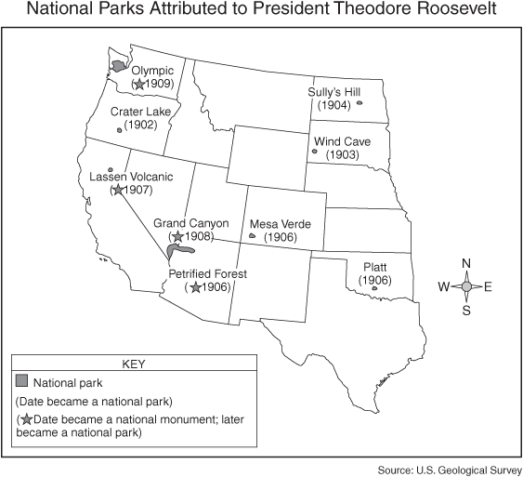
31. This map represents wilderness areas protected by the Federal government as a part of this movement:

a. Suffrage

b. Civil Rights

c. Conservation

d. Green Movement

32. In the United States during the early part of the twentieth century, reform writers, called Muckrakers, helped to bring about passage of federal legislation designed to
a. increase immigration b. protect the consumer
- encourage the growth of corporations. d. sell public lands to private developers.

33. As a part of his “Square Deal” Teddy Roosevelt promised to do all of the following except:
a. break up big business monopolies (trusts)
b. protect the environment and public health
c. improve working conditions for factory workers
- avoid conflicts with other countries

Chapter 10: Imperialism (5 Questions)
3a W: Describe and evaluate the evolution of United States domestic and foreign policies from Reconstruction to the present, including: 4. Imperialism
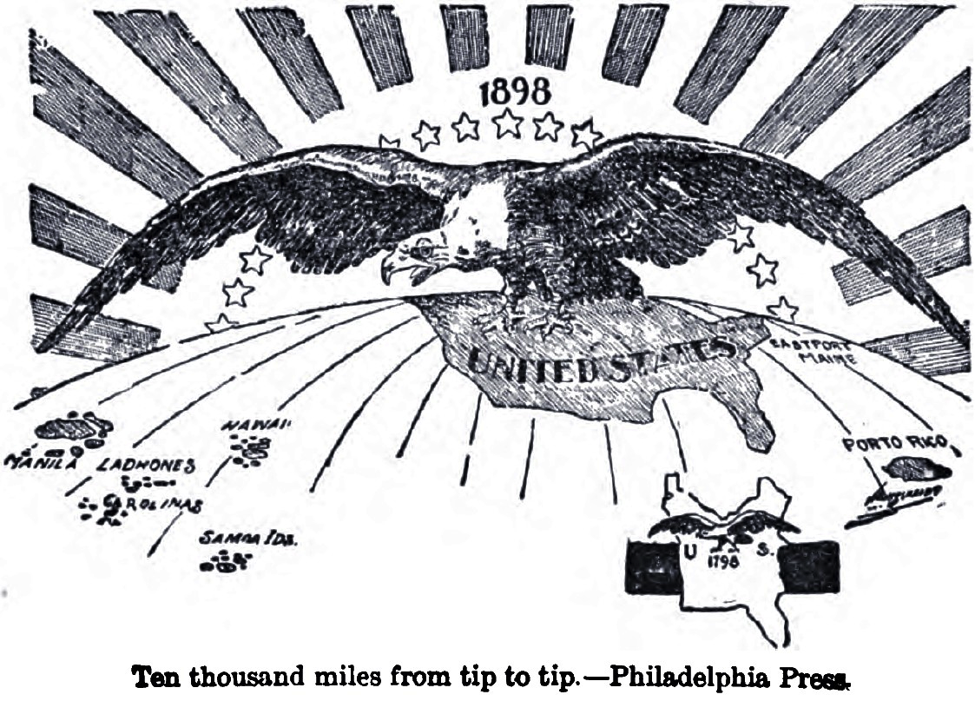
34. This political cartoon represents:

a. The policy of anti-imperialism

b. the large addition of territory to the
United States between 1798 and 1898

c. Conservationist successful attempts at
saving the bald eagle from extinction

d. Roosevelt's Square Deal.

35. Conclusions about the relations between the United States and Spain during the period leading to the Spanish-American War would probably be most valid if they were based on a study of
a. editorials published in newspapers during that time.
b. biographies of Presidents William McKinley and Theodore Roosevelt.
c. the diary of a member of the crew of the battleship Maine.
d. Government documents, as interpreted by several historians with different viewpoints.

36. One major result of the Spanish-American War was that the United States
a. established many foreign-aid programs
b. obtained overseas colonies
c. abandoned the principles of the Monroe Doctrine.
d. settled disputes by relying on international peace organizations.

37. The United States supported the Open Door policy towards China mainly to
a. construct military bases
b. bring about democratic government.
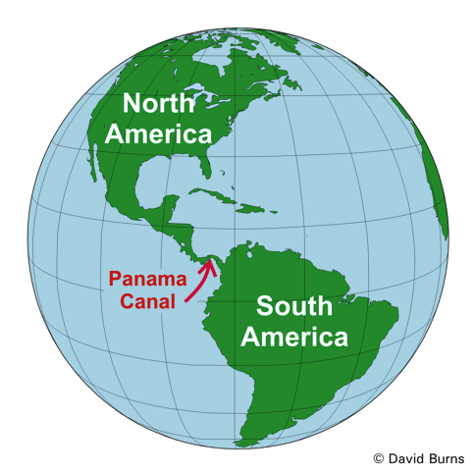
c. encourage European nations to leave
d. increase trading opportunities

38. How did the building of the Panama Canal support United States efforts to become a world power?
a. It gave the United States a colony in Central America.
b. It prevented Japan and China form attacking Hawaii
c. It opened up a new avenue for trade with China.
d. By provided a shortcut between the Atlantic Ocean and
Pacific Ocean, it opened up new trading opportunities.

Chapter 11: World War I (9 Questions)
Standard 3a X: Causes, comparisons, and results of major twentieth-century wars

14. 39. Which of the following was not a cause of World War I?
a. | American isolationism
b. | imperialist competition
c. | European nationalism
d. | the stockpiling of weapons

17. 40. The policy that kept the United States out of the war for three years was called
a. | neutrality.
b. | the alliance system.
c. | the convoy system.
d. | nationalism.  41. Of the following, the most compelling reason for the United States to enter WWI
  a. | a moral obligation to halt the refugee crisis in Belgium.
  b. | the outrage of American citizens over German submarine warfare.
  c. | a desire to become more involved in the affairs of Europe.
  d. | concern over the repayment of Allied debts to American banks.

42. What caused widespread starvation in Germany?
a. | the British blockade
b. | the Allied bombing of German farms
c. | the devaluation of German currency
d. | a severe drought

43. Gains made by American women during World War I include:
a. acceptance as full-fledged members of the U.S. Army.
b. the beginnings of a movement for woman suffrage.
c. equal pay for equal work in many war industries.
d. increased support for women's right to vote.

44. President Woodrow Wilson’s Fourteen Points were intended to
a. make the United States, Great Britain, and France into leading world powers
b. redistribute Germany’s colonies among the Allied nations
c. prevent international tensions from leading to another war
d. punish Germany for causing World War I

45. The war might have involved only two nations, Austria-Hungary and Serbia, if not for
a. the American Expeditionary Force.
b. imperialism.
c. propaganda.
d. the alliance system.

46. The Espionage and Sedition Acts affected freedom of speech because they
a. forced restaurant owners to offer "liberty sandwiches" rather than "hamburgers."
b. allowed the government to silence ideas that challenged its authority.
c. forced the repeal of the First Amendment.
d. promoted biased ideas designed to sway people's thinking.

47. The Treaty of Versailles overlooked the importance of
a. identifying the guilty party in a war.
b. treating all nations justly, including the losers of a war.
c. including powerful nations like the U. S. in international peace-keeping organizations.
d. crippling any nations that might prove dangerous in the future.

