**CIRCUITS WORKSHEET**

1. Determine the equivalent (total) resistance for each of the following circuits below.

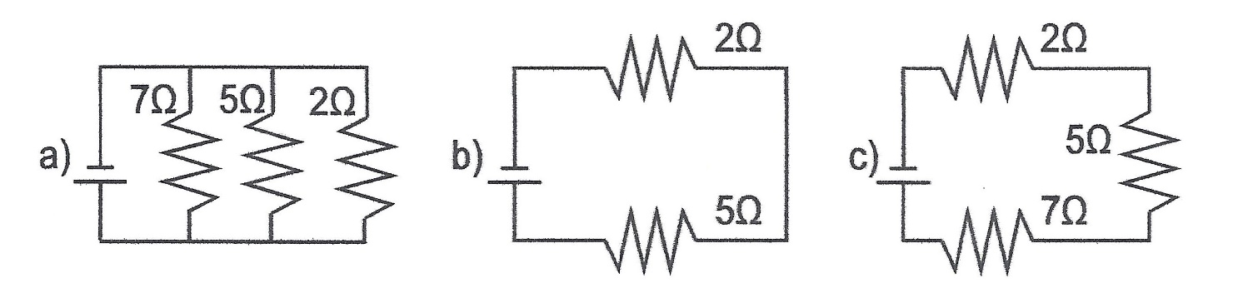

2. Determine the total voltage (electric potential) for each of the following circuits below.

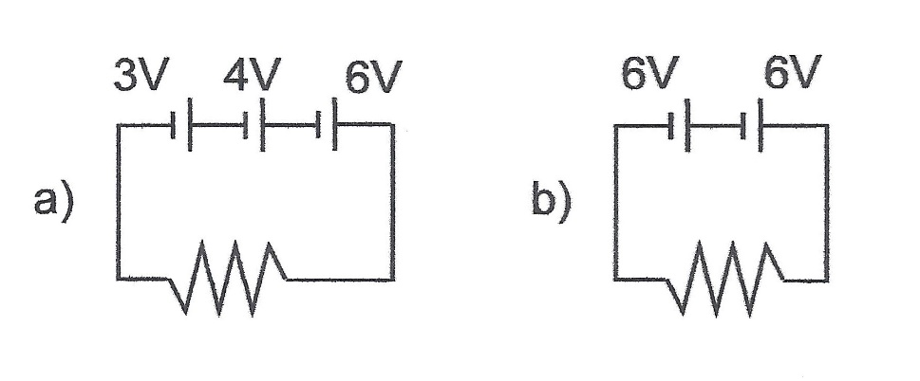

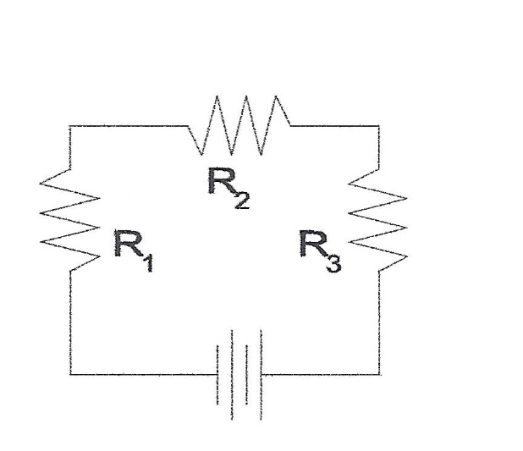3. Fill out the table for the circuit diagramed at the right.

|  |  |  |  |
| --- | --- | --- | --- |
| Circuit Position | Voltage (V) | Current (A) | Resistance (Ω) |
| 1 |  |  | 10.0 |
| 2 |  |  | 20.0 |
| 3 |  |  | 30.0 |
| Total | 6.00 |  |  |

4. Fill out the table for the circuit diagramed at the right.

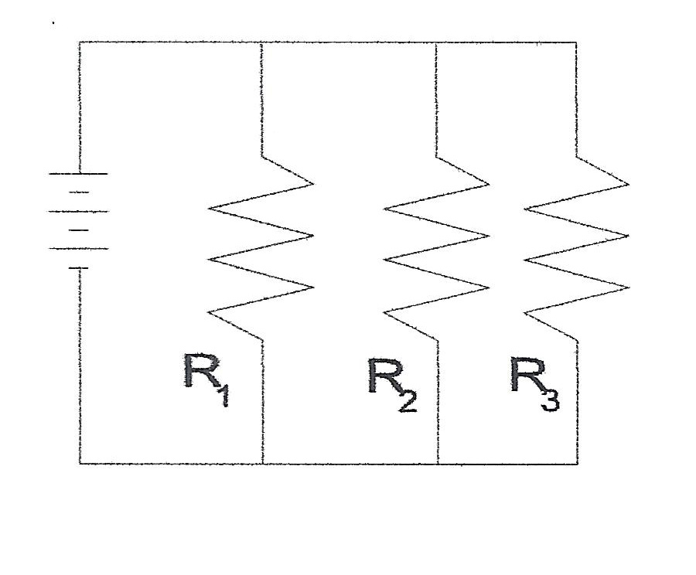

|  |  |  |  |
| --- | --- | --- | --- |
| Circuit Position | Voltage (V) | Current (A) | Resistance (Ω) |
| 1 |  |  | 10.0 |
| 2 |  |  | 20.0 |
| 3 |  |  | 30.0 |
| Total | 6.00 |  |  |

5. Fill out the table for the circuit diagramed at the right.

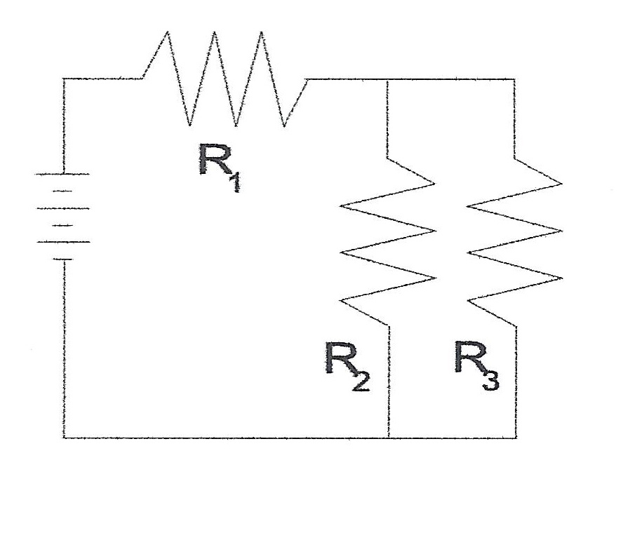

|  |  |  |  |
| --- | --- | --- | --- |
| Circuit Position | Voltage (V) | Current (A) | Resistance (Ω) |
| 1 |  |  | 10.0 |
| 2 |  |  | 20.0 |
| 3 |  |  | 30.0 |
| Total | 6.00 |  |  |

Questions 6 and 7 refer to the following:

The diagram to the right represents an electric circuit consisting of four resistors and a 12-volt battery.

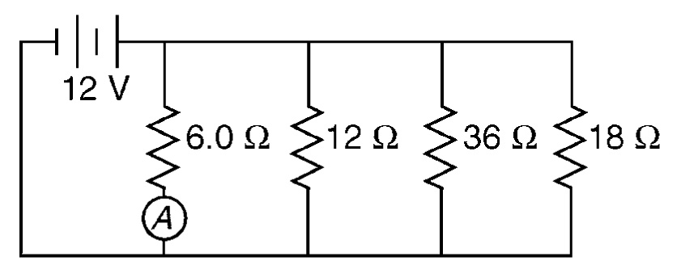

6) What is the equivalent resistance of the circuit shown?

7) What is the current measured by ammeter *A* shown in the diagram?

8) A 6.0-ohm lamp requires 0.25 ampere of current to operate. In which circuit below would the lamp operate correctly when switch *S* is closed?

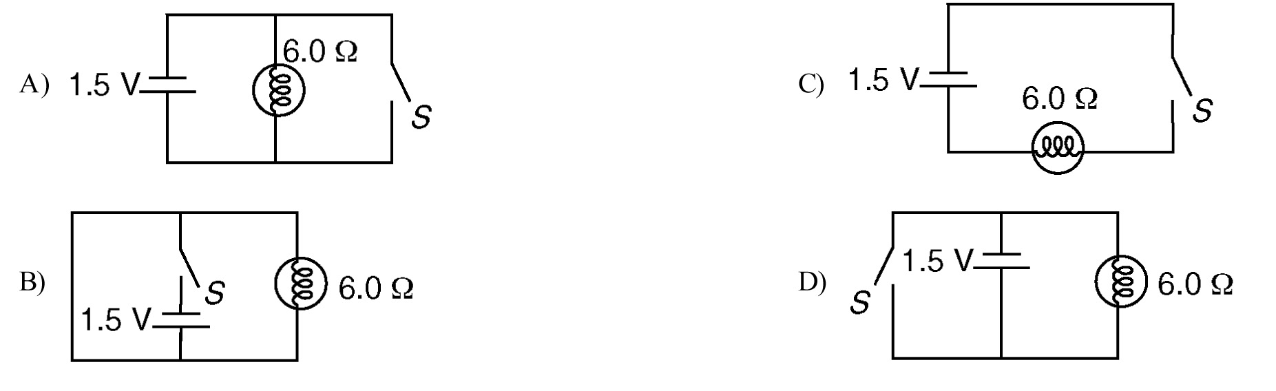

Questions 9 and 10 refer to the following:

A 50.-ohm resistor, an unknown resistor *R*, a 120-volt source, and an ammeter are connected in a complete circuit. The ammeter reads 0.50 ampere.

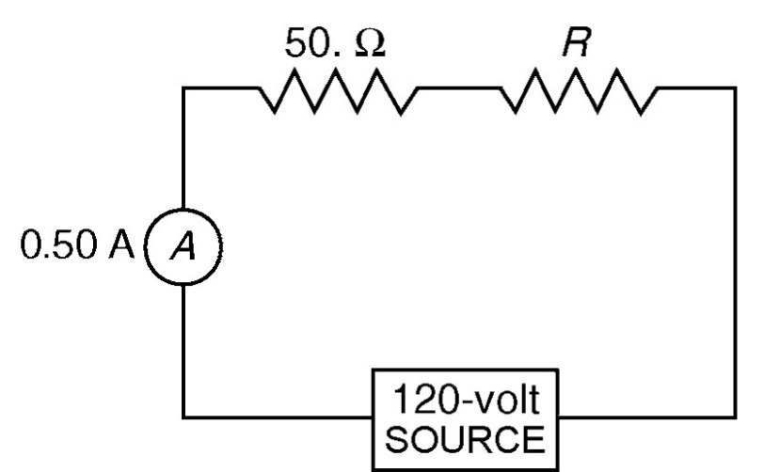

9) Calculate the equivalent resistance of the circuit shown.

10) Determine the resistance of resistor *R* shown in the diagram.

Questions 11 through 13 refer to the following:

A 3.0-ohm resistor, an unknown resistor, *R*, and two ammeters, *A*1 and *A*2, are connected as shown below with a 12-volt source. Ammeter *A*2 reads a current of 5.0 amperes.

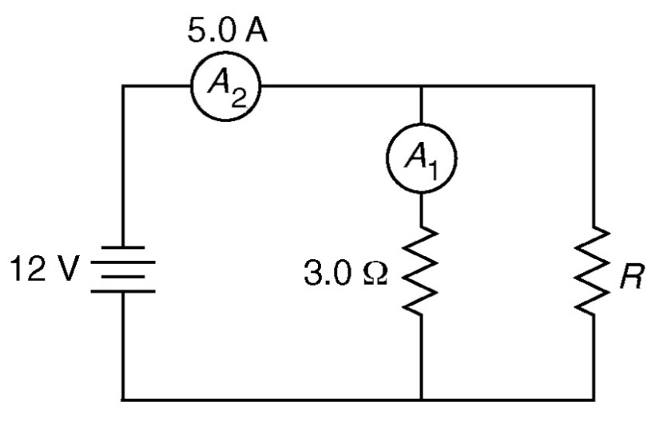

11) Determine the equivalent resistance of the circuit shown.

12) Calculate the current measured by ammeter *A*1 in the diagram shown.

13) Calculate the resistance of the unknown resistor, *R* in the diagram shown.

14. The load across a 50.0-V battery consists of a series combination of two lamps with resistances of 125 Ω  and 225 Ω.

a. Find the total resistance of the circuit.

b. Find the current in the circuit.

c. Find the potential difference across the 125-Ω  lamp.

15. The load across a 12-V battery consists of a series combination of three resistances are 15 Ω, 21 Ω, and 24 Ω, respectively.

a. Draw the circuit diagram.

b. What is the total resistance of the load?

c. What is the magnitude of the circuit current?

16. The load across a 40-V battery consists of a series combination of three resistances R1, R2, and R3. R1 is 240 Ω  and R3 is 120 Ω. The potential difference across R1 is 24 V.

a. Find the current in the circuit.

b. Find the equivalent resistance of the circuit.

c. Find the resistance of R2.

17. The load across a 12-V battery consists of a series combination of three resistances R1, R2, and R3. R1 is 210 Ω, R2 is 350 Ω, and R3 is 120 Ω.

a. Find the equivalent resistance of the circuit.

b. Find the current in the circuit.

c. Find the potential difference across R3.

18. Two resistances, one 12 Ω  and the other 18 Ω, are connected in parallel. What is the equivalent resistance of the parallel combination?

19. Three resistances of 12 Ω  each are connected in parallel. What is the equivalent resistance?

20. Two resistances, one 62 Ω  and the other 88 Ω, are connected in parallel. The resistors are then connected to a 12-V battery.

a. What is the equivalent resistance of the parallel combination?

b. What is the current through each resistor?

21. A 110-V household circuit that contains an 1800-W microwave, a 1000-W toaster, and an 800-W coffeemaker is connected to a 20-A fuse. Determine the current. Will the fuse melt if the microwave and the coffeemaker are both on?

22. A 35-Ω, 55-Ω, and 85-Ω  resistor are connected in parallel. The resistors are then connected to a 35-V battery.

a. What is the equivalent resistance of the parallel combination?

b. What is the current through each resistor?

23. Resistors R1, R2, and R3 have resistances of 15.0 Ω, 9.0 Ω, and 8.0 Ω  respectively. R1 and R2 are connected in series, and their combination is in parallel with R3 to form a load across a 6.0-V battery.

a. Draw the circuit diagram.

b. What is the total resistance of the load?

c. What is the current in R3?

d. What is the potential difference across R2?

24. A 15.0-Ω  resistor is connected in series to a 120-V generator and two 10.0-Ω resistors that are connected in parallel to each other.

a. Draw the circuit diagram.

b. What is the total resistance of the load?

c. What is the magnitude of the circuit current?

d. What is the current in one of the 10.0-Ω resistors?

e. What is the potential difference across the 15.0-Ω  resistor?

Answers

1a) 1.2 Ω 1b) 7 Ω 1c) 14 Ω

2a) 13 V 2b) 12 V **6**) 3.0 Ω

7) 2.0 A 8) C 9) 240 Ω

10) 190 Ω 11) 2.4 Ω 12) 4.0 A

13) 12 Ω 14a) 350. Ω 14b) 0.143 A

14c) 17.9 V 15b) 60. Ω 15c) 0.20 A

16a) 0.10 A 16b) 400 Ω 16c) 40. Ω

17a) 680 Ω 17b) 0.018 A 17c) 2.2 V

18) 7.2 Ω 19) 4.0 Ω 20a) 36 Ω

20b) I62Ω = 0.19 A; I88Ω = 0.14 A

21) I = 23.6 A so fuse will melt 22a) 17 Ω

22b) I35Ω = 1.0 A; I55Ω = 0.64 A; I85Ω = 0.41 A

23b) 6.0 Ω 23c) 0.75 A 23d) 2.3 V

24b) 20.0 Ω 24c) 6.0 A 24d) 3.0 A

24e) 90. V