**Pencil Holder**

Pencils rolling off tables drive me crazy. I found this cord hider at Lowes in 5 ft. lengths. It has a self- stick strip on the bottom. I use a tin snip to cut the 5 ft. length into 1 ½ “ pieces. You can adjust this to your liking. The front of the channel is actually open. In the beginning of the year, we use fat pencils. I stretch the tube open a little to adjust for this. Later in the year, skinny pencils fit easily. I place a cut piece at the top of each student’s place, above their name tag. These usually last all year unless the student is especially rough taking out and putting back pencils. I have used these on slant top desks as well. They work much better than the little indent provided for pencils on these desks. The nice thing about this is that pencils can be retrieved and put away without having to get a pencil box out. We then practice putting our pencils away (quietly) pointy end first. (You could also stick them directly on name tags if you don’t want to stick things on desks).

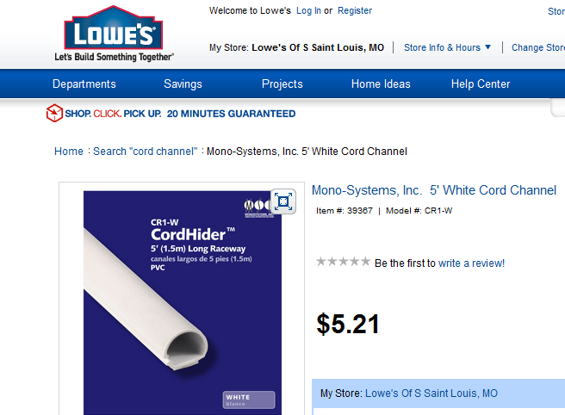

Pencil holders

Desk

Name Tag

Name Tag

**Name Tags**

To avoid removing tape and damaging name tags, I use two pieces of Velcro on the back of each name tag and on the desk. I place them uniformly on the backs so that I am able to move name tags without any trouble. It is also nice when we want to clean our tables. It also works much better than the expensive plastic pouches they would like to sell you.



You can use the smaller circles or continuous on a roll and cut to desired length. Just make sure you get “sticky-back”. I have had the desk side pieces on for three years. Washing tables/desks won’t remove them. Use a razor blade to remove.

Make sure you always use the same part on the table (plastic part vs. smooth part) so that all name tags will stick.

It is better to buy name tags that are pre-laminated and not laminate them. Removing name tags seems to pull off our machine’s film.

Name tag back

Name Tag

Velcro squares

Velcro squares

Desk

**Center Recording Ideas**

I’ve tried travel logs, and for most of my Kg students and possibly some other early learners, it seems that managing a travel log or other journal at centers is just too difficult. I found a website on one of the Reading Street Links that had some great one-page activities that gave children a chance to document their work at centers. <http://kindergartenersrock.wikispaces.com/>

I believe these would also be good for 1st grade. I think the management idea would be great for any level. I have now created a one page activity sheet for students to use at each center to document what they have done, e.g., at the word building center, they have a sheet to write the words they have created, at the alphabet center, they have a sheet with all upper and lower case alphabets so that they can circle the letters they worked with, at the listening and library centers, they fill out a story log.

At each center, I hung a clipboard with activity sheets and a cup with pencils (keeping track of their pencils was also a problem when we used travel logs). When center time is over, they write their name, date their paper, and place it in a designated area. I use recycled paper for this as much as possible. I have not thought of anything for the computer station, but I am working on it.

As far as management, I use an idea from another SF website. I want children to have some choice, so I divided centers between three walls. (Assumption, 4 reading groups, 1 group with teacher, three groups at centers). Each wall has at least 8 different activities. Each day, we rotate which group will go to A,B or C wall. To make sure students are not at centers too long, one rotation is quiet seat work for all students not with teacher. I am in the process of adding colors to identify difficulty level for some tasks using reading group colors of blue, yellow, green, which students understand.