Directions for Signing in Microsoft Teams on a Computer, iPad, or Cell Phone Through the Internet. (NOTE: District iPads will already have a Microsoft Teams app icon.)
- Go to Microsoft Teams https://teams.microsoft.com/
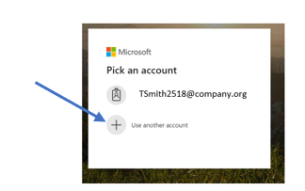
- If this screen pops up, select Use another account.

- Type in your student’s email address that the teacher provided. Make sure to type the entire email address. Ex: tsmith2518@slps.org. If you are using your phone, it might prompt you to download the app at this time. Go ahead and click download the app.
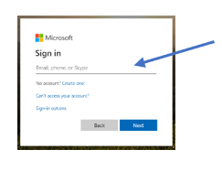

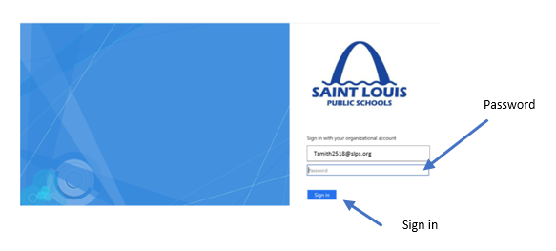
- Type in your student’s password. Then click Sign in.

- You are ready to start. You can use Teams as a web-base or download the app on your computer or mobile phone. I have found it to work better as a app. To download the app, go to Step 6.
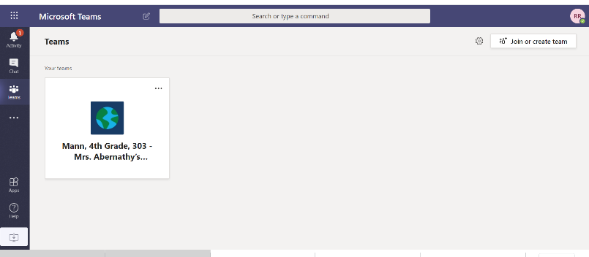

- Click on the circle in the top right corner with your student’s initials. Then click on either Download the desktop app or Download the mobile app.
