Arrival & Dismissal  All students enter the building through Door 6 (Howell Street) beginning at 7:50 AM. Breakfast is provided for all students each day.  The school day ends at 3:02 PM. Students who are pick-up may be picked up beginning at 3:00 PM from the gym. If you need to change your child’s transportation on any given day, please communicate this change with the main office by 2:00 PM. The main office is closed from 2:30-3:00 PM each day and students must be picked up from the gym.  Dress Code  All students must come to school in uniform clothing every day.  - Tops – Powder blue, White, Green, or Navy  - Pants, Shorts, Skirts, and Jumpers – Tan, black, khaki, or navy; NO JEANS  - Footwear– students should wear athletic shoes on their assigned PE days so that they may fully participate in activities; Flip flops and sandals are never to be worn for your child’s safety.  For students’ comfort, they may wear jackets, sweatshirts, and hoodies, but hoods may not be worn.  On Fridays, students may wear jeans (may not have holes) and a uniform shirt, Nance T-shirt, or other school-appropriate T-shirt. Students who do not follow the school dress code will be asked to contact parents/guardians to bring appropriate clothes to school.  Snacks and Drinks  All students are provided a healthy breakfast and lunch each day, along with regular fruits and vegetables for snacks. Students may not eat snacks and drinks (besides water) that are brought to school, with the exception of a full lunch.  Cell Phones & Electronic Devices  In accordance with district policy, students are not allowed to have cell phones visible or in use during the school day. Phones must be stored in book bags in classroom lockers each morning. Violations of this policy may lead to cell phones being confiscated. In case of emergency, please contact the main office to reach your child. |  |  | Parent and Family Handbook  2023-2024  - 1616 California  St. Louis, MO 63104  (314) 771-2539  www.slps.org/hodgen  Bell Times: 9:20 AM-4:17 PM

Our Mission:  The mission of Earl Nance Sr. Elementary School is to empower students to have a voice within their community. All students will achieve success by experiencing a school environment that promotes literacy, equity, innovation, social justice, and belonging.  Our Vision:  Nance Elementary students will be empowered as change agents to make a positive impact on the world.  Nance Elementary students agree to demonstrate HEART and follow the Nance Knights Responsibility Policy:  Honesty- To speak or act truthfully, no matter the outcome  Empathy- To understand the feelings of others  Accountability- To demonstrate the power to own your actions  Respect- To treat yourself and others with kindness  Tenacity- To keep going even when things get tough  The Knights Have HEART Matrix below outlines the expectations for student behaviors throughout the school.  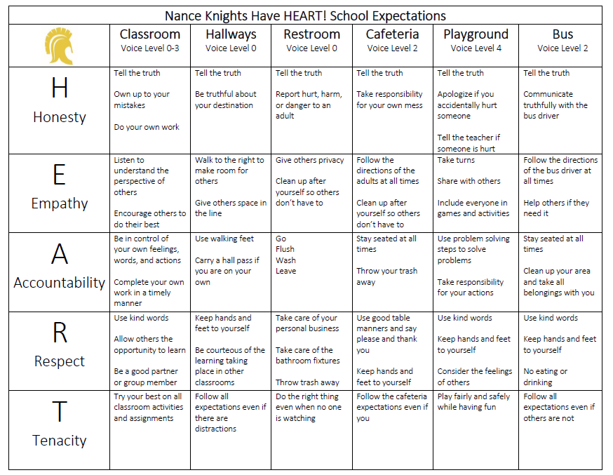 |  |  | Academic Expectations  Student academic progress is assessed throughout the year based on progress towards mastery of grade level standards. The chart below outlines how student grades are determined by using Standards-Based Grading.  Each quarter, progress reports are issued to students after five weeks. Report cards are completed at the end of each quarter. Parent teacher conferences are held at the end of first and third quarter.  Please refer to the one-page handout, “What Nance Knights Need to Know” for more detailed information about academic expectations at each grade level.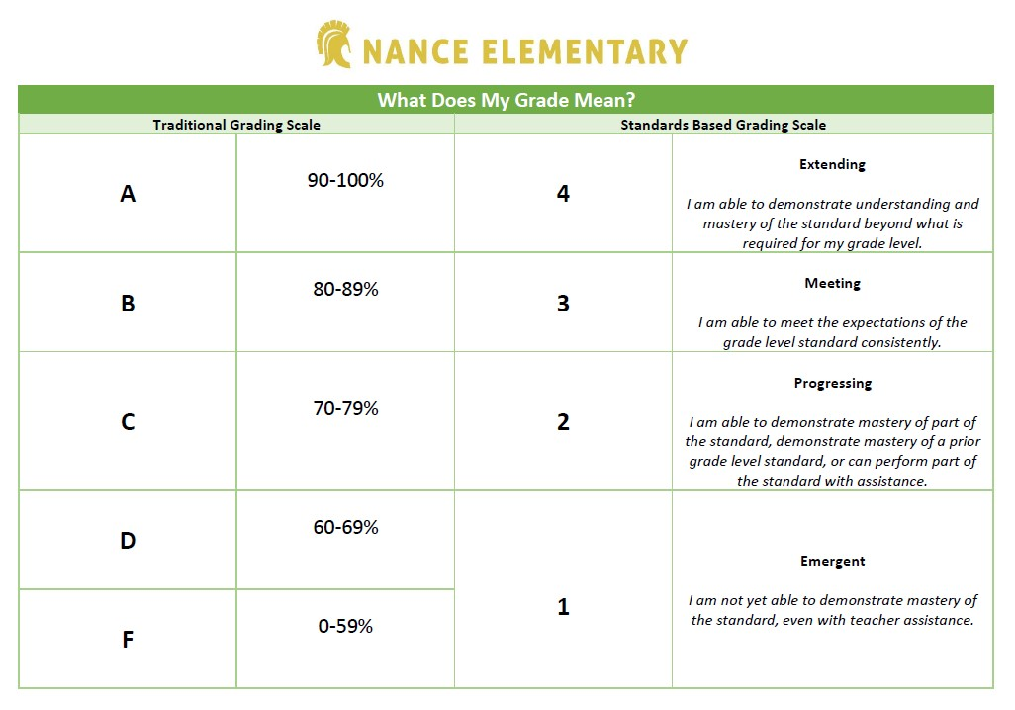  Communicating with Staff  All Nance staff can be reached via SLPS e-mail, by phone at (314) 867-0634, and by using Class Dojo. Please contact your child’s teacher or the main office to make an appointment with school staff as unplanned appointments may not be able to be accommodated. Please ensure the main office and your child’s teacher are provided with updated contact information at all times.

